SPARE - PARTS CATALOG

CF MOTO
U-FORCE 1000 XL

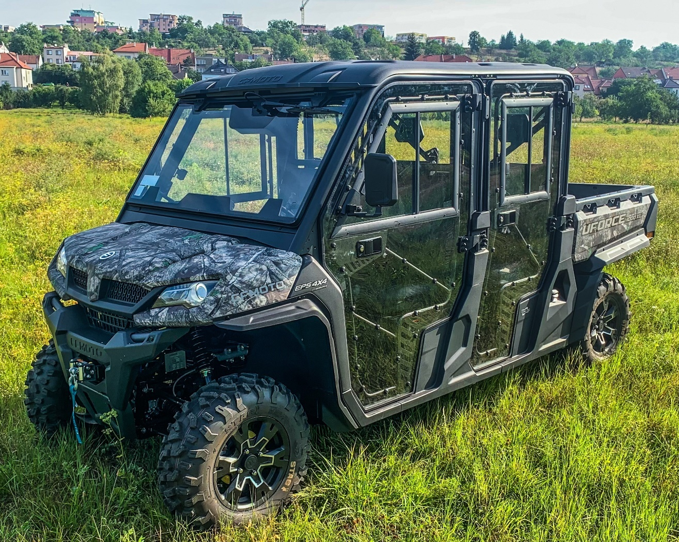

CAB PREVIEW
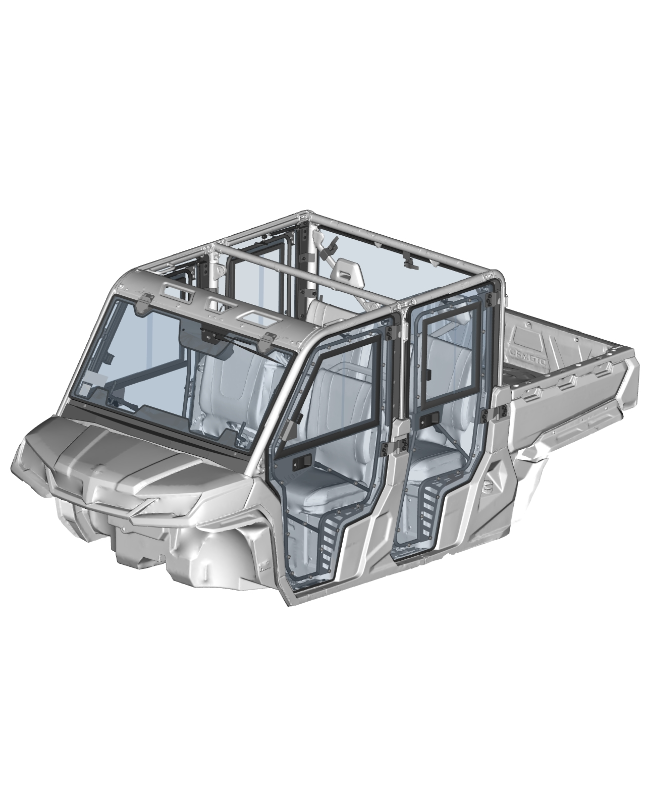

ALL PANELS
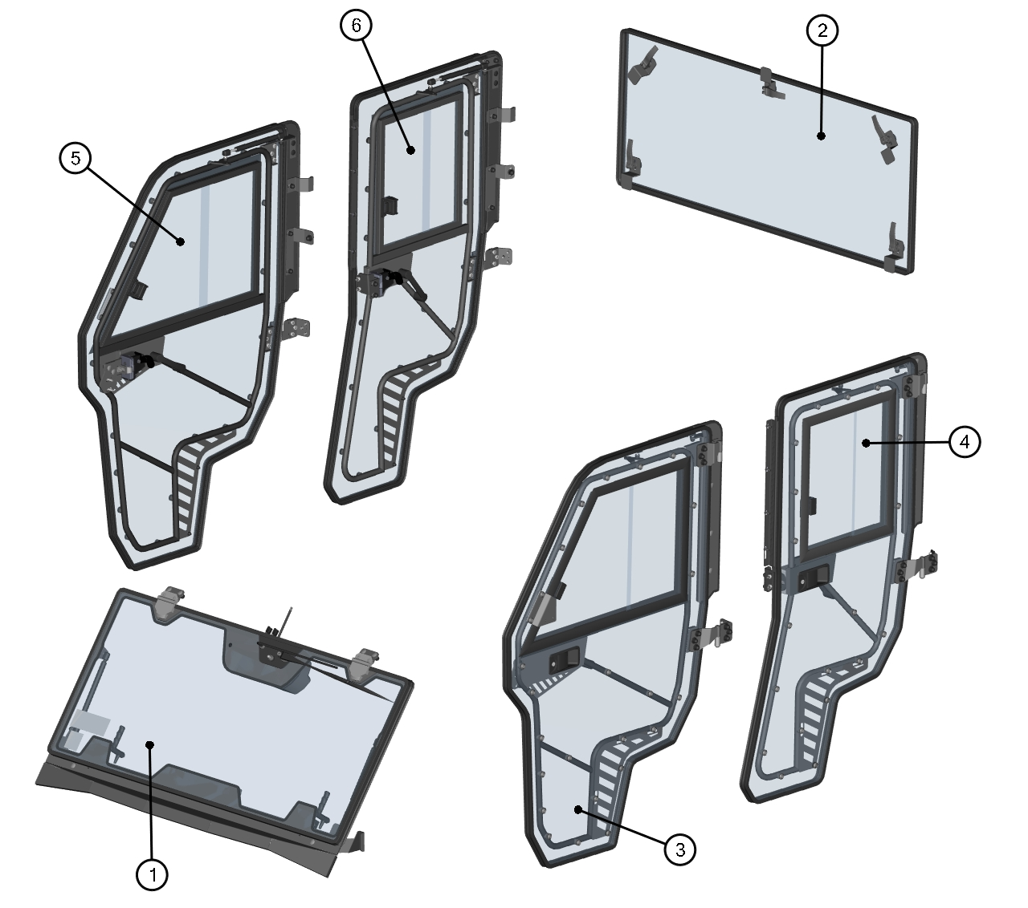

ID | Catalog no. | Description | Qty |  | Page |  | Price
1 | 64S03U01S10 | FRONT PANEL | 1 |  | 5
2 | 64S03U01S20 | REAR PANEL | 1 |  | 9
3 | 64S03U05S40 | FRONT LEFT DOOR | 1 |  | 11
4 | 64S03U05S41 | REAR LEFT DOOR | 1 |  | 16
5 | 64S03U05S50 | FRONT RIGHT DOOR | 1 |  | 22
6 | 64S03U05S51 | REAR RIGHT DOOR | 1 |  | 27
- | ----- | ELECTROINSTALLATION | 1 |  | 32

FRONT PANEL
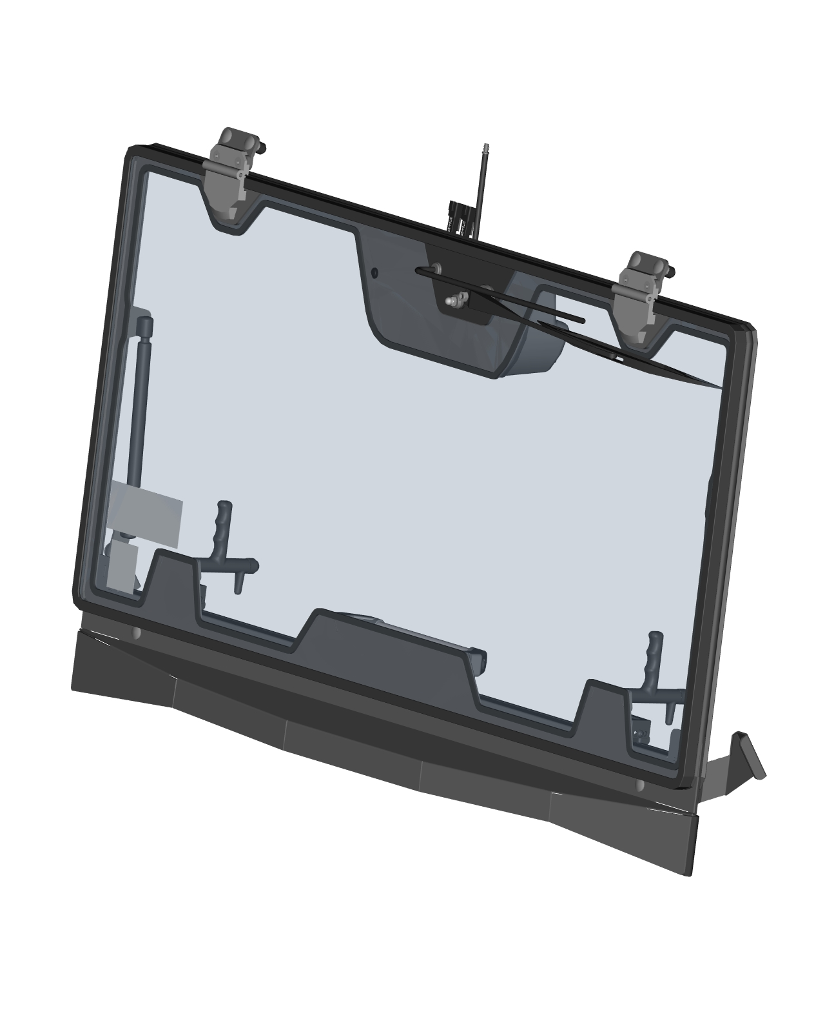

FRONT PANEL ASSEMBLIES
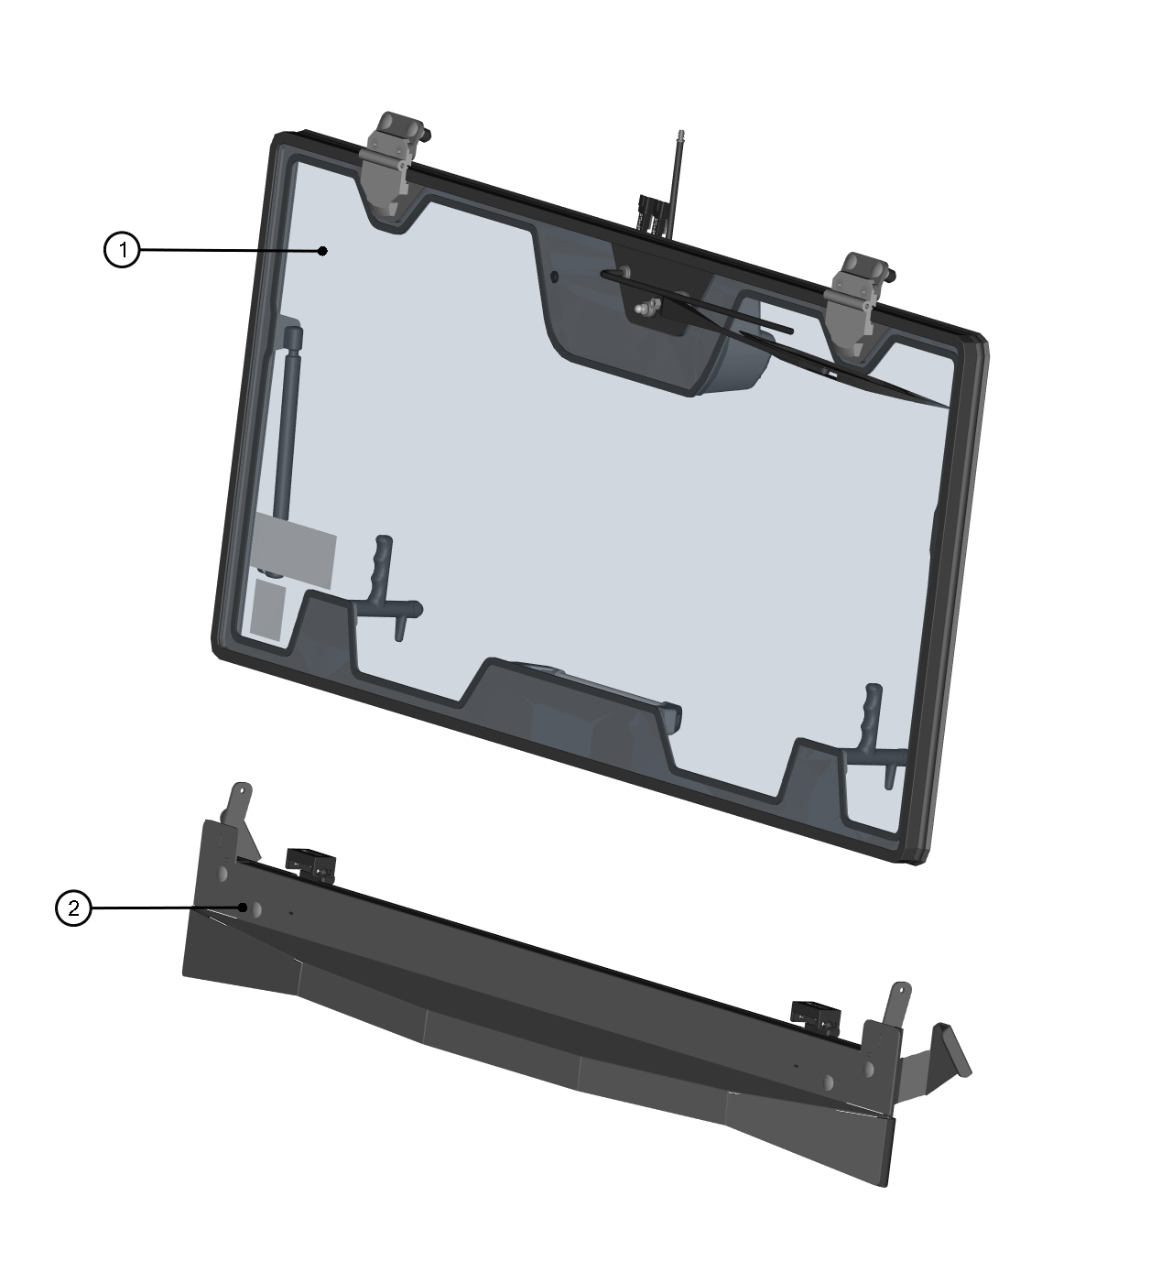

ID | Description | Page | Qty
1 | FRONT GLASS ASSEMBLY | 6 | 1
2 | FRONT BOTTOM LEDGE | 7 | 1

FRONT GLASS ASSEMBLY
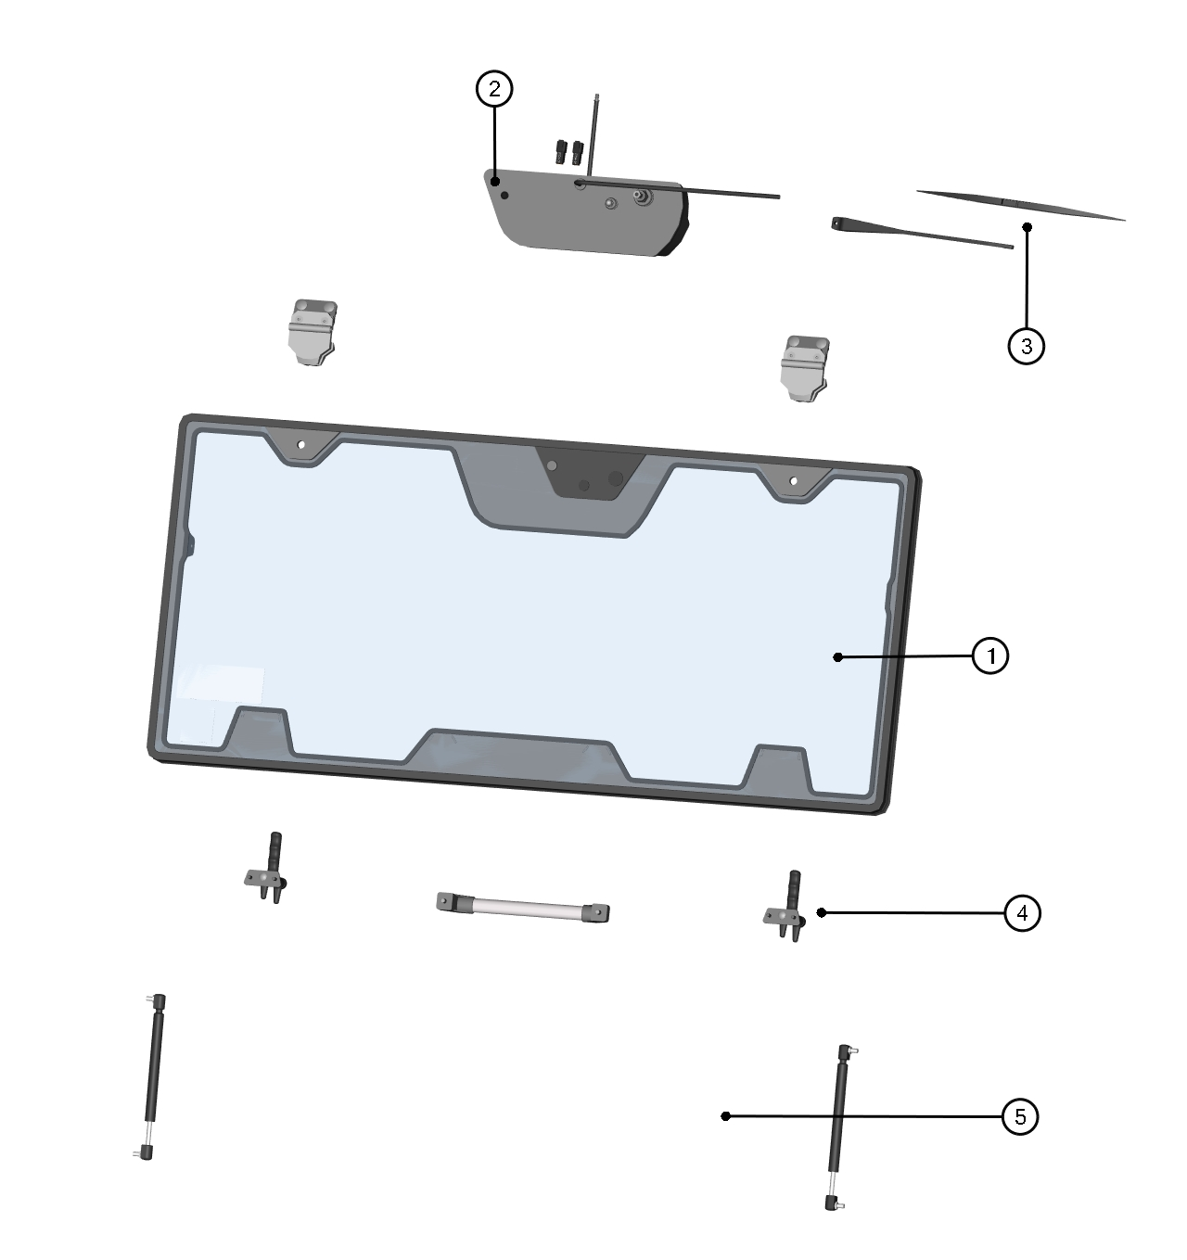

ID | Catalog no. | Description | Qty |  | Price
1 | 64S03U01-15M001 | FRONT GLASS WITH REINFORCEMENT AND SEALING | 1
2 | 74S02U01-01M002 | WIPER MOTOR ASSEMBLY | 1
3 | 64S03U05-10PKM001 | WIPER ARM WITH BLADE | 1
4 | 64S03U05-10PKM002 | FRONT GLASS HARDWARE KIT | 1
5 | 000868 | GAS SPRING | 2

FRONT BOTTOM LEDGE
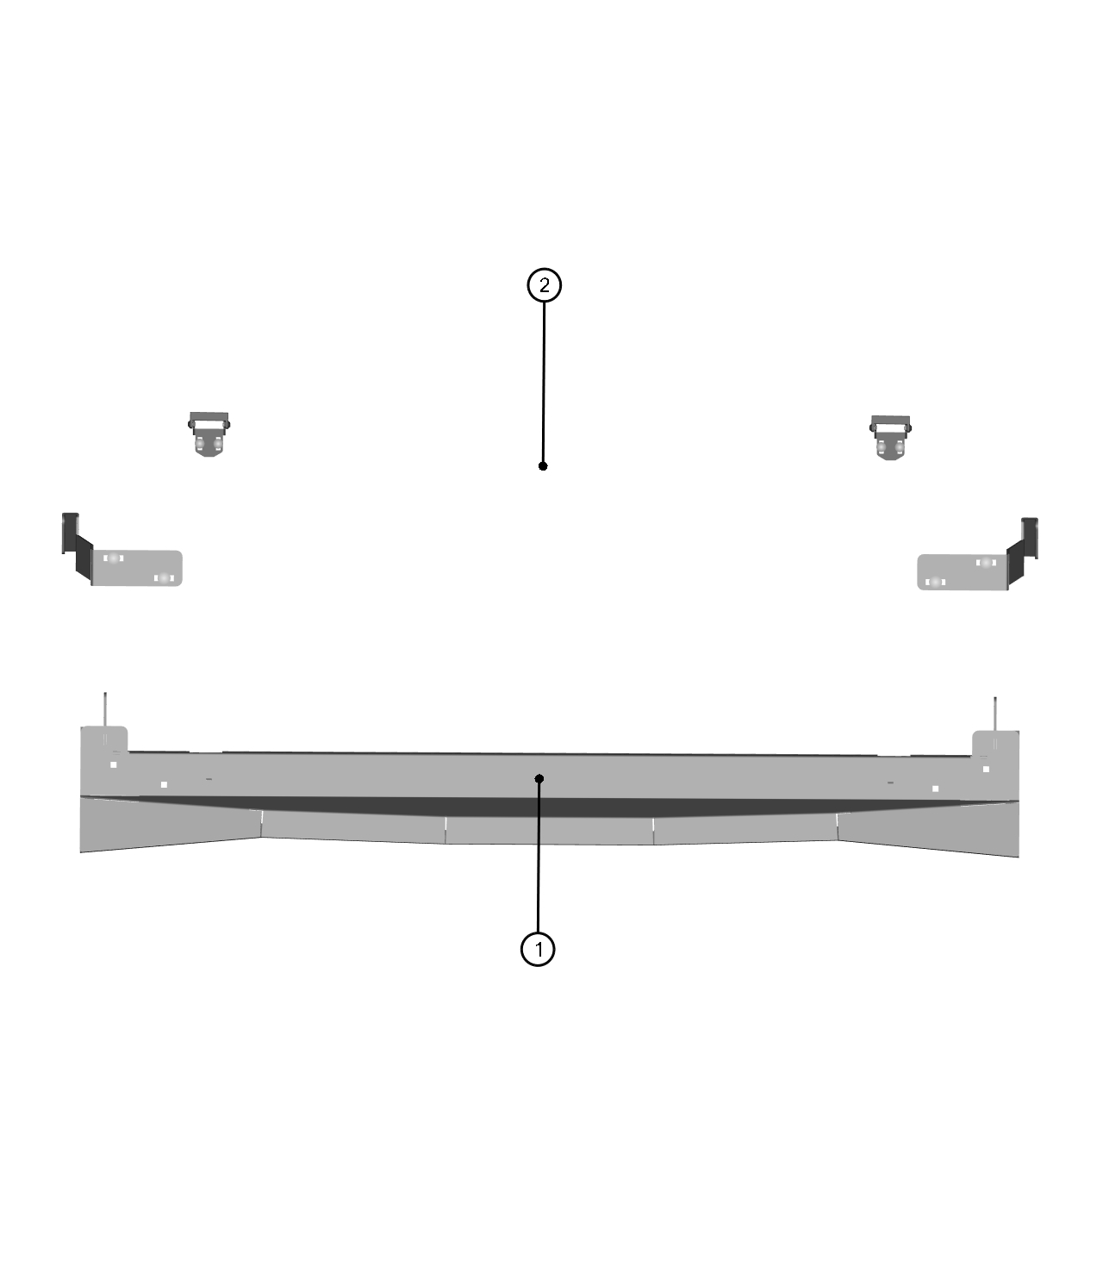

ID | Catalog no. | Description | Qty |  | Price
1 | 64S03U05-10PKM003 | FRONT BOTTOM LEDGE ASSEMBLY | 1
2 | 64S03U05-10PKM004 | FRONT BOTTOM LEDGE HARDWARE KIT | 1

REAR PANEL
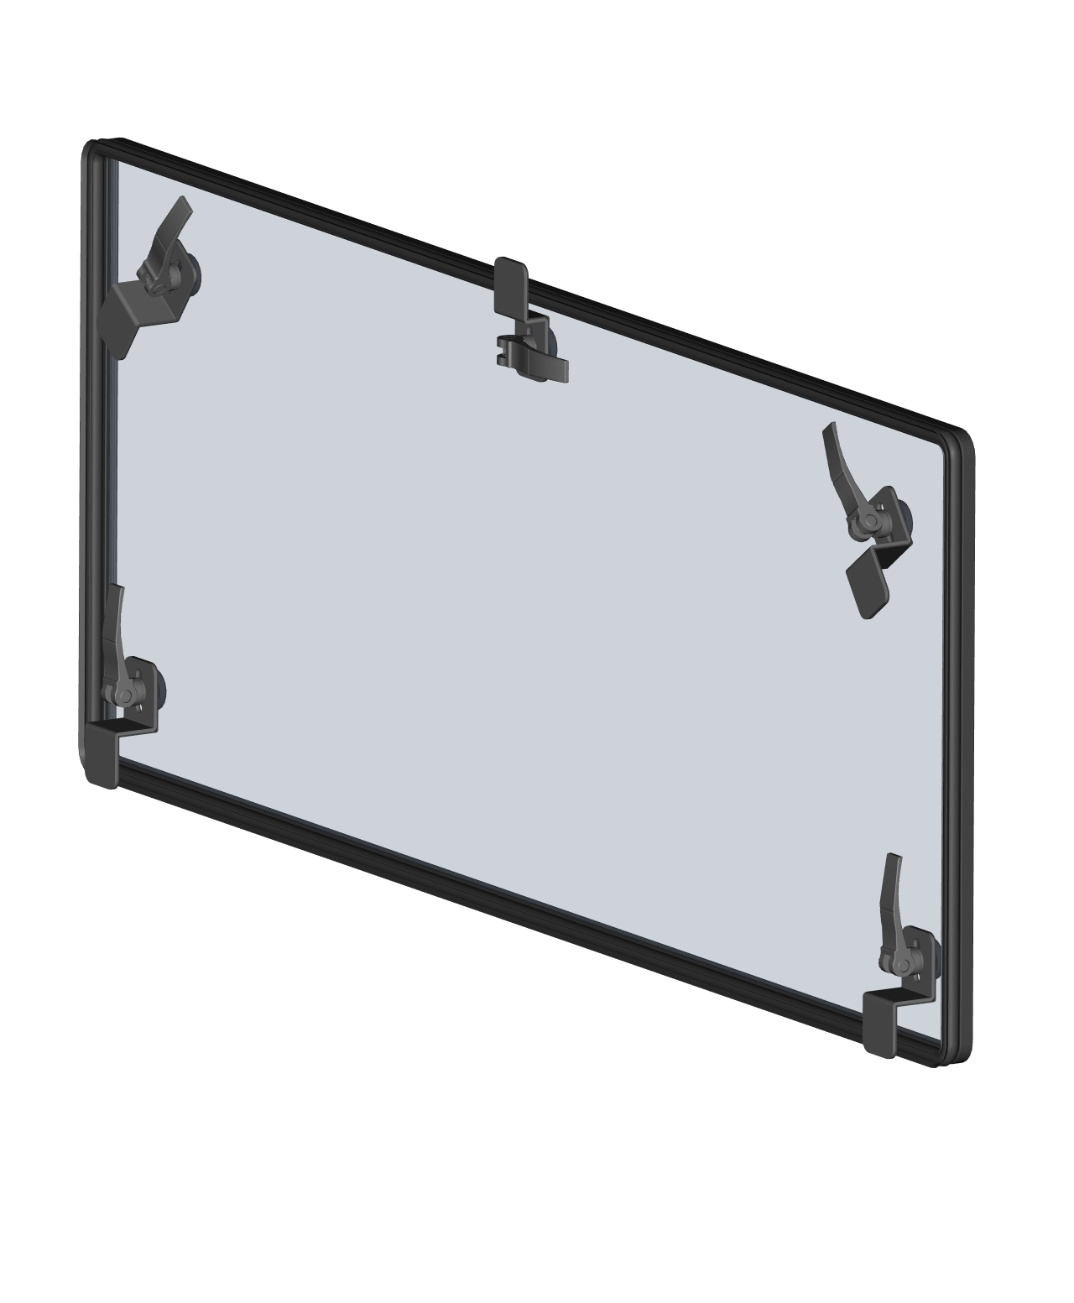

REAR PANEL ASSEMBLIES
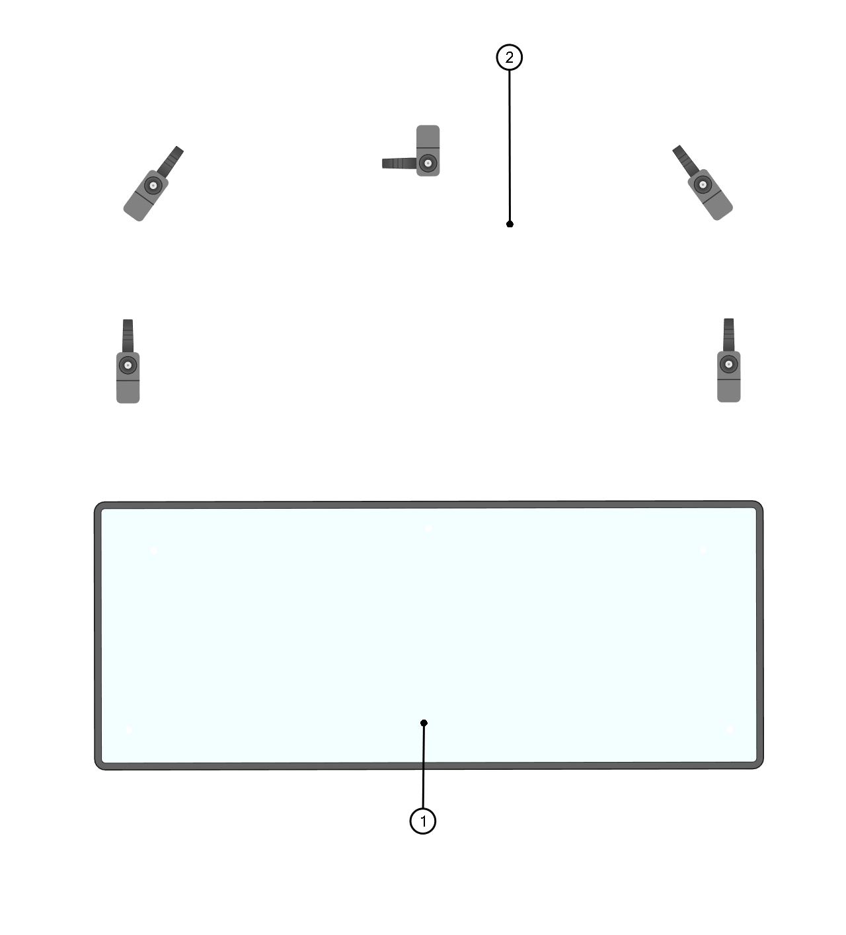

ID | Catalog no. | Description | Qty |  | Price
1 | 64S03U01-20M001 | REAR GLASS WITH SEALING ASSEMBLY | 1
2 | 64S03U05-20PKM001 | REAR GLASS HARDWARE KIT | 1

FRONT LEFT DOOR
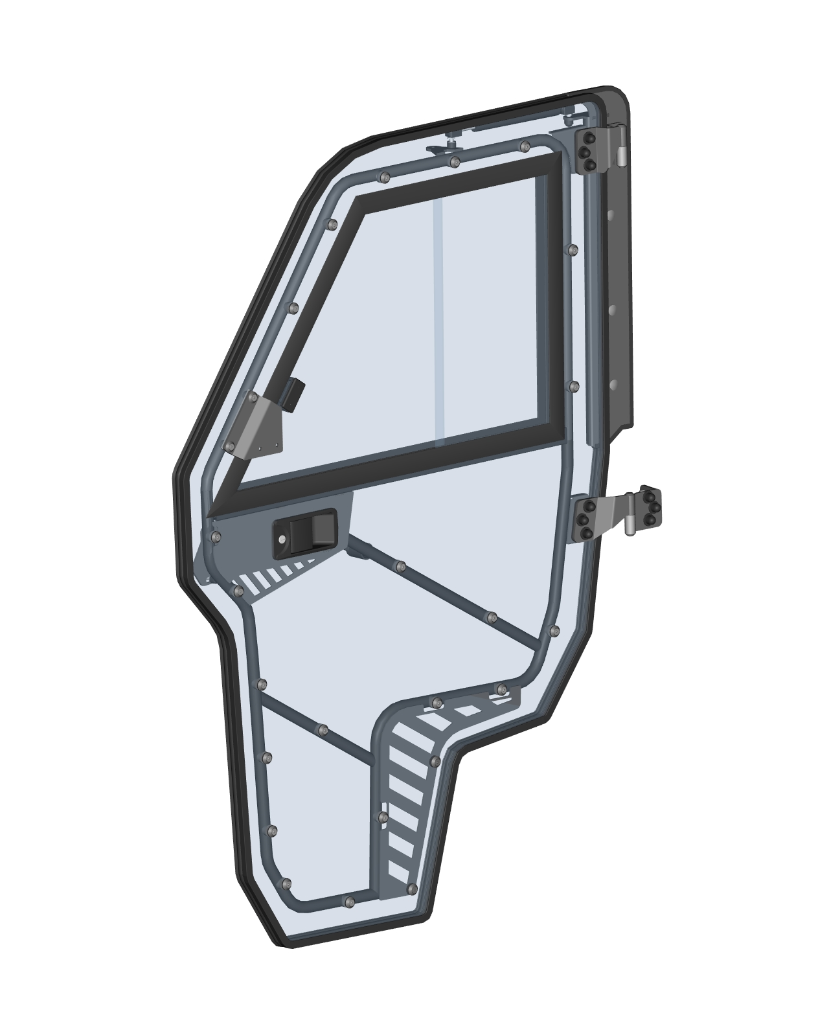

FRONT LEFT DOOR ASSEMBLIES
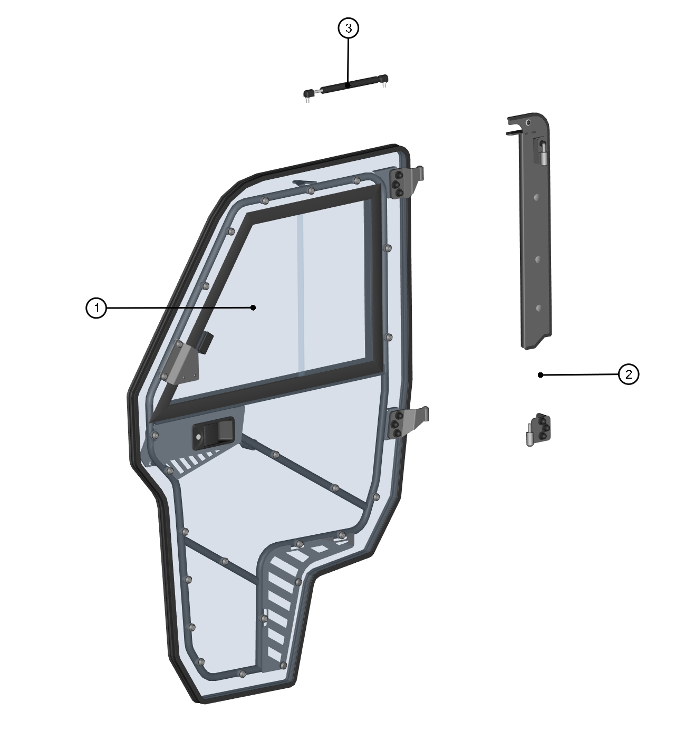

ID | Description | Page | Qty
1 | FRONT LEFT DOOR ASSEMBLY | 13 | 1
2 | FRONT LEFT DOOR BASE ASSEMBLY | 14 | 1
3 | DOOR GAS SPRING ASSEMBLY | 12 | 1

DOOR GAS SPRING ASSEMBLY
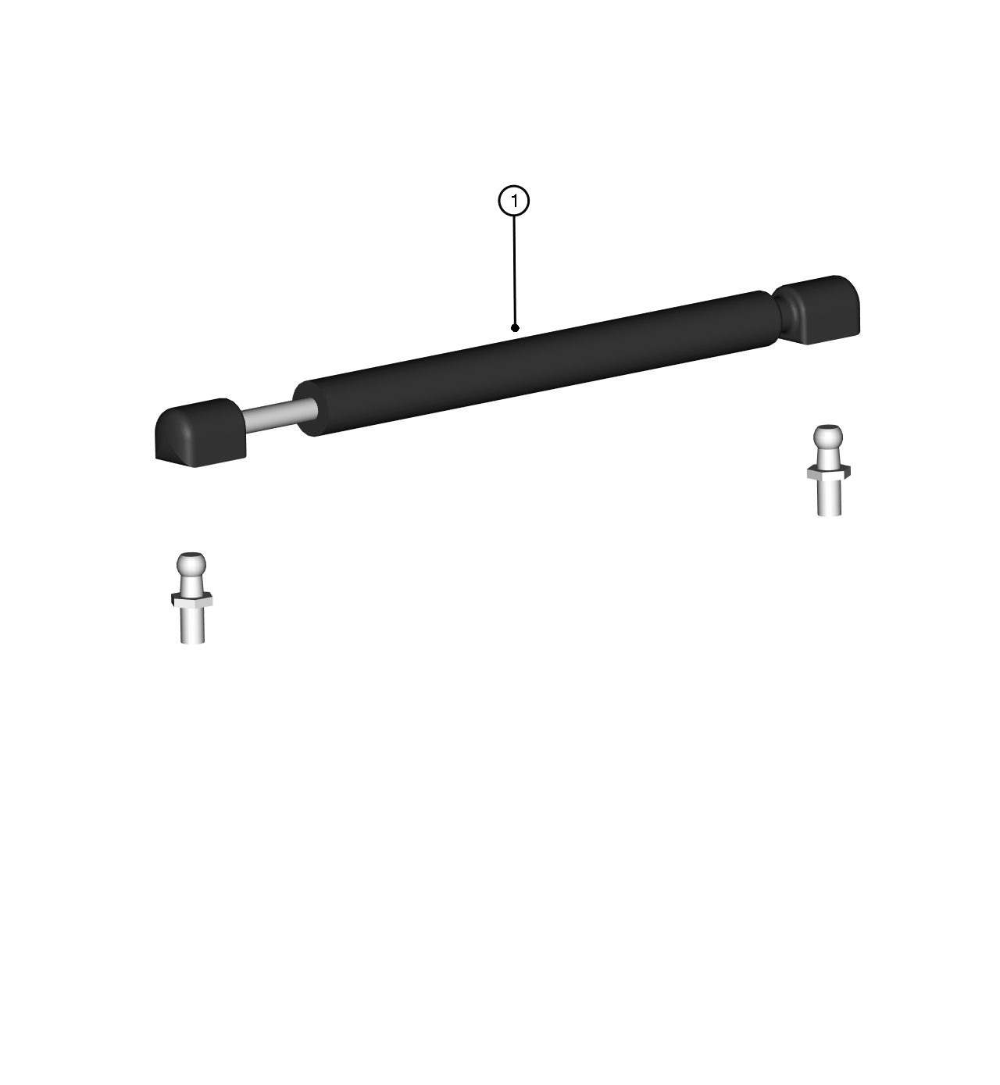

ID | Catalog no. | Description | Qty |  | Price
1 | 000865 | GAS SPRING | 1

FRONT LEFT DOOR ASSEMBLY
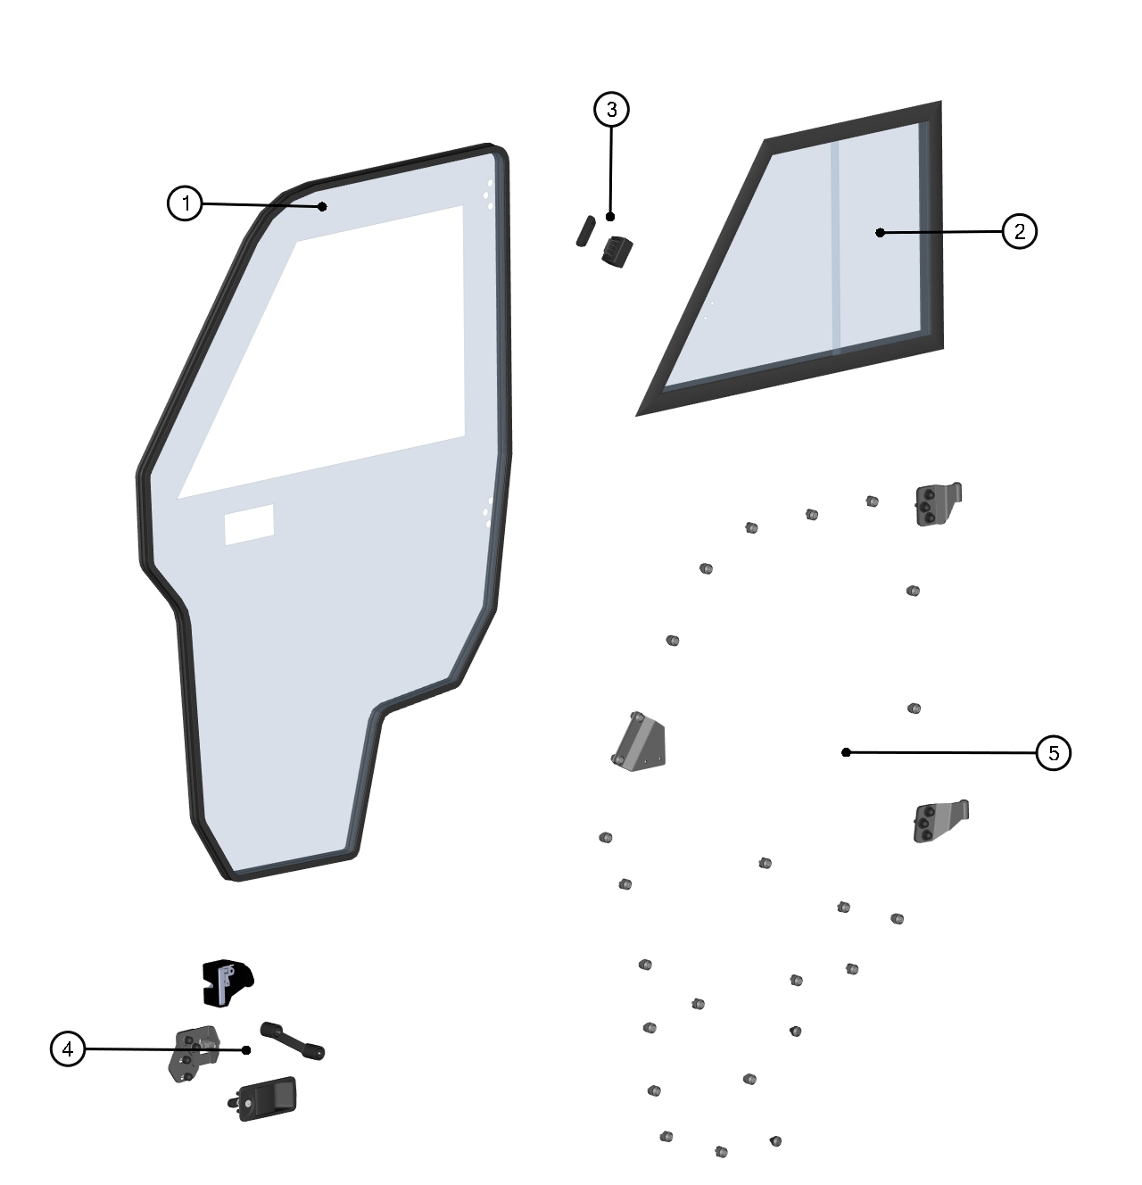

ID | Catalog no. | Description | Qty |  | Price
1 | 64S03U05-40PKM001 | FRONT LEFT POLY WITH SEALING | 1
2 | 64S03U01-40M011 | FRONT LEFT WINDOW ASSEMBLY | 1
3 | 00-030E08 | GLASS LOCK WITH STOP KIT | 1
4 | 64S03U05-40PKM002 | FRONT LEFT LOCK WITH STOP KIT | 1
5 | 64S03U05-40PKM003 | FRONT LEFT DOOR HINGES WITH FIXING KIT | 1

FRONT LEFT DOOR BASE ASSEMBLY
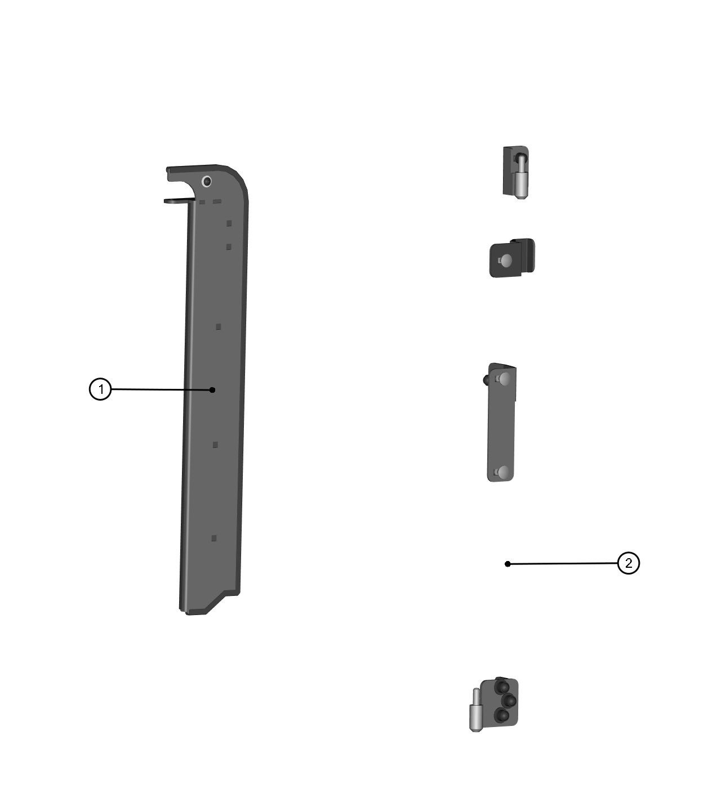

ID | Catalog no. | Description | Qty |  | Price
1 | 64S03U05-40PKM004 | FRONT LEFT DOOR BASE | 1
2 | 64S03U05-40PKM005 | FRONT LEFT DOOR BASE HARDWARE KIT | 1

REAR LEFT DOOR
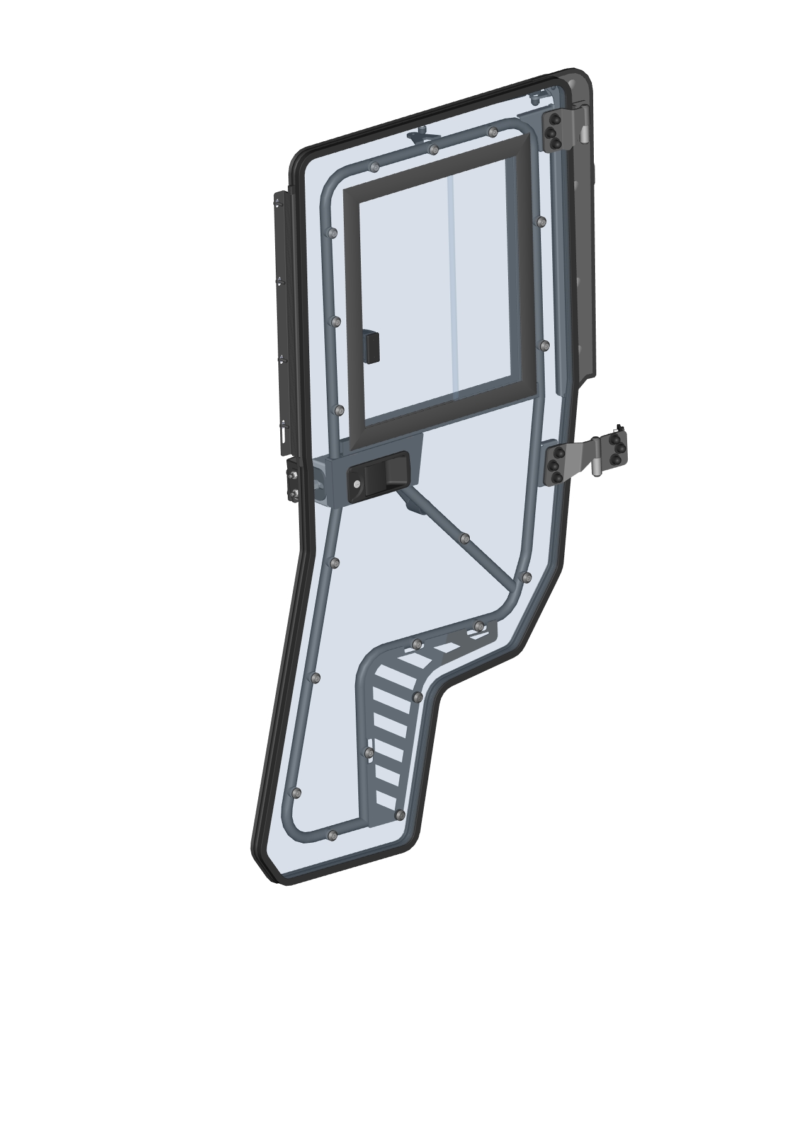

REAR LEFT DOOR ASSEMBLIES
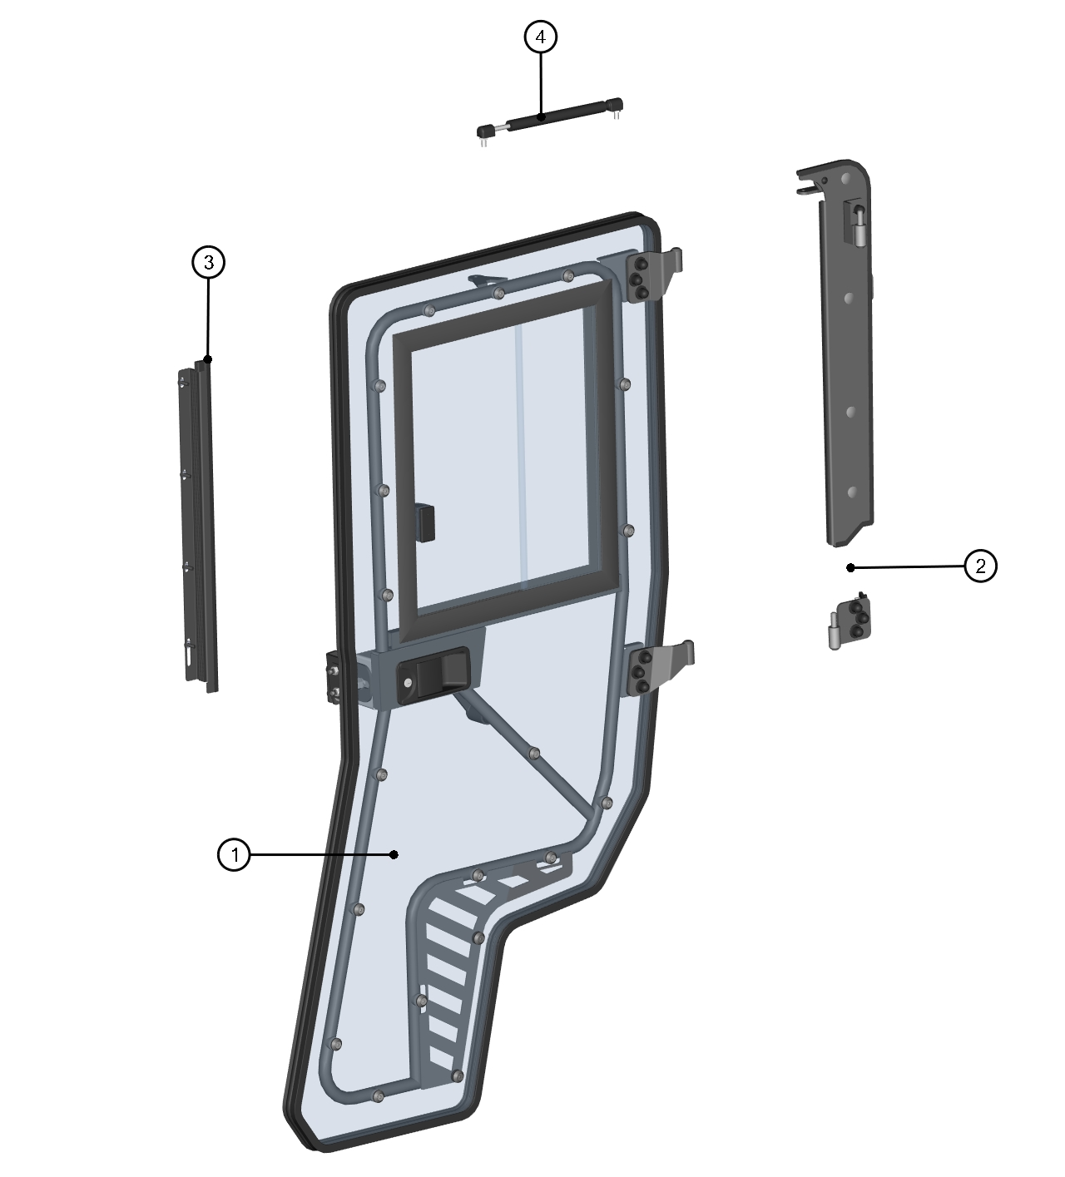

ID | Description | Page | Qty
1 | REAR LEFT DOOR ASSEMBLY | 18 | 1
2 | REAR LEFT DOOR BASE ASSEMBLY | 19 | 1
3 | REAR LEFT DOOR SEALING LEDGE ASSEMBLY | 20 | 1
4 | DOOR GAS SPRING ASSEMBLY | 17 | 1

DOOR GAS SPRING ASSEMBLY

ID | Catalog no. | Description | Qty |  | Price
1 | 000865 | GAS SPRING | 1

REAR LEFT DOOR ASSEMBLY
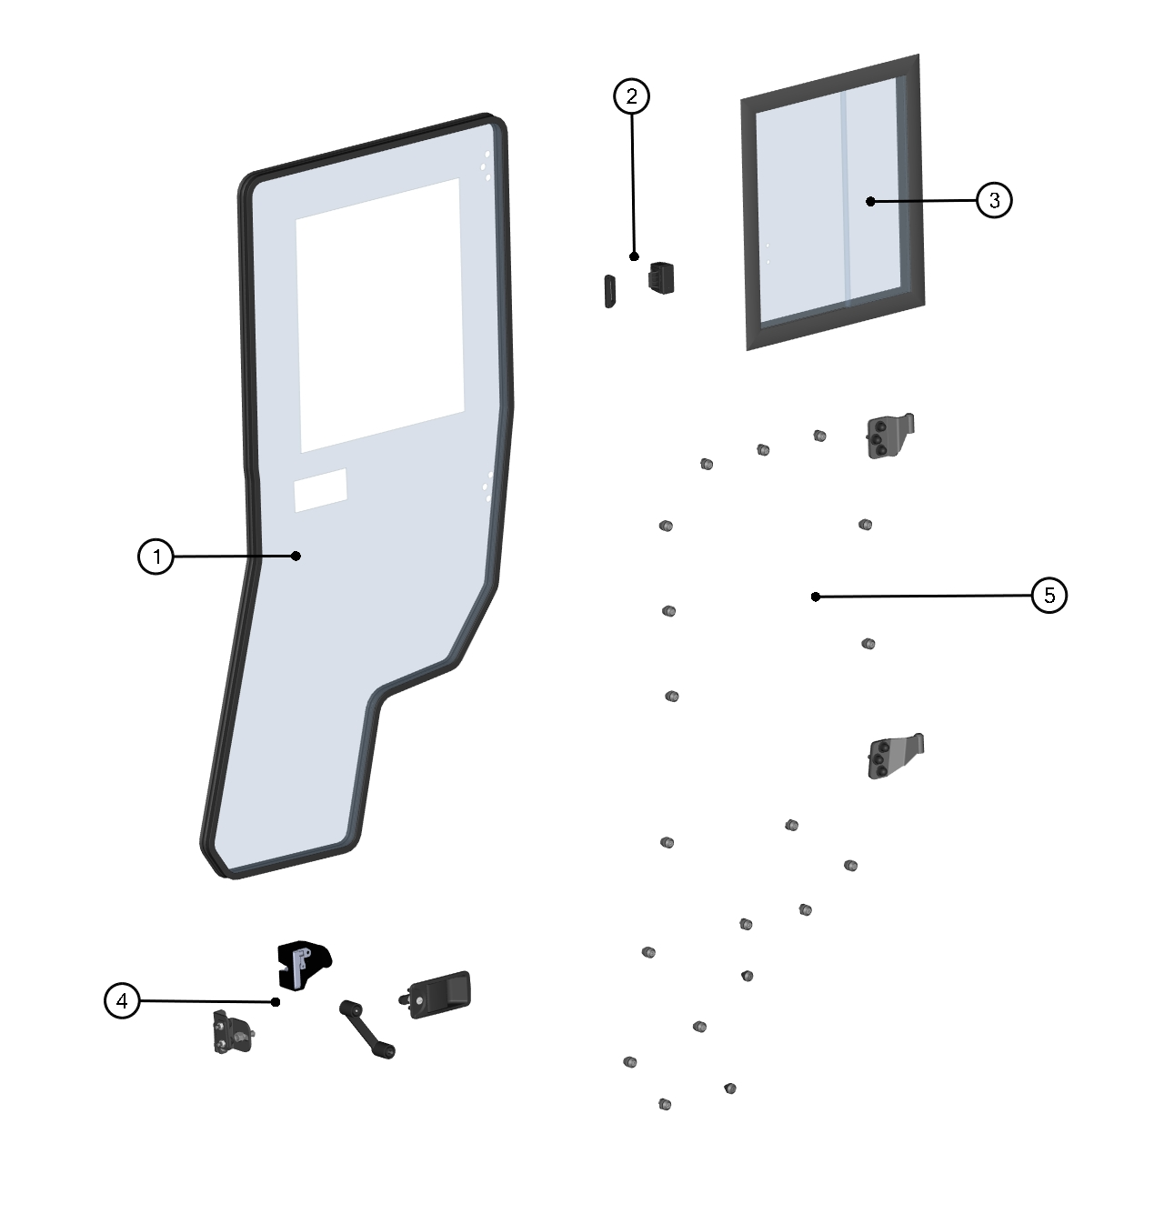

ID | Catalog no. | Description | Qty |  | Price
1 | 64S03U05-40PKM006 | REAR LEFT POLY WITH SEALING | 1
2 | 00-030E08 | GLASS LOCK WITH STOP KIT | 1
3 | 64S03U05-41M002 | REAR LEFT WINDOW ASSEMBLY | 1
4 | 64S03U05-40PKM007 | REAR LEFT LOCK WITH STOP KIT | 1
5 | 64S03U05-40PKM008 | REAR LEFT DOOR HINGES WITH FIXING KIT | 1

REAR LEFT DOOR SEALING LEDGE ASSEMBLY
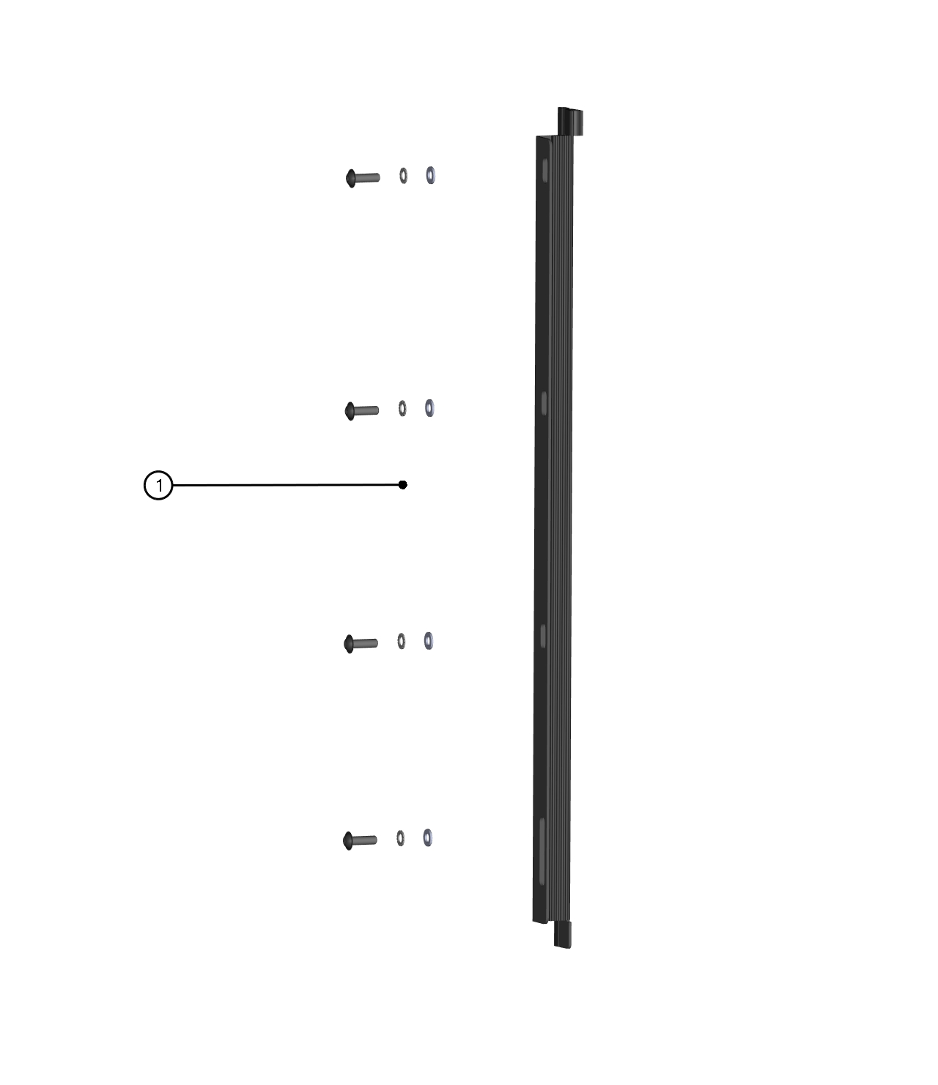

ID | Catalog no. | Description | Qty |  | Price
1 | 64S03U05-41M009 | REAR LEFT DOOR SEALING LEDGE ASSEMBLY | 1

REAR LEFT DOOR BASE ASSEMBLY
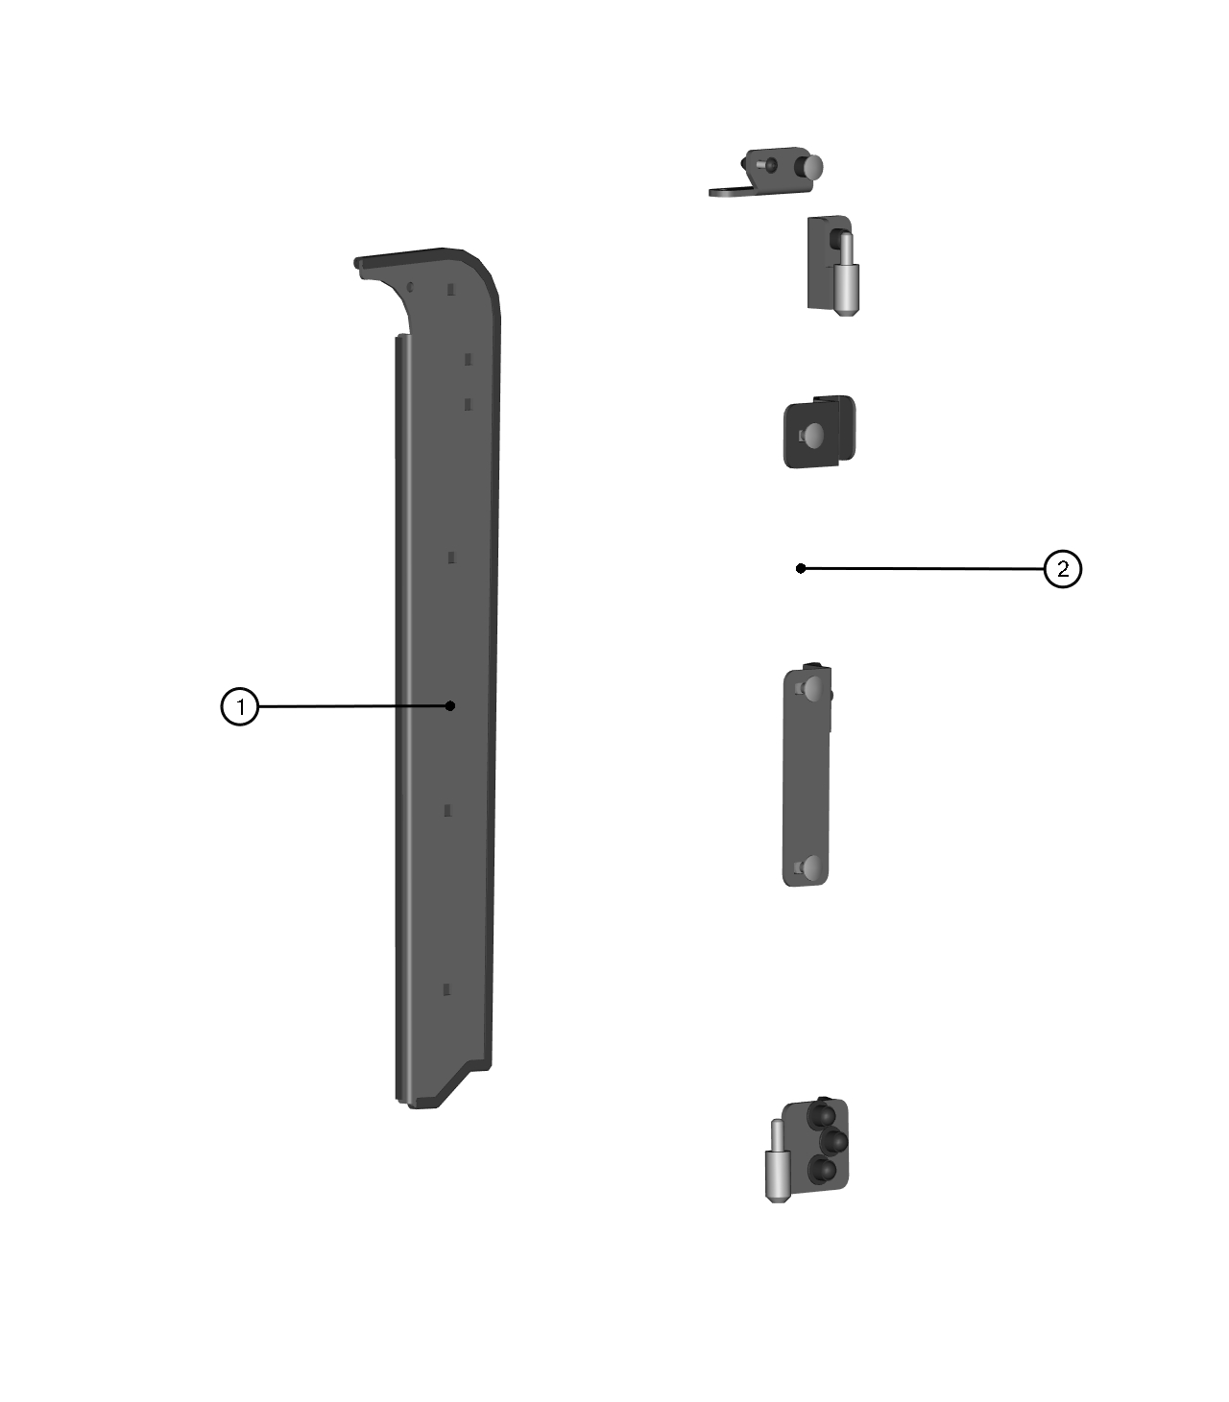

ID | Catalog no. | Description | Qty |  | Price
1 | 64S03U05-40PKM009 | REAR LEFT DOOR BASE | 1
2 | 64S03U05-40PKM010 | REAR LEFT DOOR BASE HARDWARE KIT | 1

FRONT RIGHT DOOR
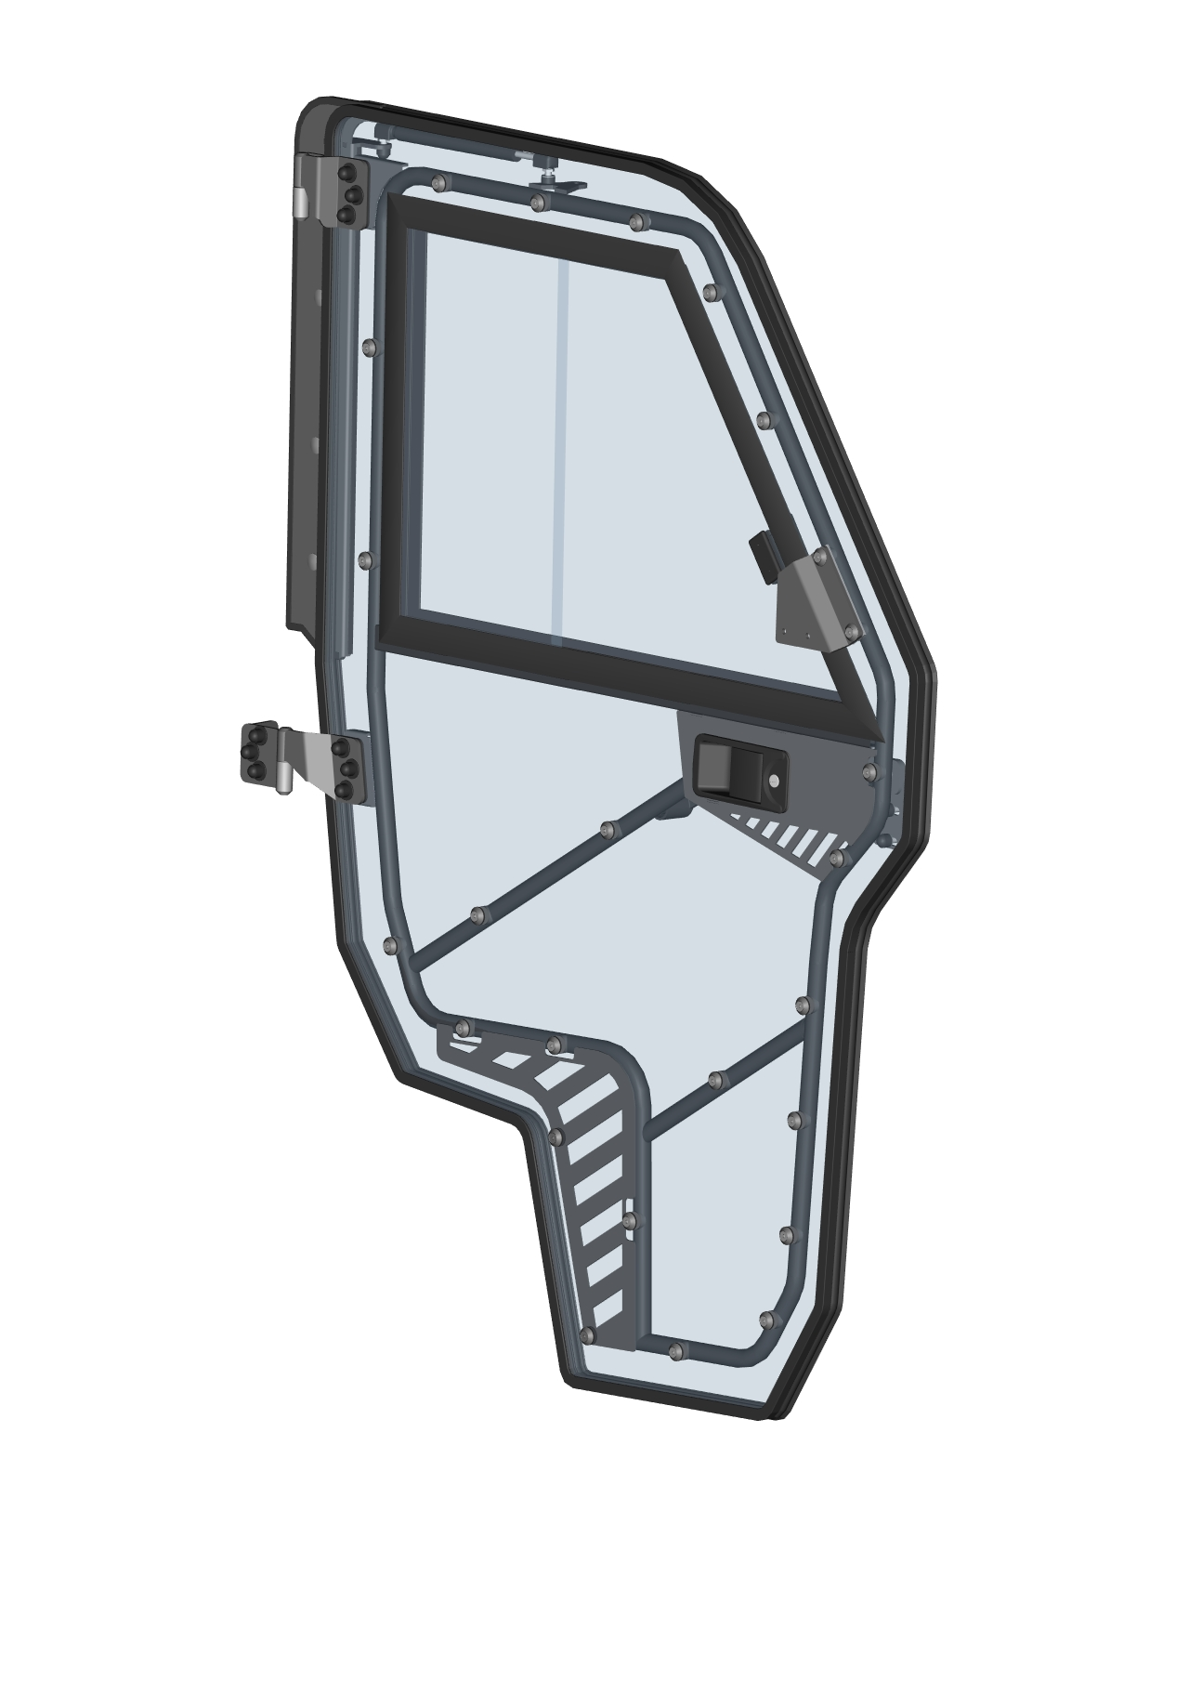
FRONT RIGHT DOOR ASSEMBLIES
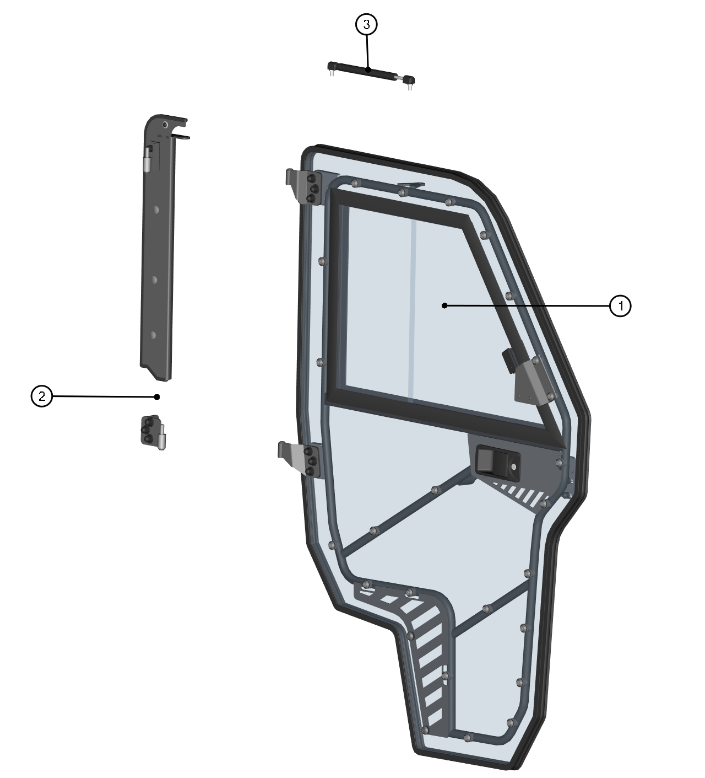

ID | Description | Page | Qty
1 | FRONT RIGHT DOOR ASSEMBLY | 24 | 1
2 | FRONT RIGHT DOOR BASE ASSEMBLY | 25 | 1
3 | DOOR GAS SPRING ASSEMBLY | 23 | 1

DOOR GAS SPRING ASSEMBLY

ID | Catalog no. | Description | Qty |  | Price
1 | 000865 | GAS SPRING | 1

FRONT RIGHT DOOR ASSEMBLY
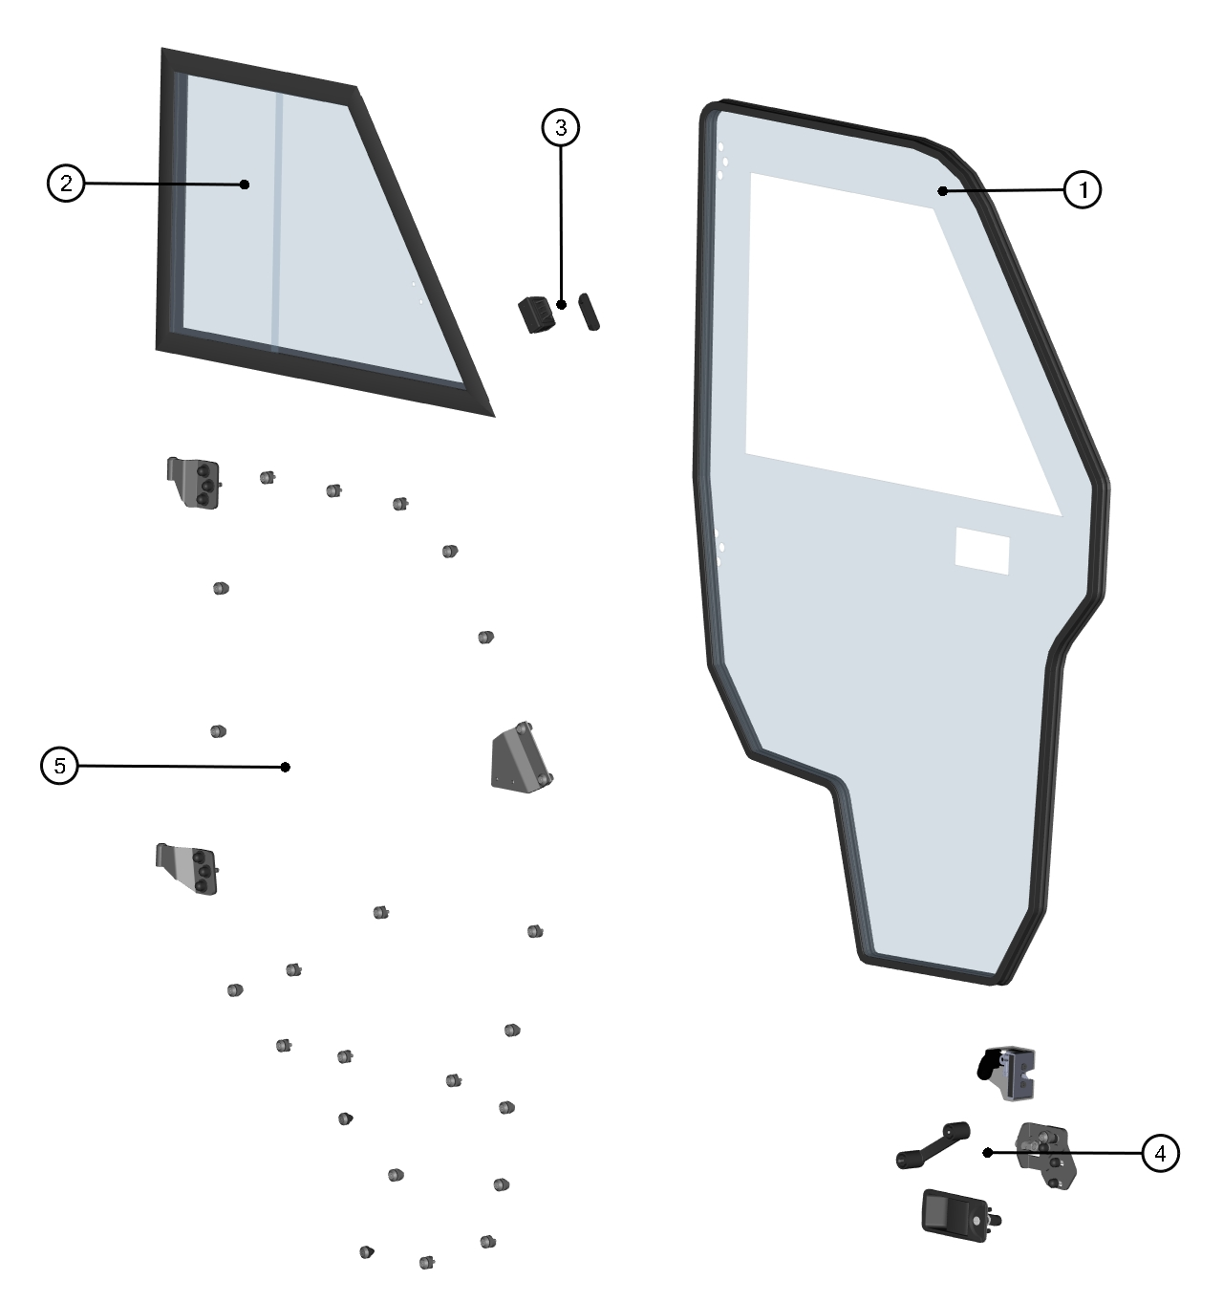

ID | Catalog no. | Description | Qty |  | Price
1 | 64S03U05-50PKM001 | FRONT RIGHT POLY WITH SEALING | 1
2 | 64S03U01-50M011 | FRONT RIGHT WINDOW ASSEMBLY | 1
3 | 00-030E08 | GLASS LOCK WITH STOP KIT | 1
4 | 64S03U05-50PKM002 | FRONT RIGHT LOCK WITH STOP KIT | 1
5 | 64S03U05-50PKM003 | FRONT RIGHT DOOR HINGES WITH FIXING KIT | 1

FRONT RIGHT DOOR BASE ASSEMBLY
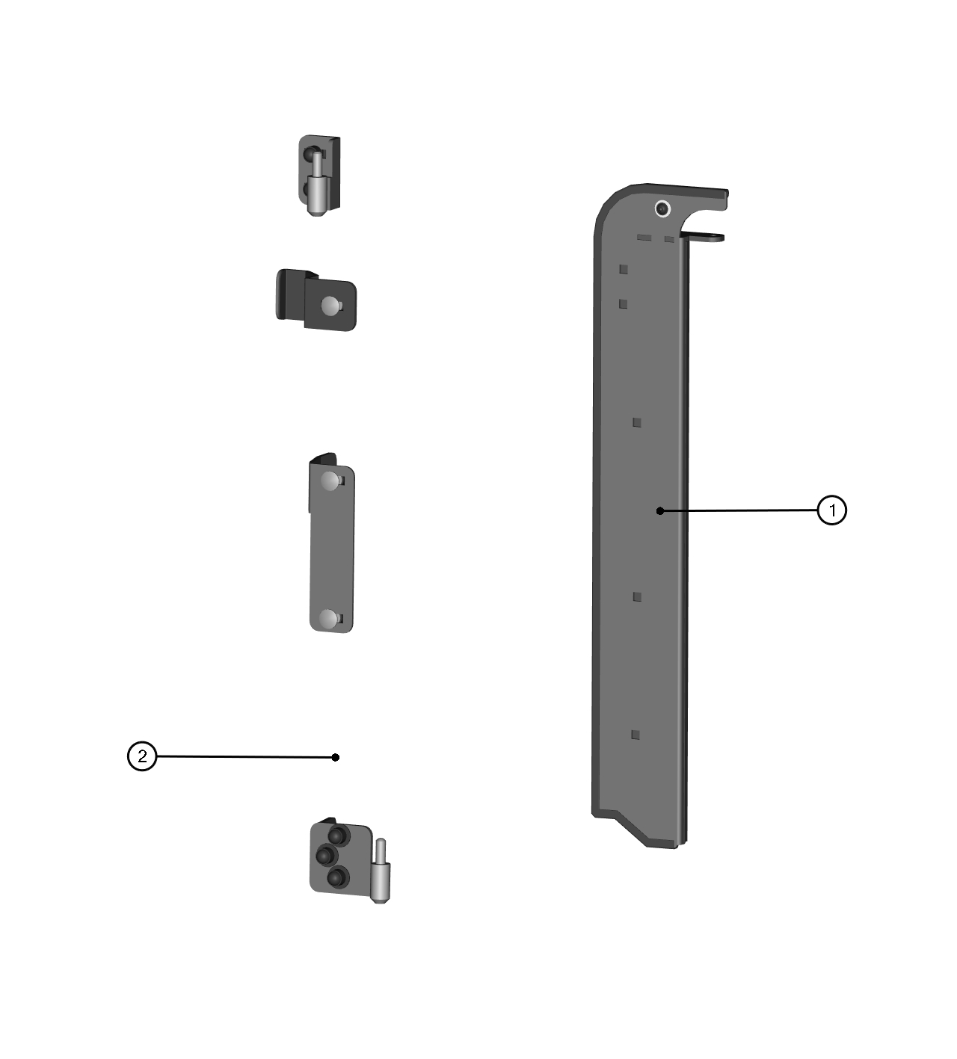

ID | Catalog no. | Description | Qty |  | Price
1 | 64S03U05-50PKM004 | FRONT RIGHT DOOR BASE | 1
2 | 64S03U05-50PKM005 | FRONT RIGHT DOOR BASE HARDWARE KIT | 1

REAR RIGHT DOOR
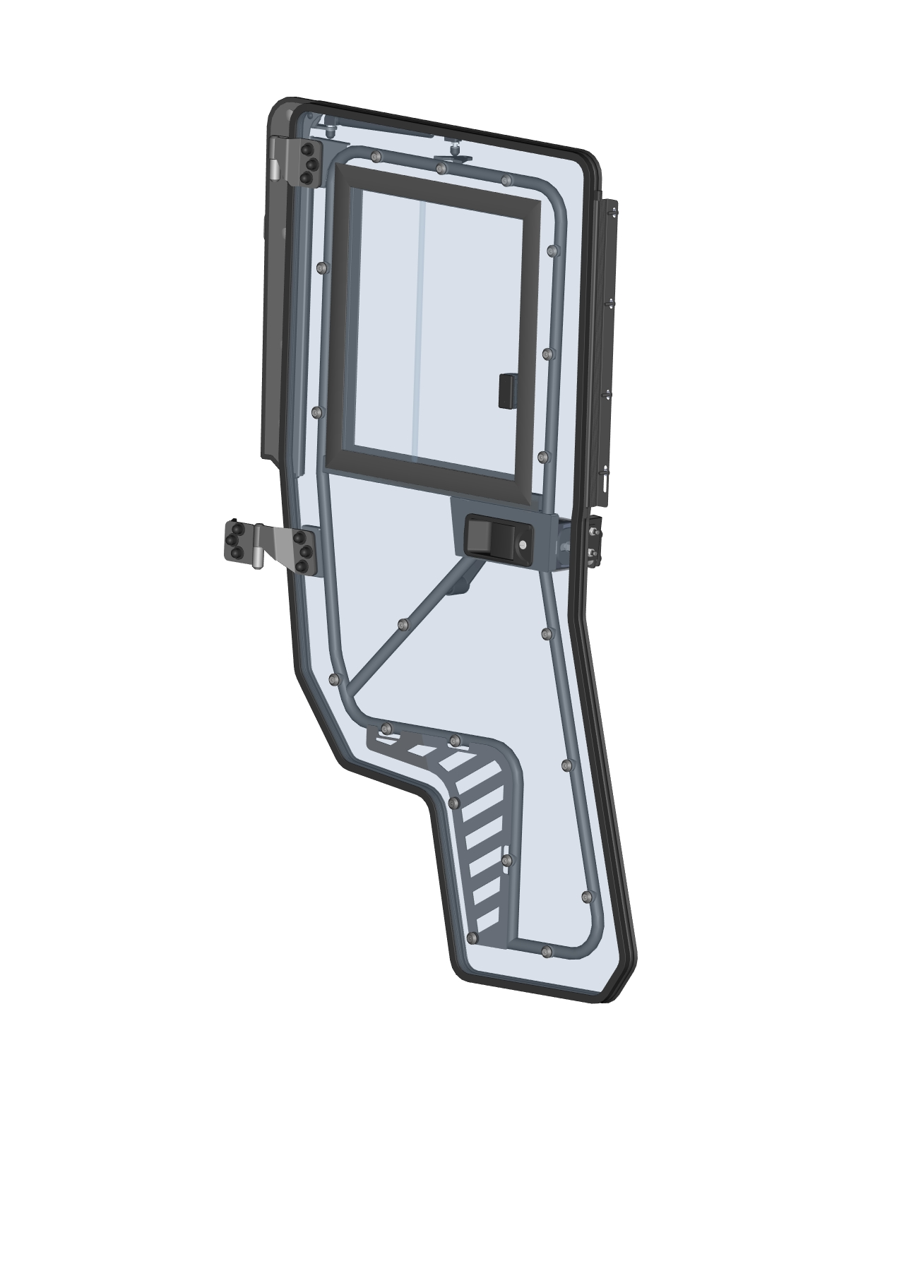
REAR RIGHT DOOR ASSEMBLIES
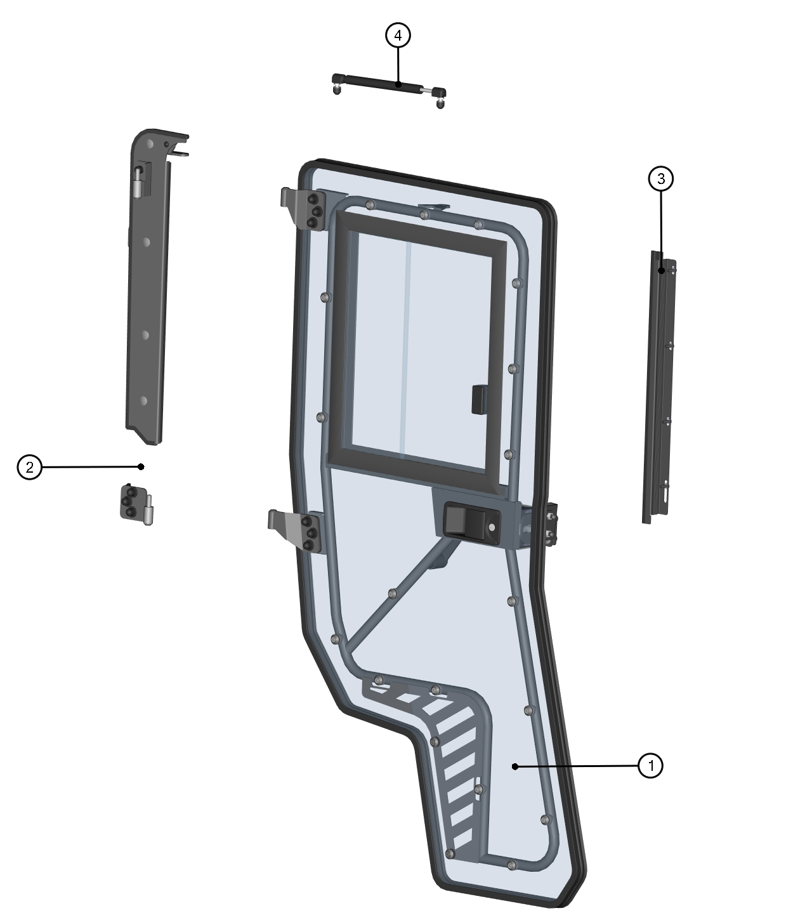

ID | Description | Page | Qty
1 | REAR RIGHT DOOR ASSEMBLY | 29 | 1
2 | REAR RIGHT DOOR BASE ASSEMBLY | 31 | 1
3 | REAR RIGHT DOOR SEALING LEDGE ASSEMBLY | 30 | 1
4 | DOOR GAS SPRING ASSEMBLY | 28 | 1

DOOR GAS SPRING ASSEMBLY

ID | Catalog no. | Description | Qty |  | Price
1 | 000865 | GAS SPRING | 1

REAR RIGHT DOOR ASSEMBLY
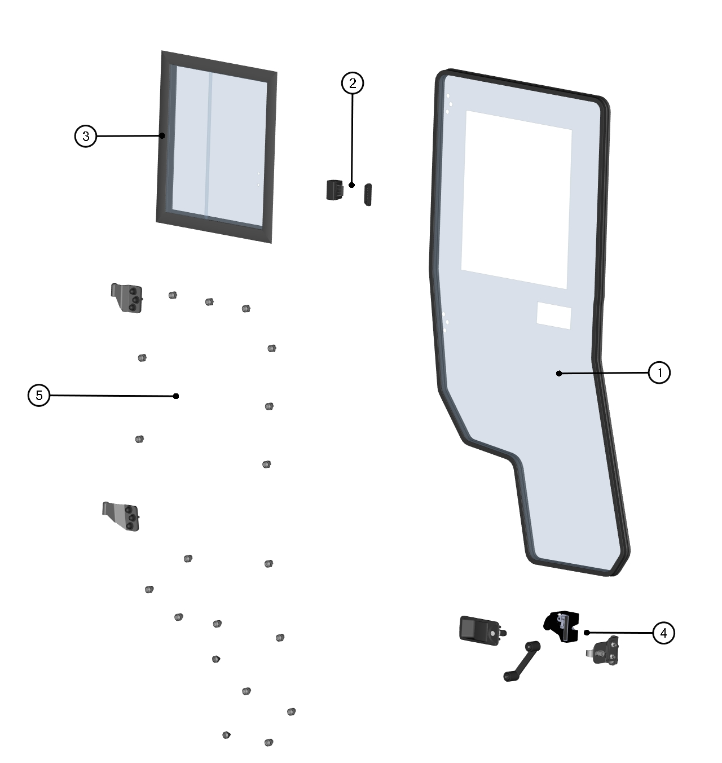

ID | Catalog no. | Description | Qty |  | Price
1 | 64S03U05-50PKM006 | REAR RIGHT POLY WITH SEALING | 1
2 | 00-030E08 | GLASS LOCK WITH STOP KIT | 1
3 | 64S03U05-51M002 | REAR RIGHT WINDOW ASSEMBLY | 1
4 | 64S03U05-50PKM007 | REAR RIGHT LOCK WITH STOP KIT | 1
5 | 64S03U05-50PKM008 | REAR RIGHT DOOR HINGES WITH FIXING KIT | 1

REAR RIGHT DOOR SEALING LEDGE ASSEMBLY
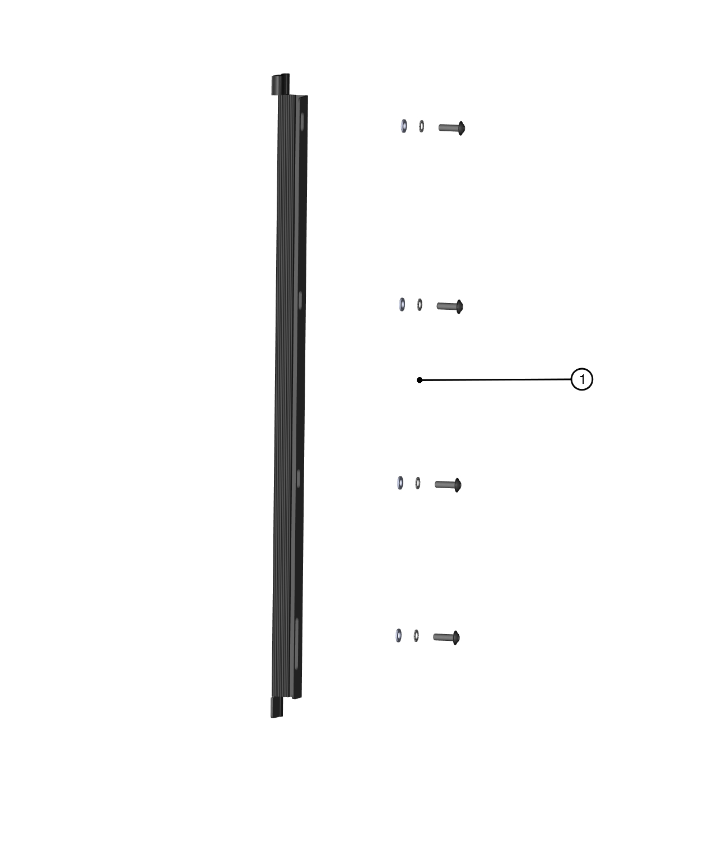

ID | Catalog no. | Description | Qty |  | Price
1 | 64S03U05-51M009 | REAR RIGHT DOOR SEALING LEDGE ASSEMBLY | 1

REAR RIGHT DOOR BASE ASSEMBLY
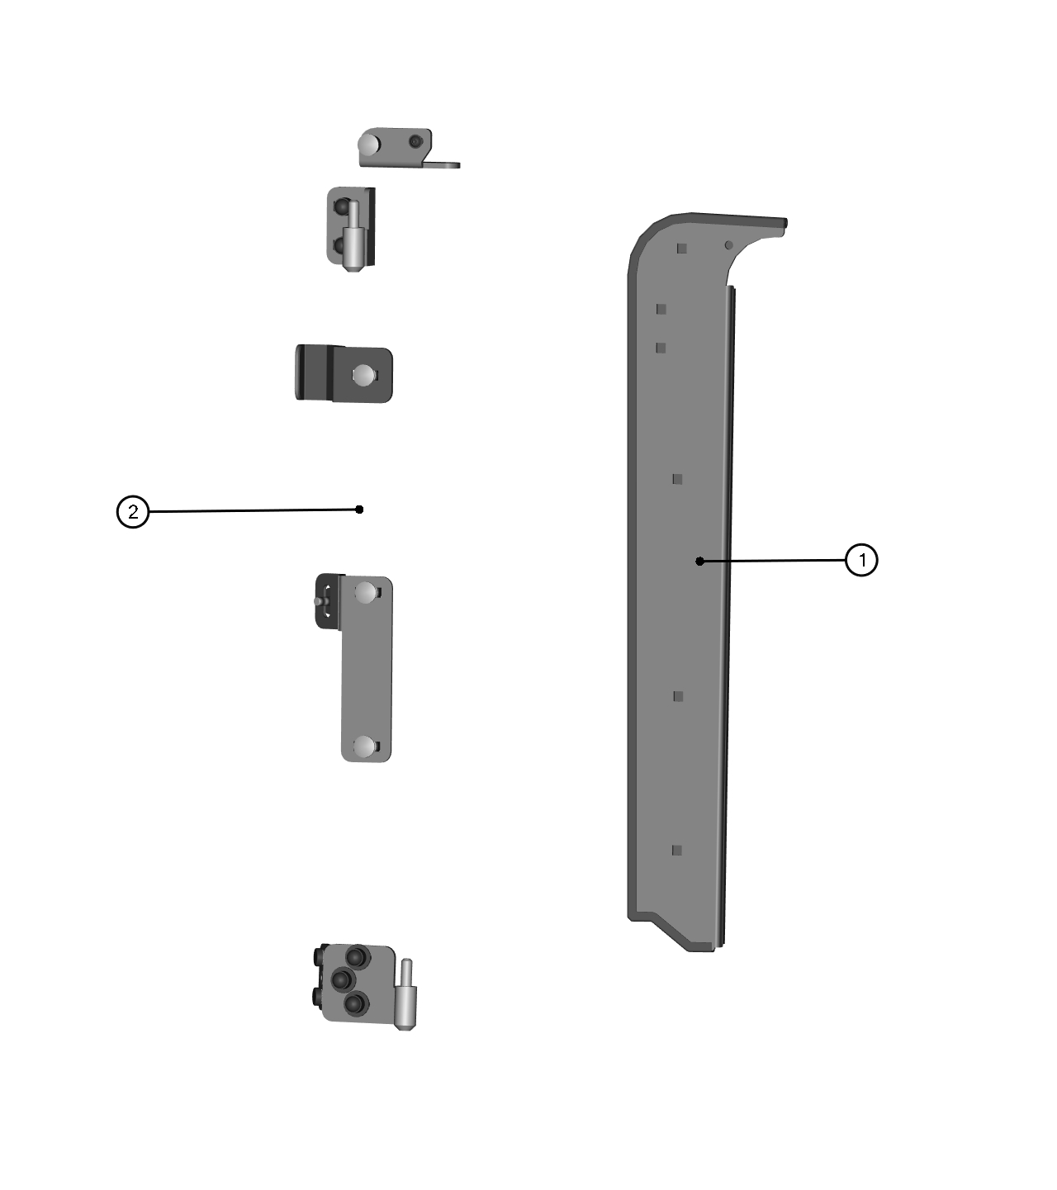

ID | Catalog no. | Description | Qty |  | Price
1 | 64S03U05-50PKM009 | REAR RIGHT DOOR BASE | 1
2 | 64S03U05-50PKM010 | REAR RIGHT DOOR BASE HARDWARE KIT | 1

ELECTROINSTALLATION

Position | Catalog no. | Description | Qty |  | Price
1 | 004322 | WIPER/WASHER SWITCH | 1
2 | 000885 | WASHER TANK | 1
3 | 009625 | FRONT WIPER + WASHER ELECTRICAL HARNESS | 1
4 | 007736 | POWER SUPPLY EXTENSION HARNESS | 1
5 | 009626 | SUPPLY ELECTRICAL HARNESS | 1
6 | 009627 | HEATER ELECTRICAL HARNESS | 1
7 | 002624 | HEATER BODY | 1
8 | 002386 | ELECTROMAGNETIC VALVE | 1
9 | 002491 | BLEEDING VALVE | 1
10 | 002471 | WATER PUMP | 1
11 | 002702 | HEATER VENTILATOR SWITCH | 1
12 | 002391 | EL. VALVE SWITCH | 1
13 | 002739 | AIR VENT | 4
14 | 005486 | INTERIOR LIGHT SWITCH | 1

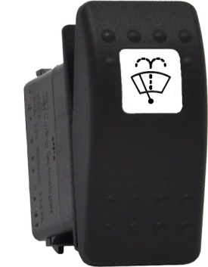 |  | 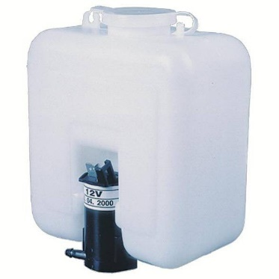
Position: 1 |  | Position: 2 |  | Position: 3
Catalog no.:  004322 |  | Catalog no.:  000885 |  | Catalog no.:  009625
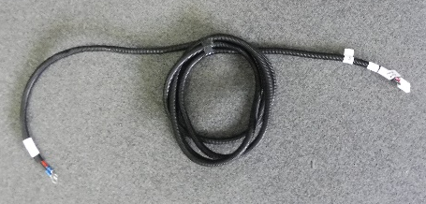
Position: 4 |  | Position: 5 |  | Position: 6
Catalog no.:  007736 |  | Catalog no.:  009626 |  | Catalog no.:  009627
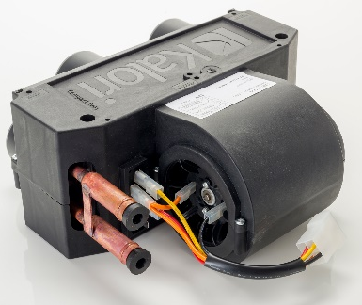 |  | 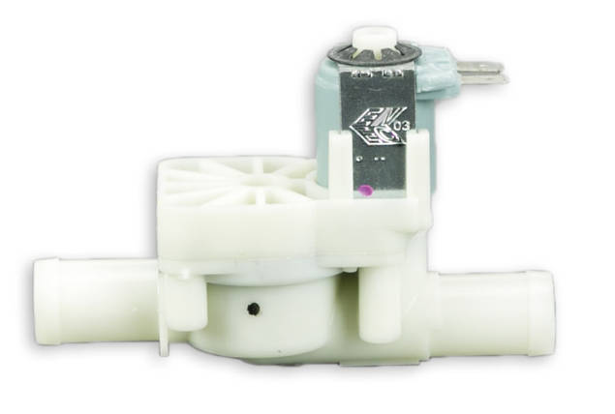 |  | 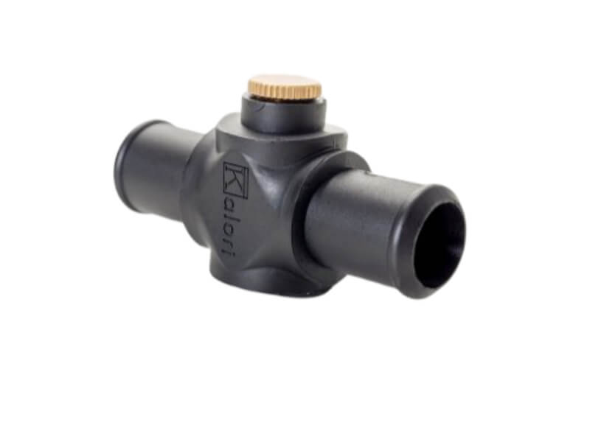
Position: 7 |  | Position: 8 |  | Position: 9
Catalog no.:  002624 |  | Catalog no.:  002386 |  | Catalog no.:  002491

 |  | 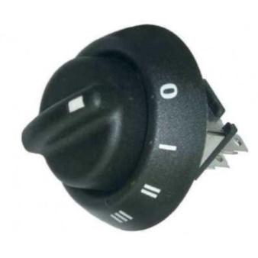
Position: 10 |  | Position: 11 |  | Position: 12
Catalog no.:  002471 |  | Catalog no.:  002702 |  | Catalog no.:  002391
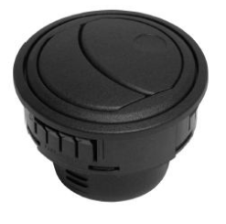
Position: 13 |  | Position: 14
Catalog no.:  002739 |  | Catalog no.:  005486

