**FLOOR MAT INSTALLATION INSTRUCTIONS**

**KIT INCLUDES:**

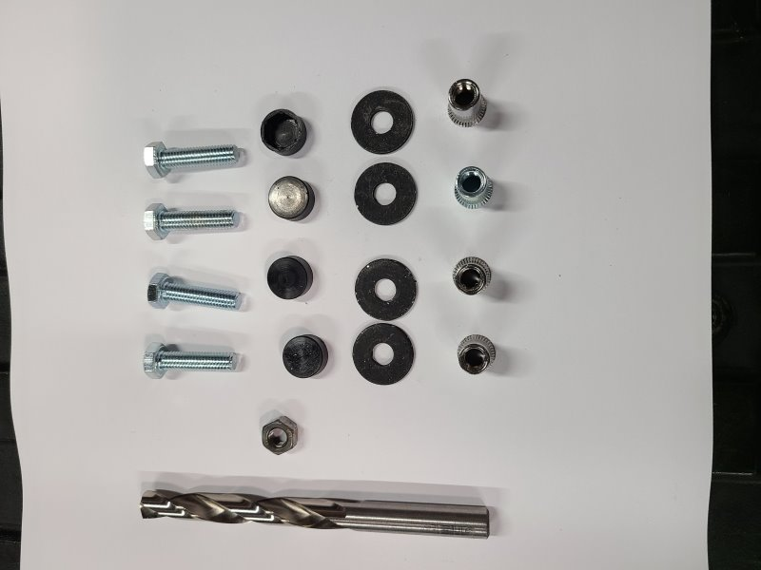

**TEMPLATES**

**MOUNTING KIT**

1. **(1) DRILL BIT**
2. **(4) MOUNTING BOLT**
3. **(1) TIGHTENING NUT**
4. **(4) NUT CAB**
5. **(4) WASHER**
6. **(4) THREADED INSERT**

D

E

F

C

A

B

* **ELECTRIC DRILL**
* **13MM OPEN END OR ADJ. WRENCHES**
* **HAMMER**
* **SCISSORS**

**TOOLS REQUIRED**

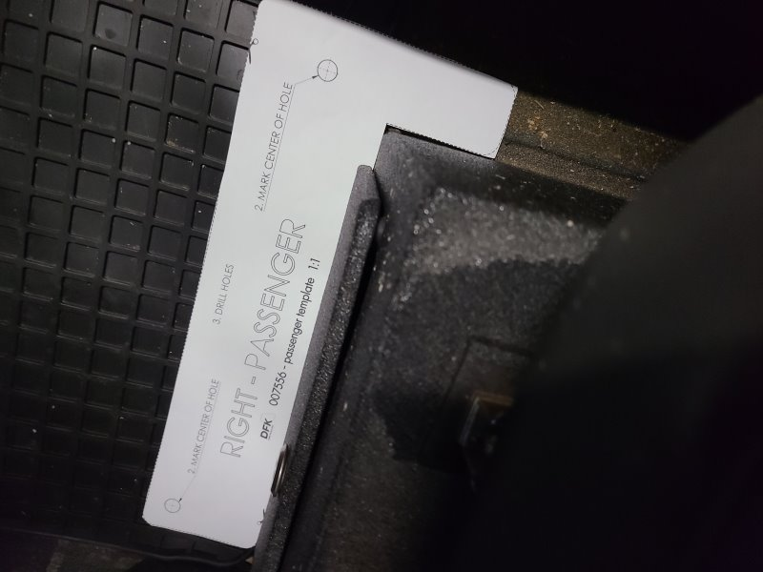

**STEP #1**

**STEP #2**

**STEP #3**

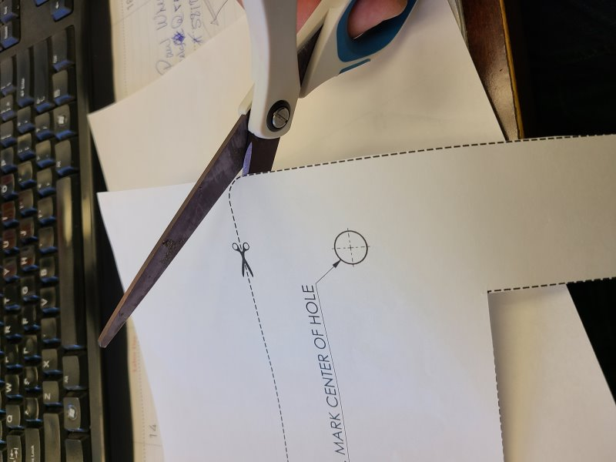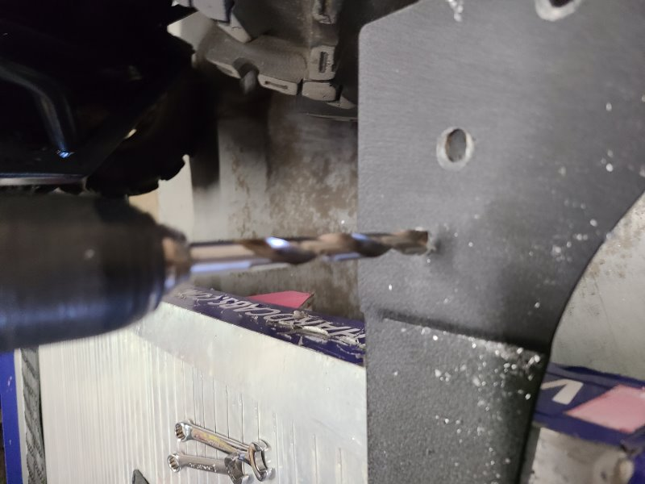

**MARK HOLES USING A STEEL PUNCH. DRILL THROUGH FLOOR WITH BIT (A) PROVIDED.**

**ALIGN TEMPLATE EITHER TIGHTLY TO FRONT AND SIDE OF SEAT BASE OR FOR CARGO BED ACCORDING TO MARKED DRAIN HOLES.**

**CUT OUT APPROPRIATE TEMPLATE ALONG DOTTED LINES**

**STEP #5**

**STEP #6**

**STEP #4**

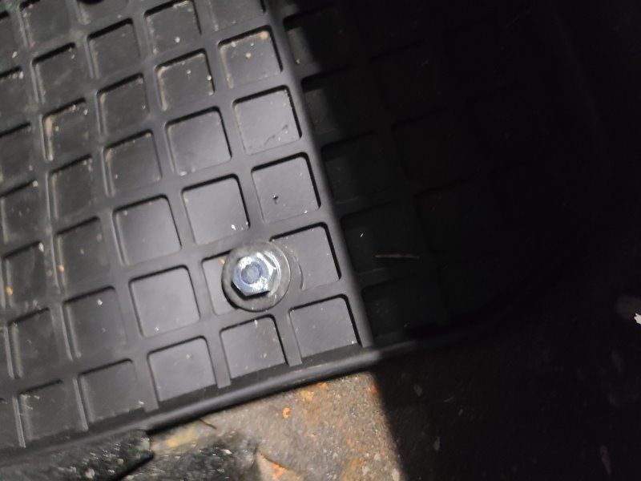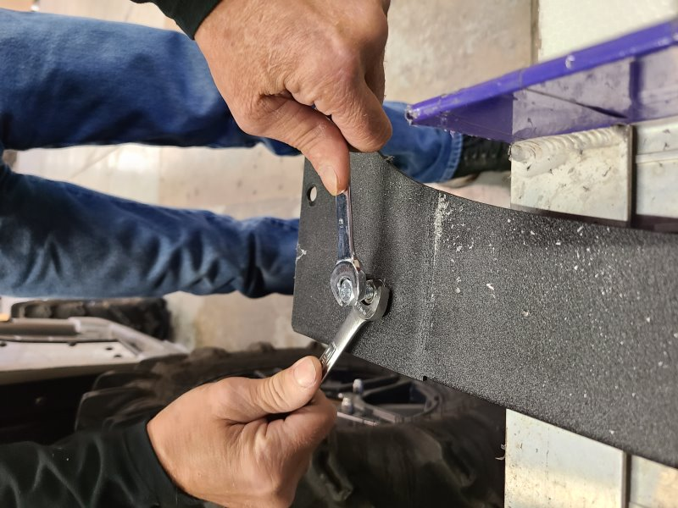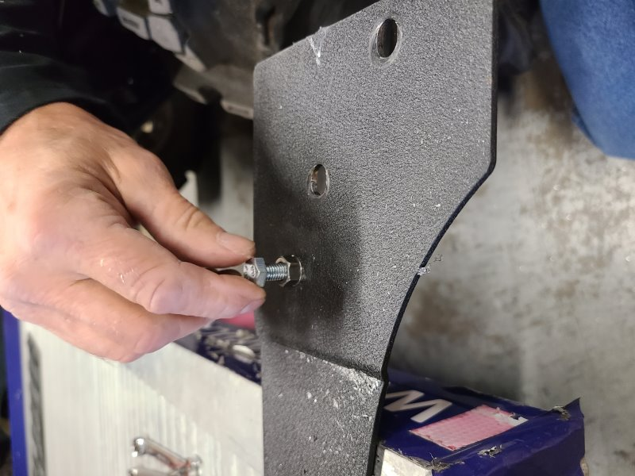

**STEP #7**

**USING (2) WRENCHES, TURN THE TIGHTENING NUT (LOWER) CLOCKWISE 2-3 COMPLETE 360° TURNS WHILE HOLDING THE BOLT STEADY TO COMPRESS THE THREADED INSERT. REMOVE BOLT AND NUT WHEN TIGHT AND INSERT HAS EXPANDED SECURELY**

***GENTLY POUND IN THE THREADED INSERT (F) INTO THE DRILLED HOLE***

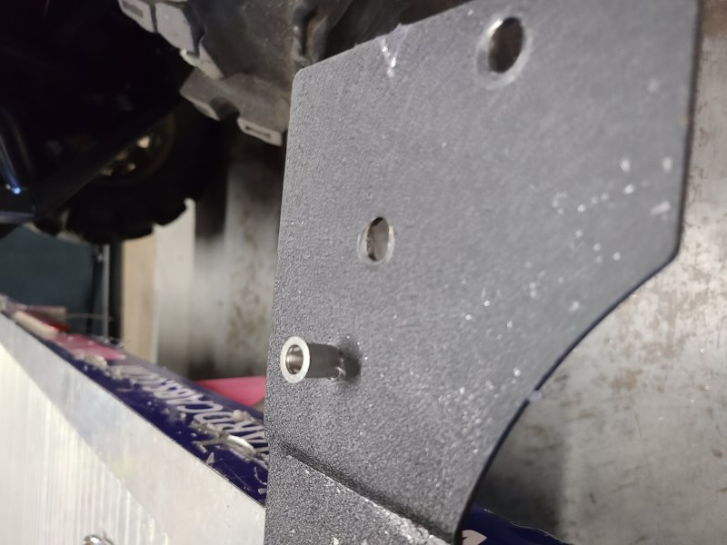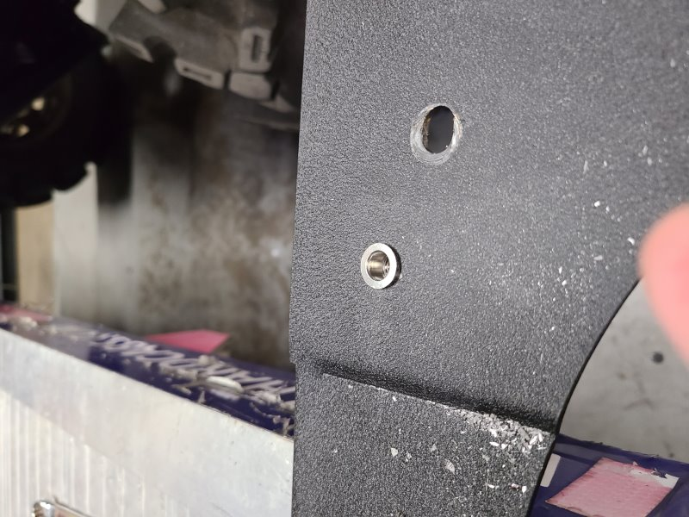

**THUMB THREAD THE TIGHTENING NUT (C) ONTO MOUNTING BOLT (B) ABOUT HALFWAY UP. THEN THREAD BOLT (B) DOWN IN THE INSERT (F) UNTIL NUT (C) IS SNUG AGAINST THE FLOOR**

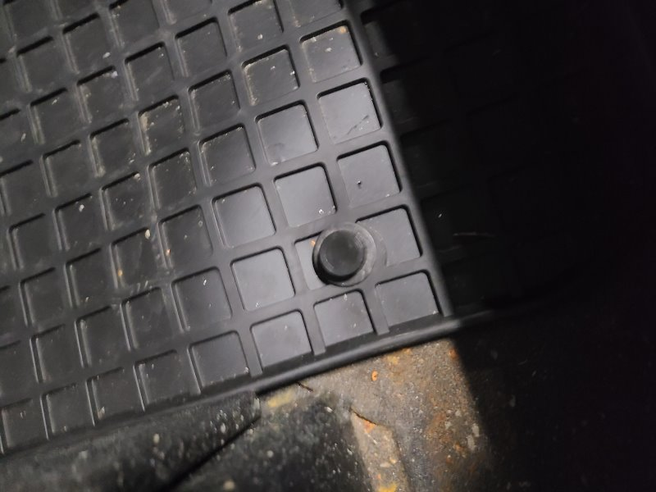

***REPEAT STEPS 1-6 FOR EACH MOUNTING POINT. POSITION THE MAT OVER THE DRILLED HOLES. ADD THE WASHER (E) TO BOLT (B) AND TIGHTEN DOWN SNUGLY. PRESS THE NUT CAP (D) OVER THE HEAD OF THE BOLTS.***

[***www.hardcabs.com***](http://www.hardcabs.com)[***info@hardcabs.com***](mailto:info@hardcabs.com) ***630-324-8585*** *V.100520*