SPARE - PARTS CATALOG

MAHINDRA
ROXOR 2

CAB PREVIEW

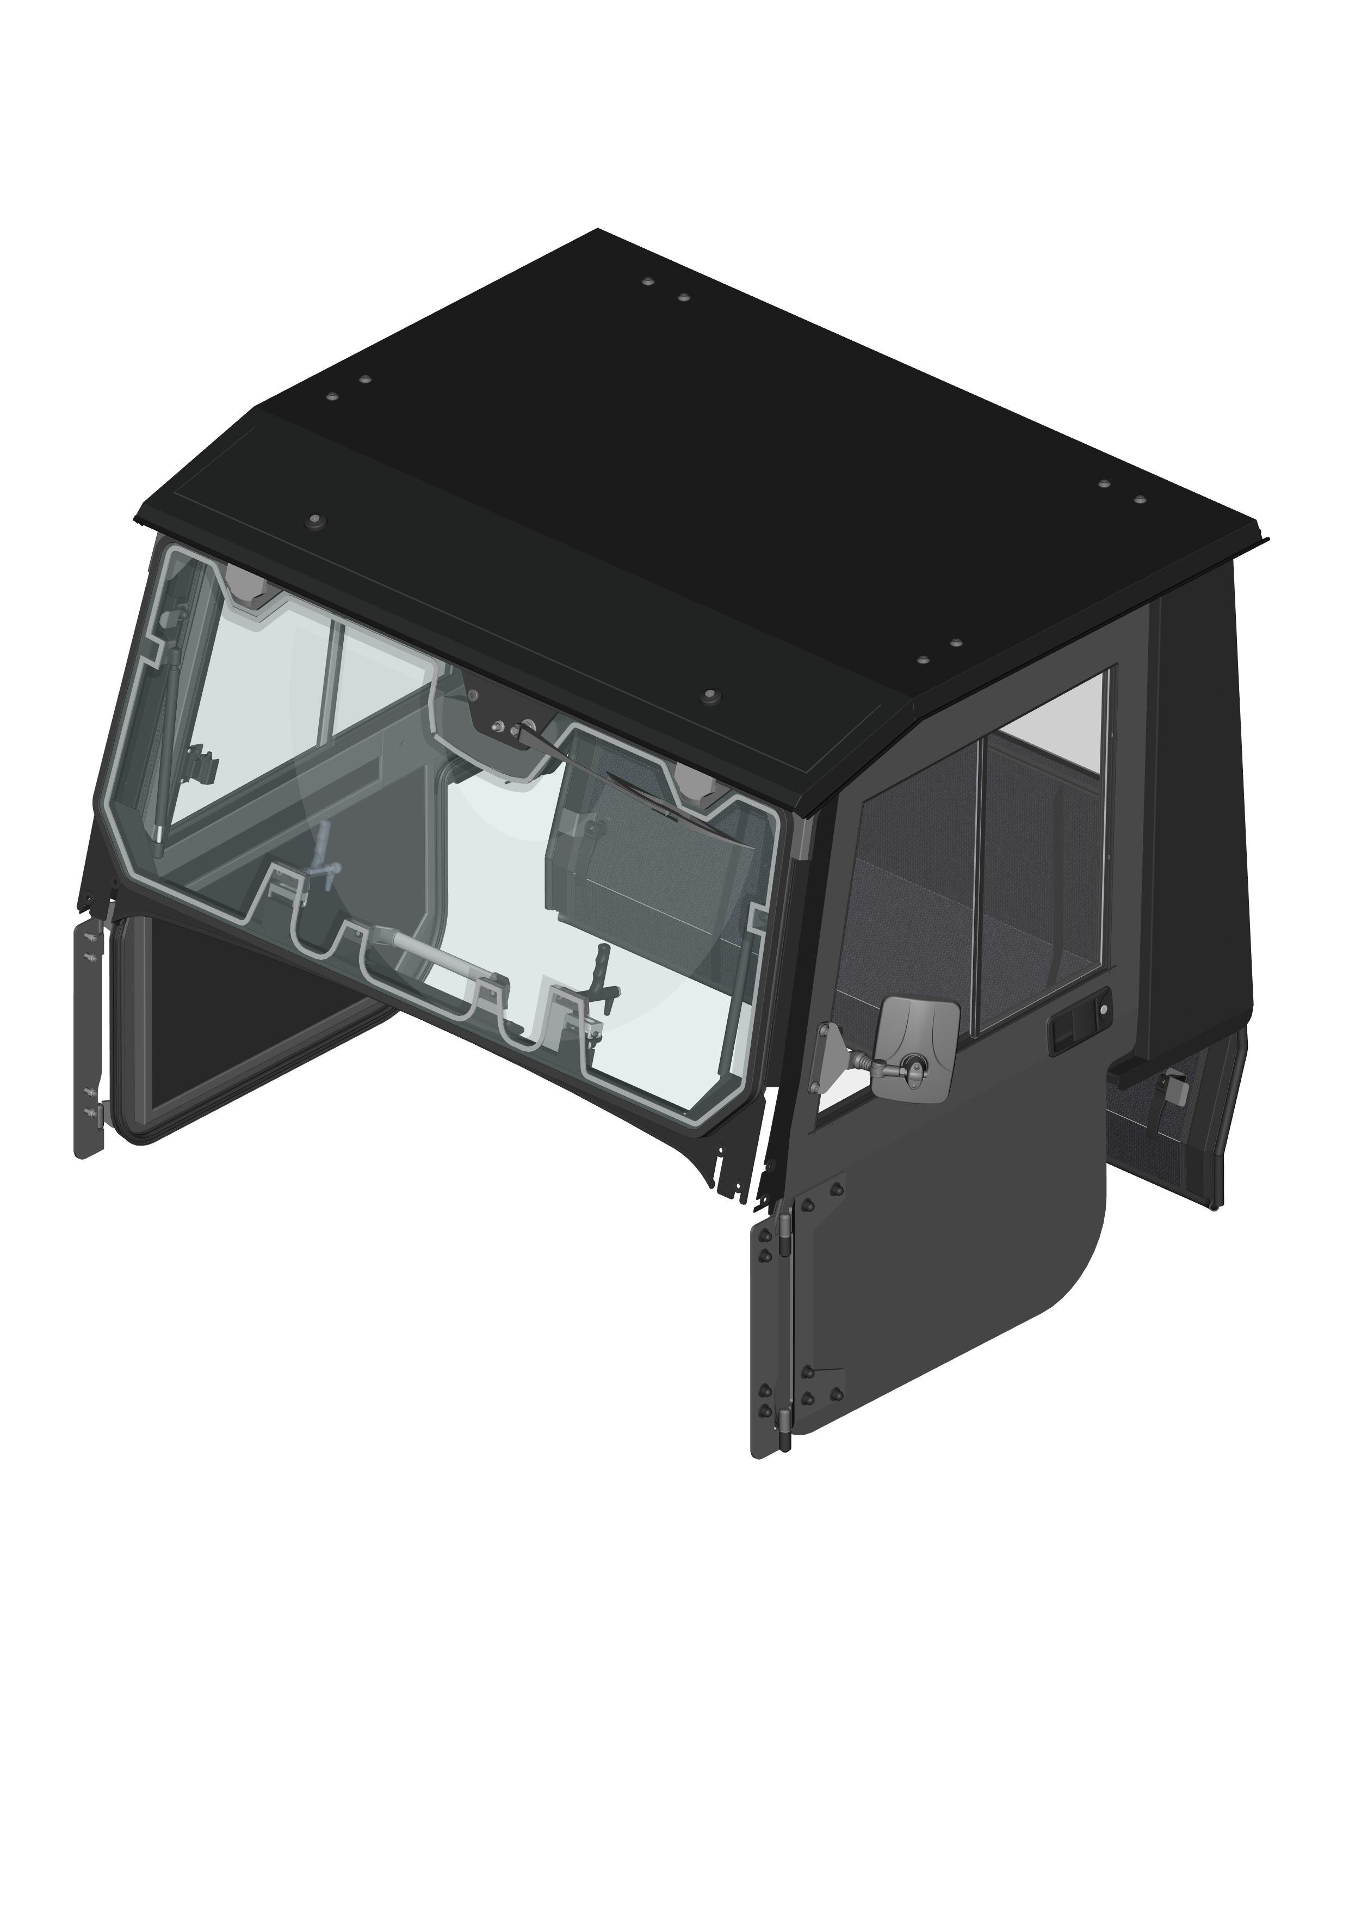

ALL PANELS
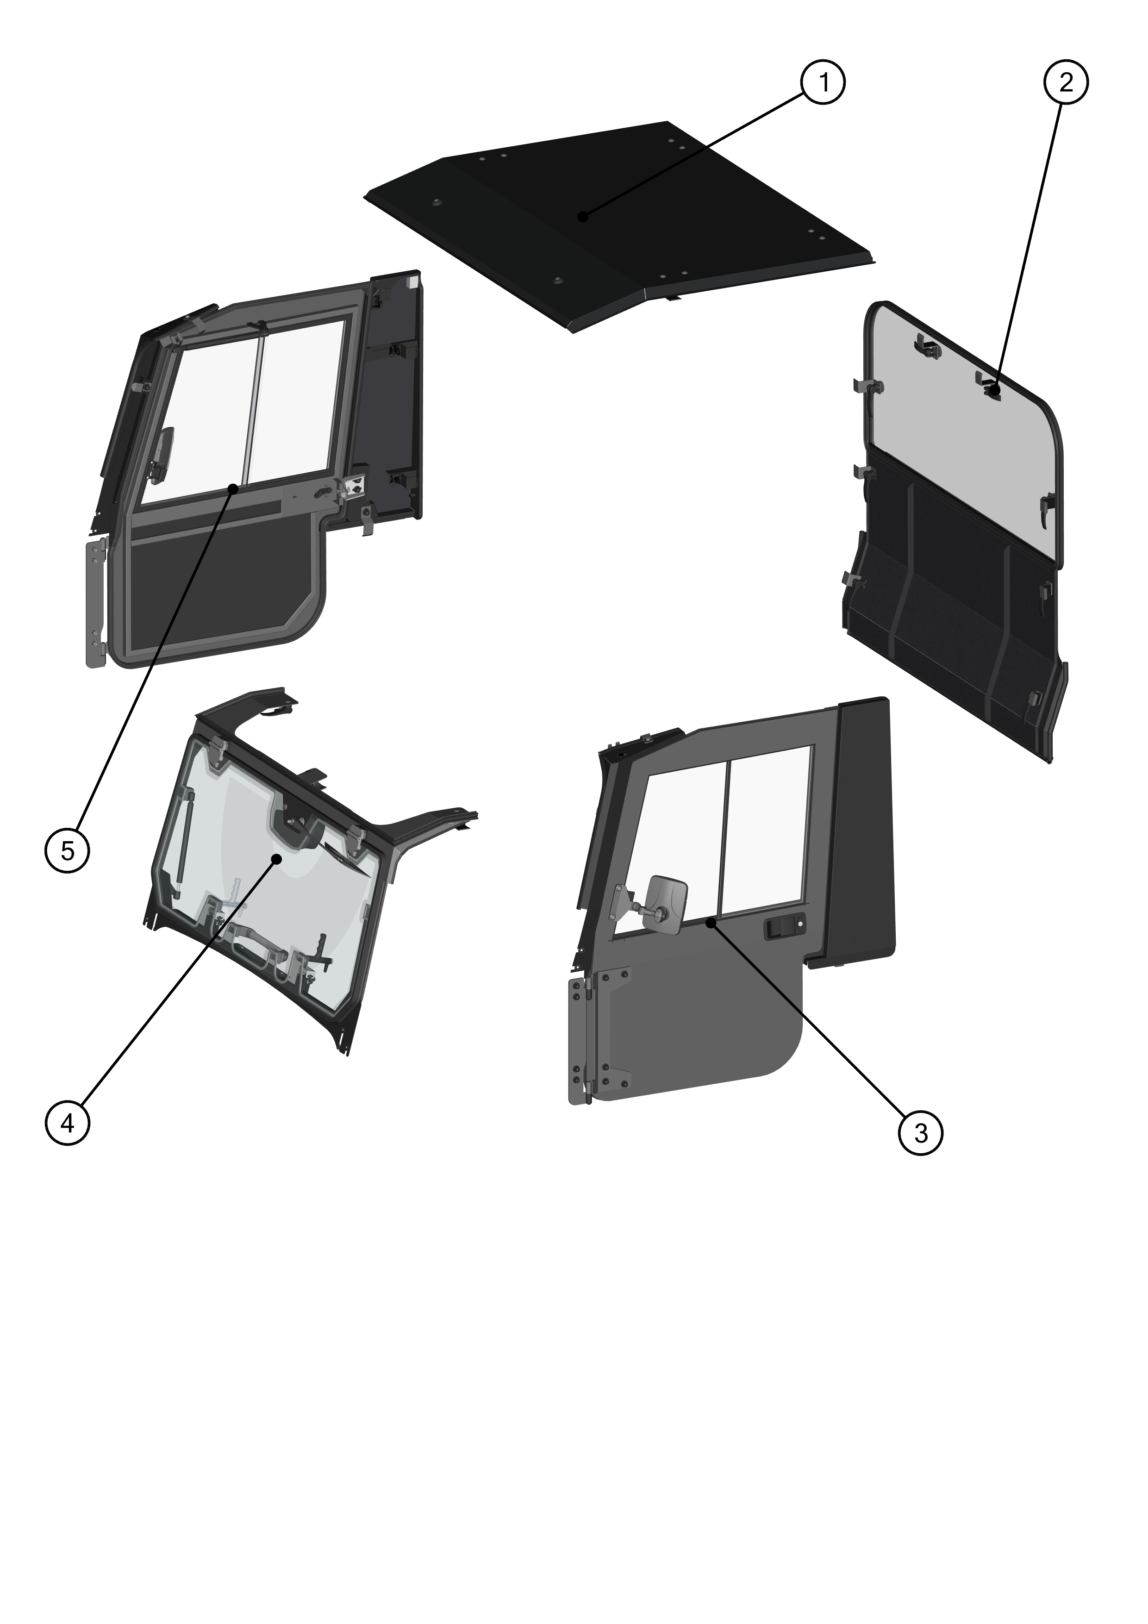

ID | Catalogue no. | Description | Qty |  | Page
1 | 71S01K01S30 | ROOF PANEL | 1 |  | 4
2 | 71S01K01S20 | REAR PANEL | 1 |  | 5
3 | 71S01K01S41 | LEFT DOOR | 1 |  | 11
4 | 71S01K01S10 | FRONT PANEL | 1 |  | 6
5 | 71S01K01S51 | RIGHT DOOR | 1 |  | 18
--- | 71S01K01S00 | ELECTRO-INSTALLATION |  |  | 25
--- | ----------- | HOT FIX KITS |  |  | 26

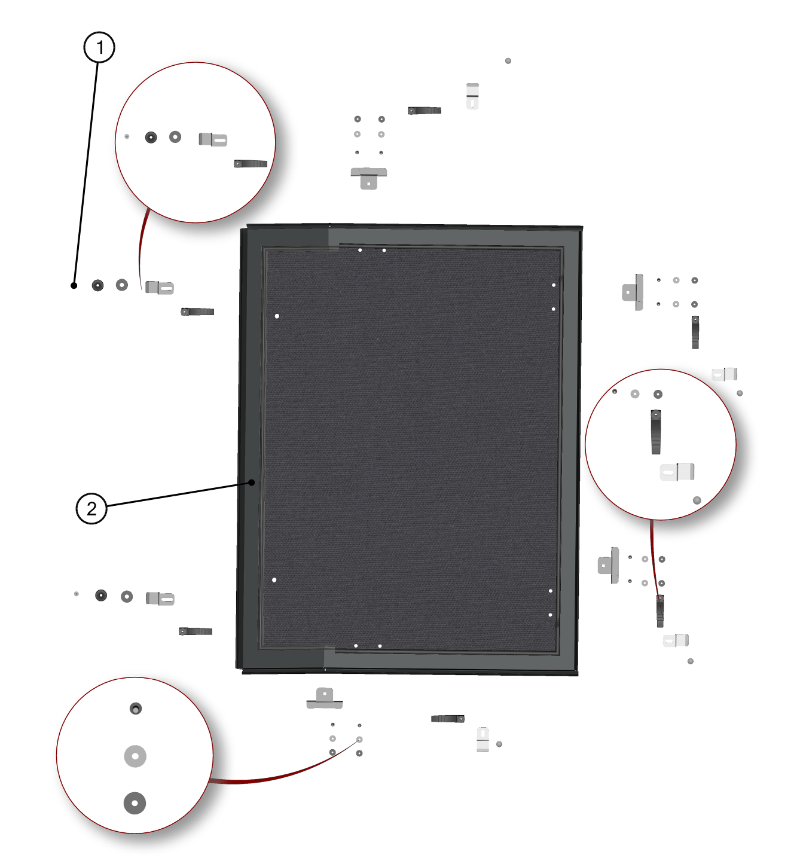
ROOF PANEL KIT

ID | KIT number | Description | List price (USD)
1 | 71S01K01-30PKM001 | Roof hardware kit
2 | 71S01K01-30M001 | Roof assembly

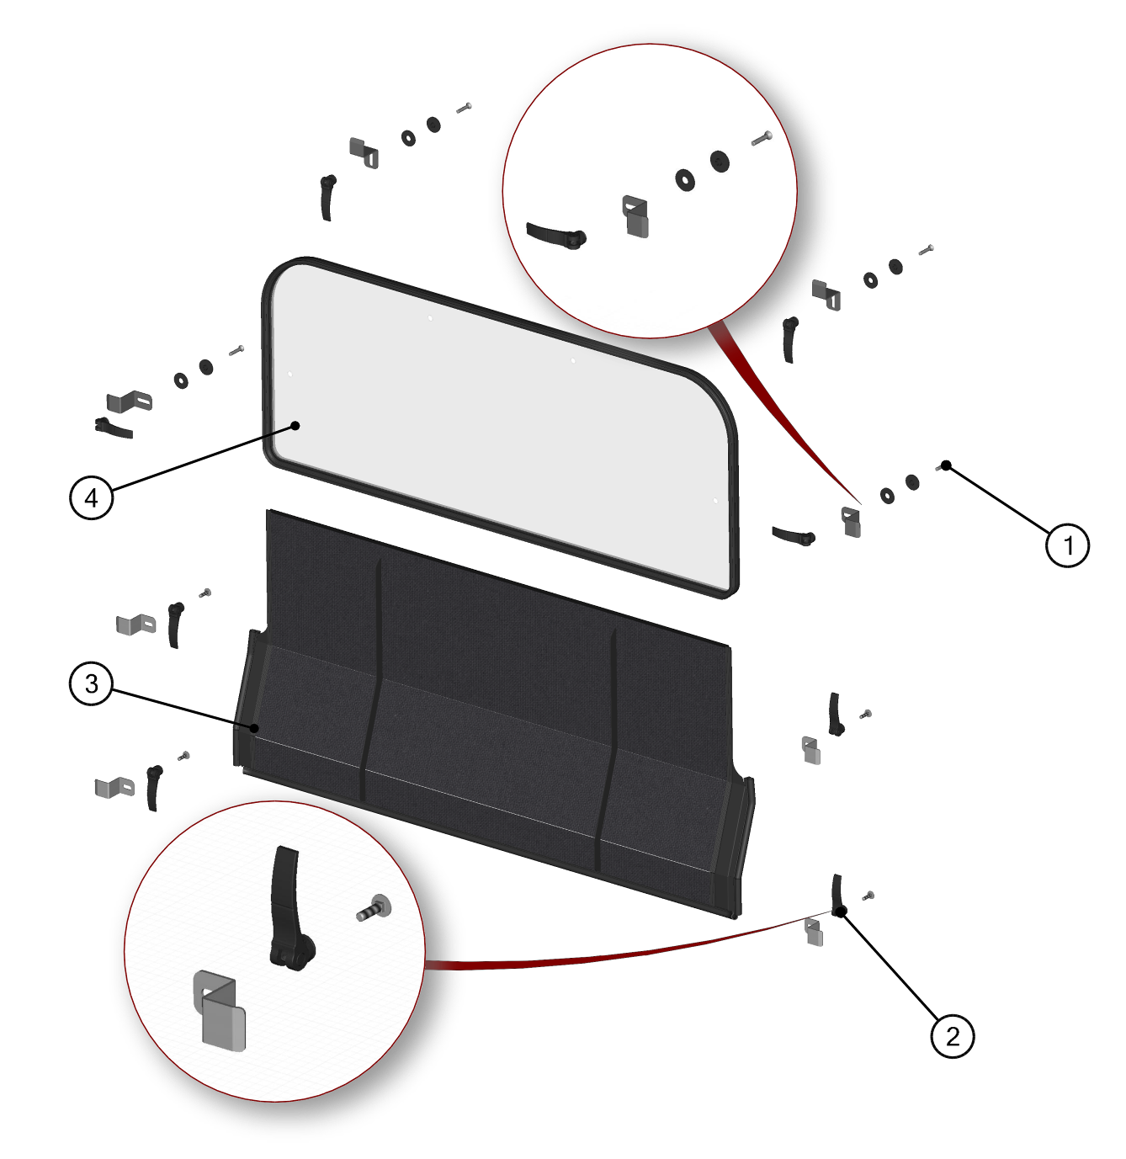
REAR PANEL KIT

ID | KIT number | Description | List price (USD)
1 | 71S01K01-20PKM001 | Rear Upper hardware kit
2 | 71S01K01-20PKM002 | Rear Lower hardware kit
3 | 71S01K01-20M001 | Rear bottom Panel
4 | 71S01K01-20M005 | Rear window Panel

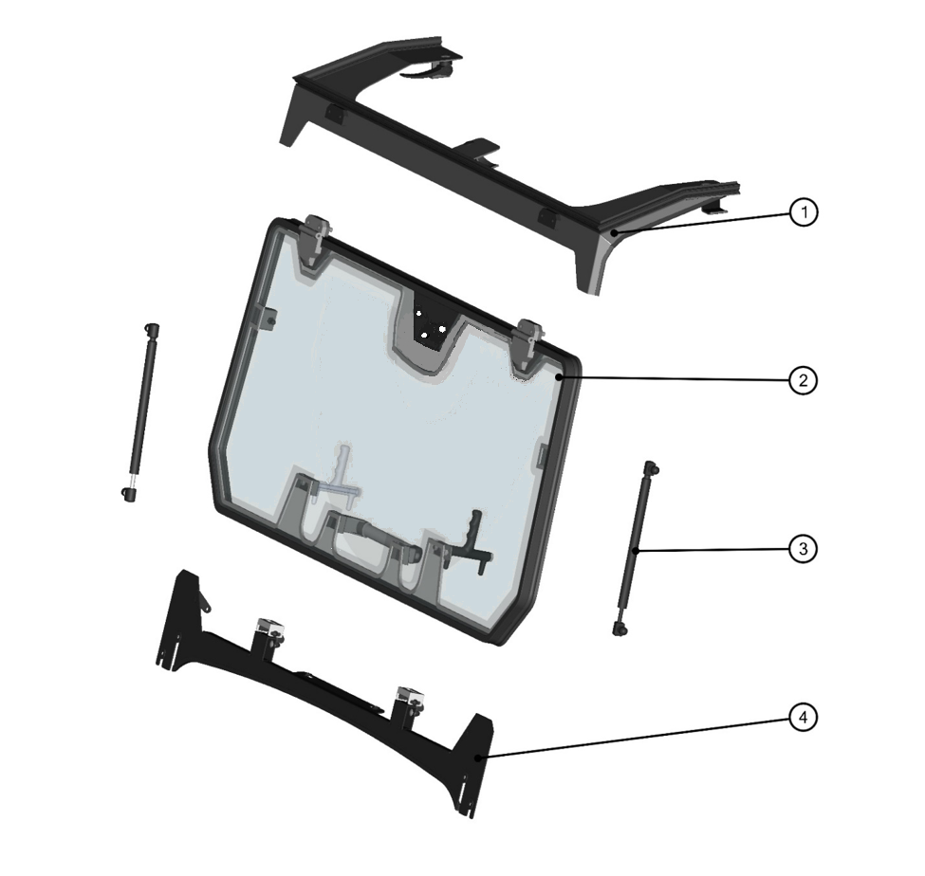
FRONT PANEL ASSEMBLIES

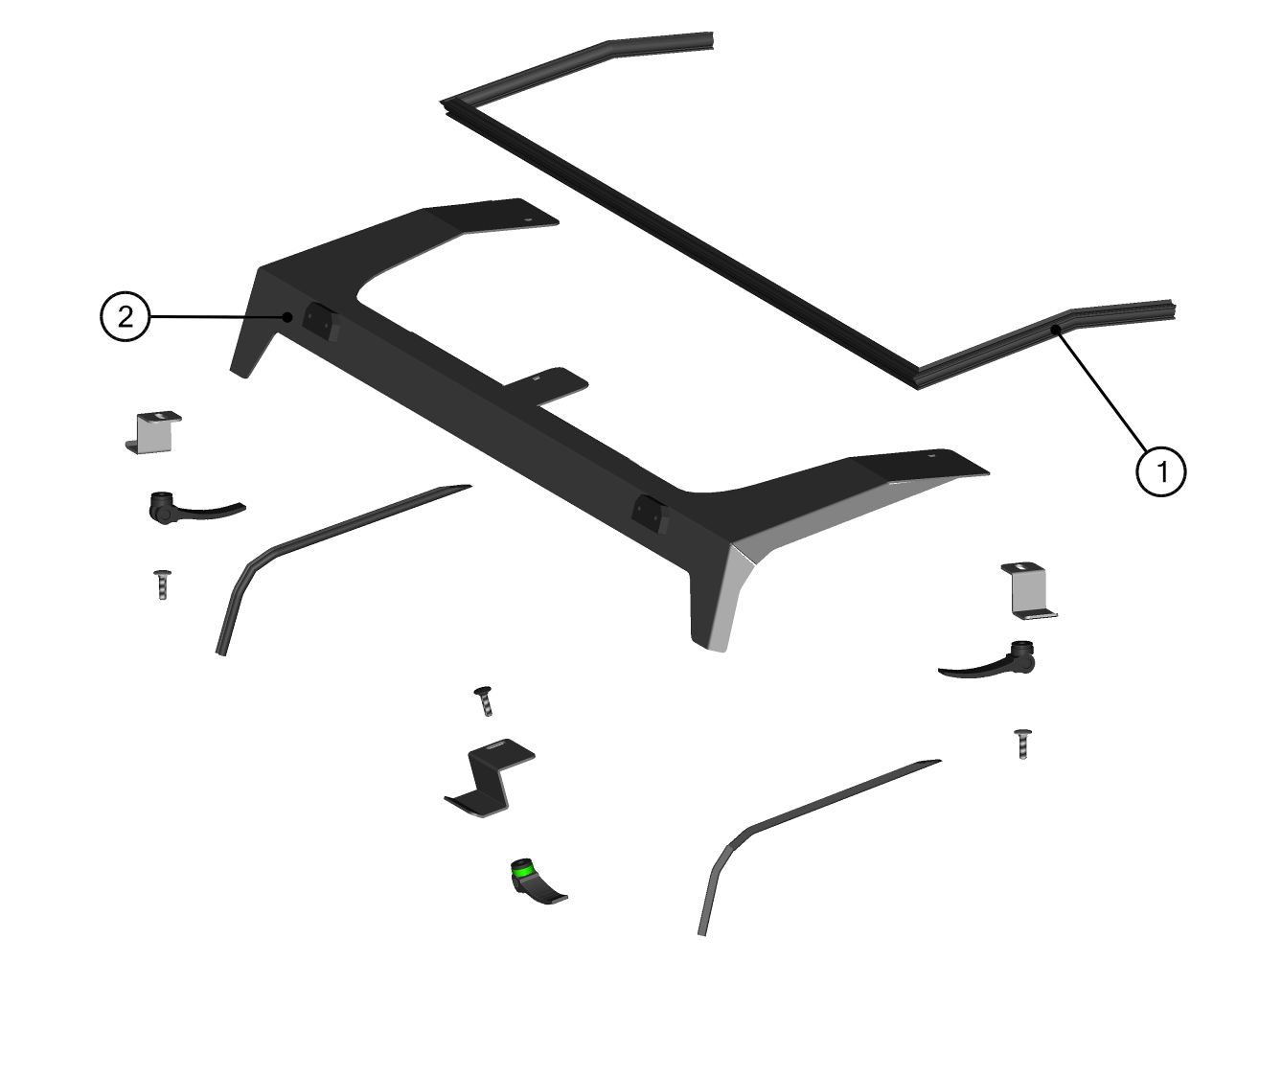
FRONT UPPER LEDGE KIT

ID | KIT number | Description | List price (USD)
1 | 71S01K01-10PKM001 | Front upper ledge hardware kit
2 | 71S01K01-10W020 | Front upper ledge assembly

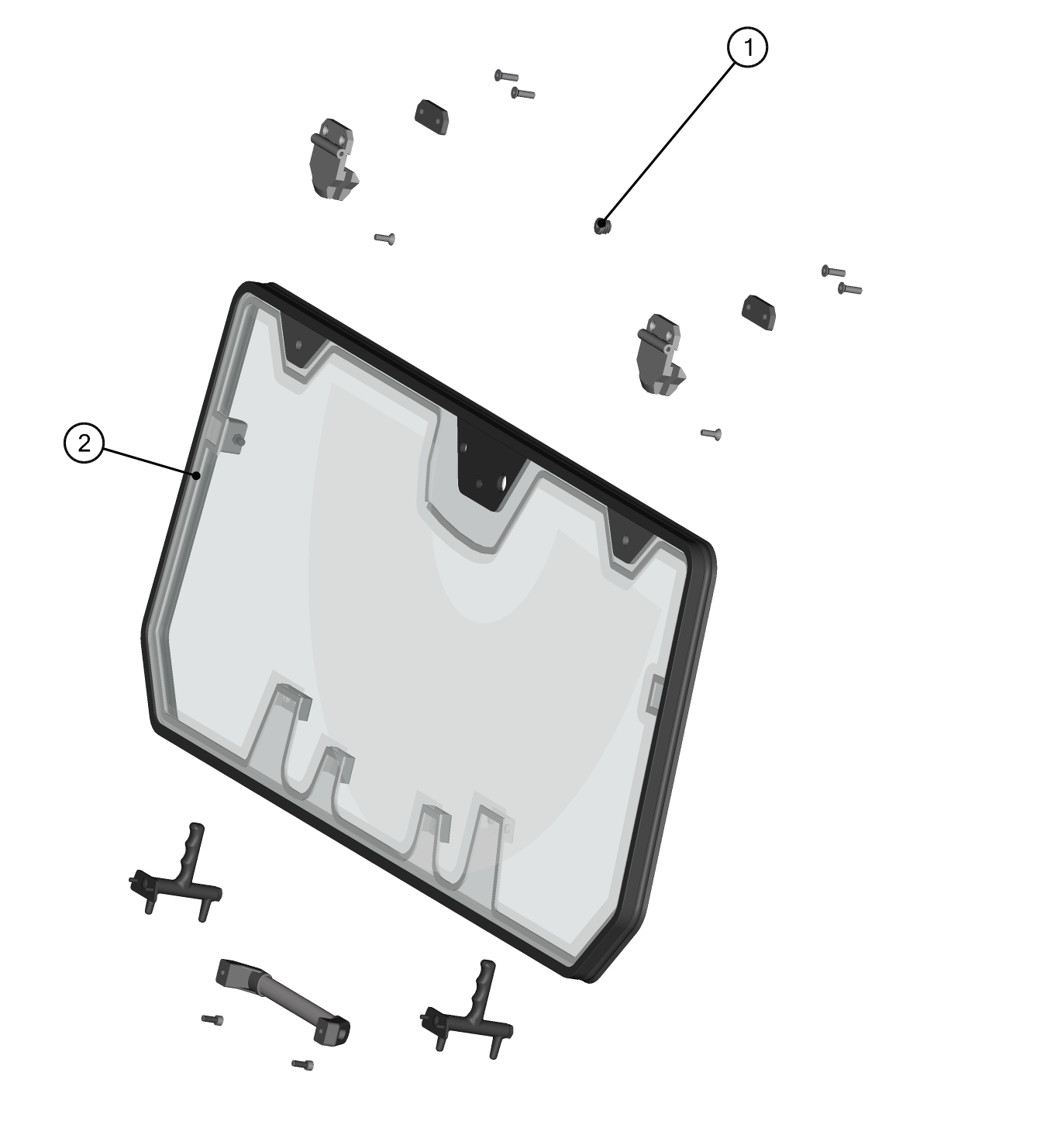
FRONT WINDOW KIT

ID | KIT number | Description | List price (USD)
1 | 71S01K01-10PKM002 | Front window hardware kit
2 | 71S01K01-10M004 | Front window assembly

FRONT GAS SPRING KIT

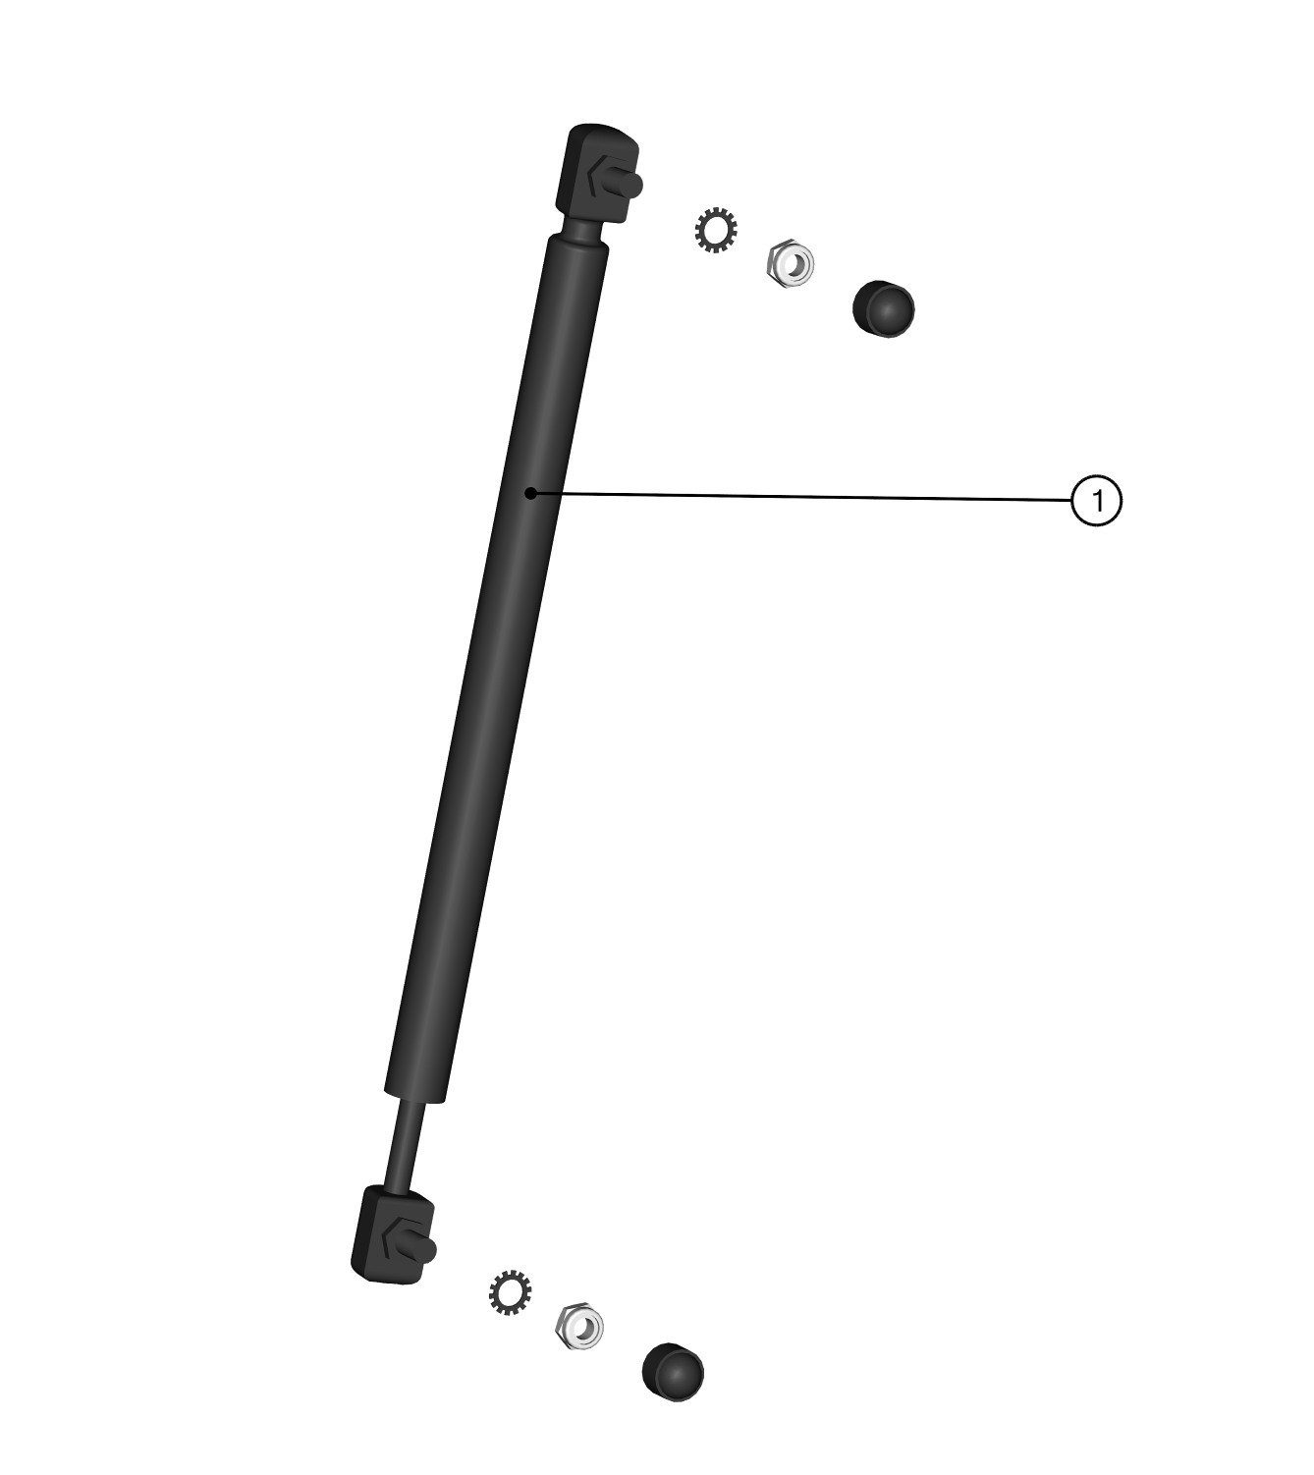

ID | KIT number | Description | List price (USD)
1 | 71S01K01-10M005 | Front window gas spring kit

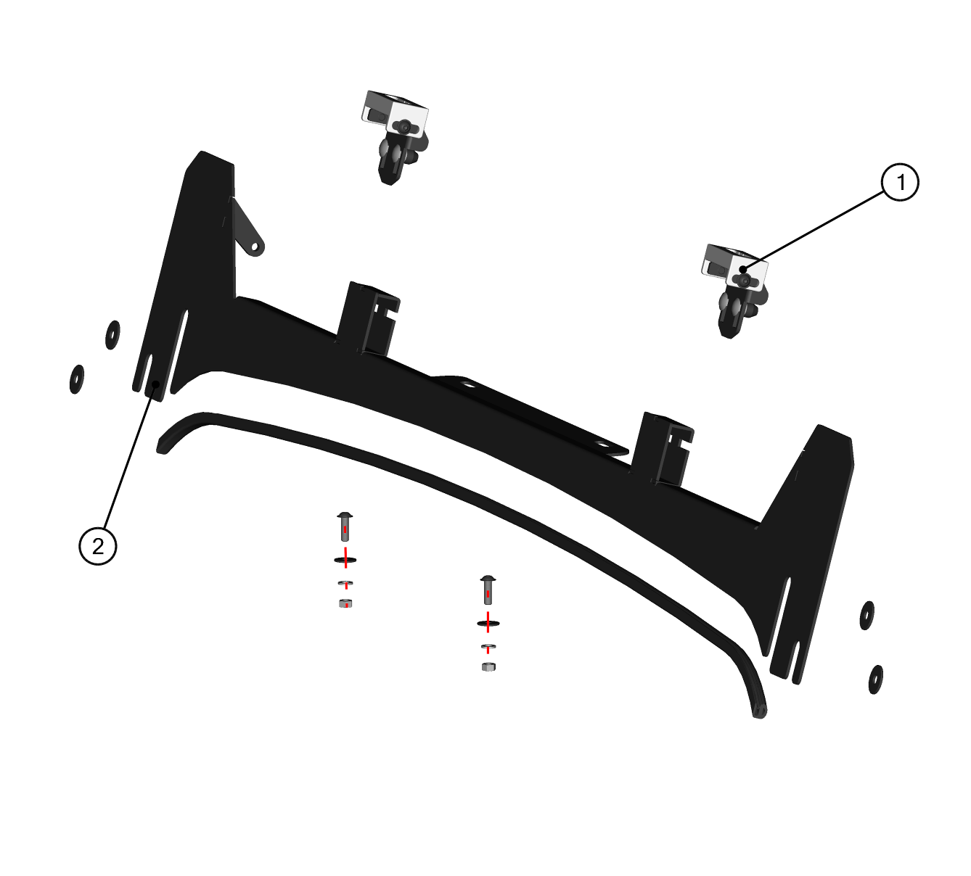
FRONT BOTTOM LEDGE KIT

ID | KIT number | Description | List price (USD)
1 | 71S01K01-10PKM003 | Front bottom ledge hardware kit
2 | 71S01K01-10W010 | Front bottom ledge assembly

LEFT DOOR

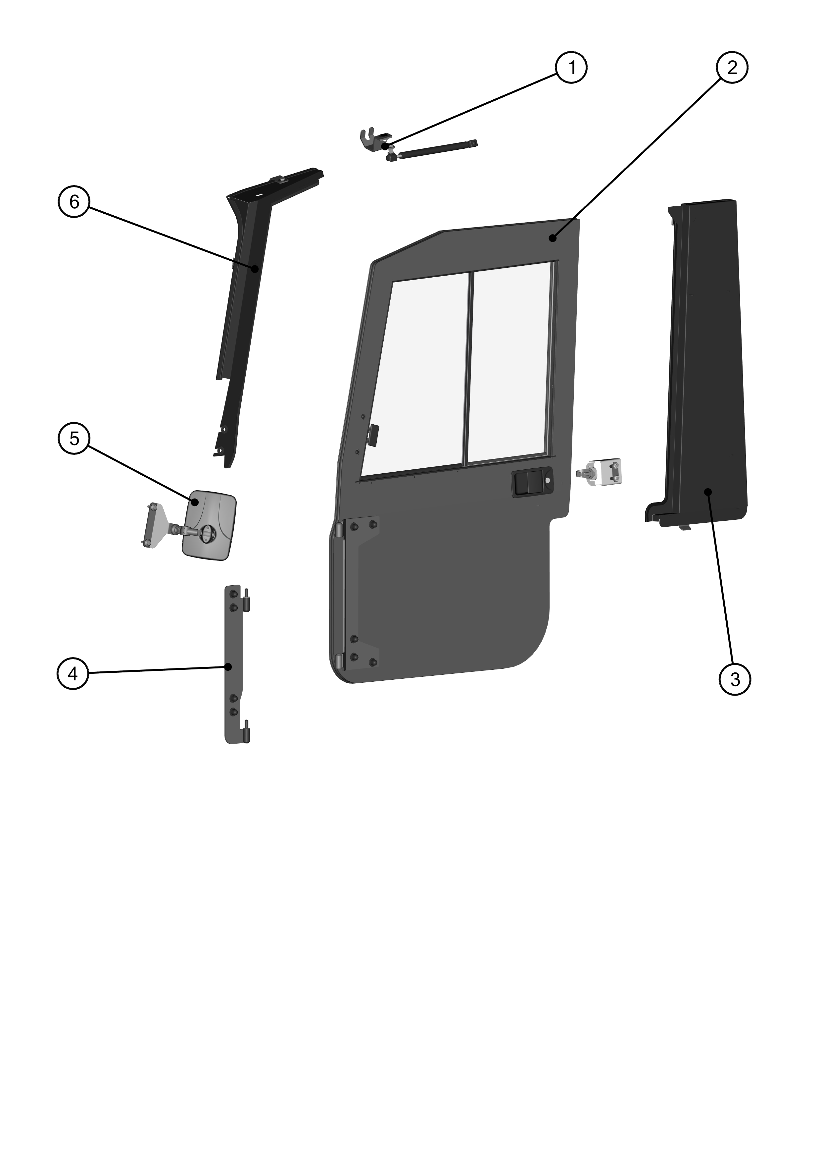

LEFT DOOR GAS SPRING ASSEMBLY
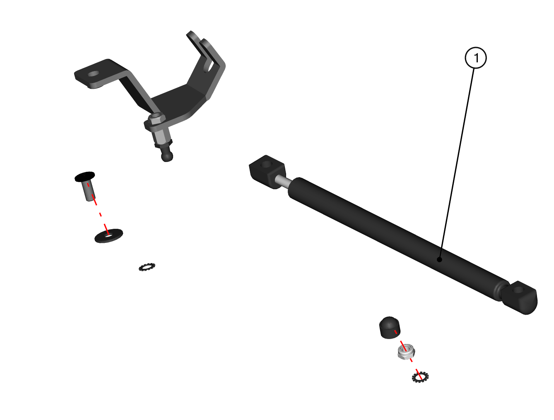

ID | KIT number | Description | List price (USD)
1 | 71S01K01-40M021 | Left gas spring assembly

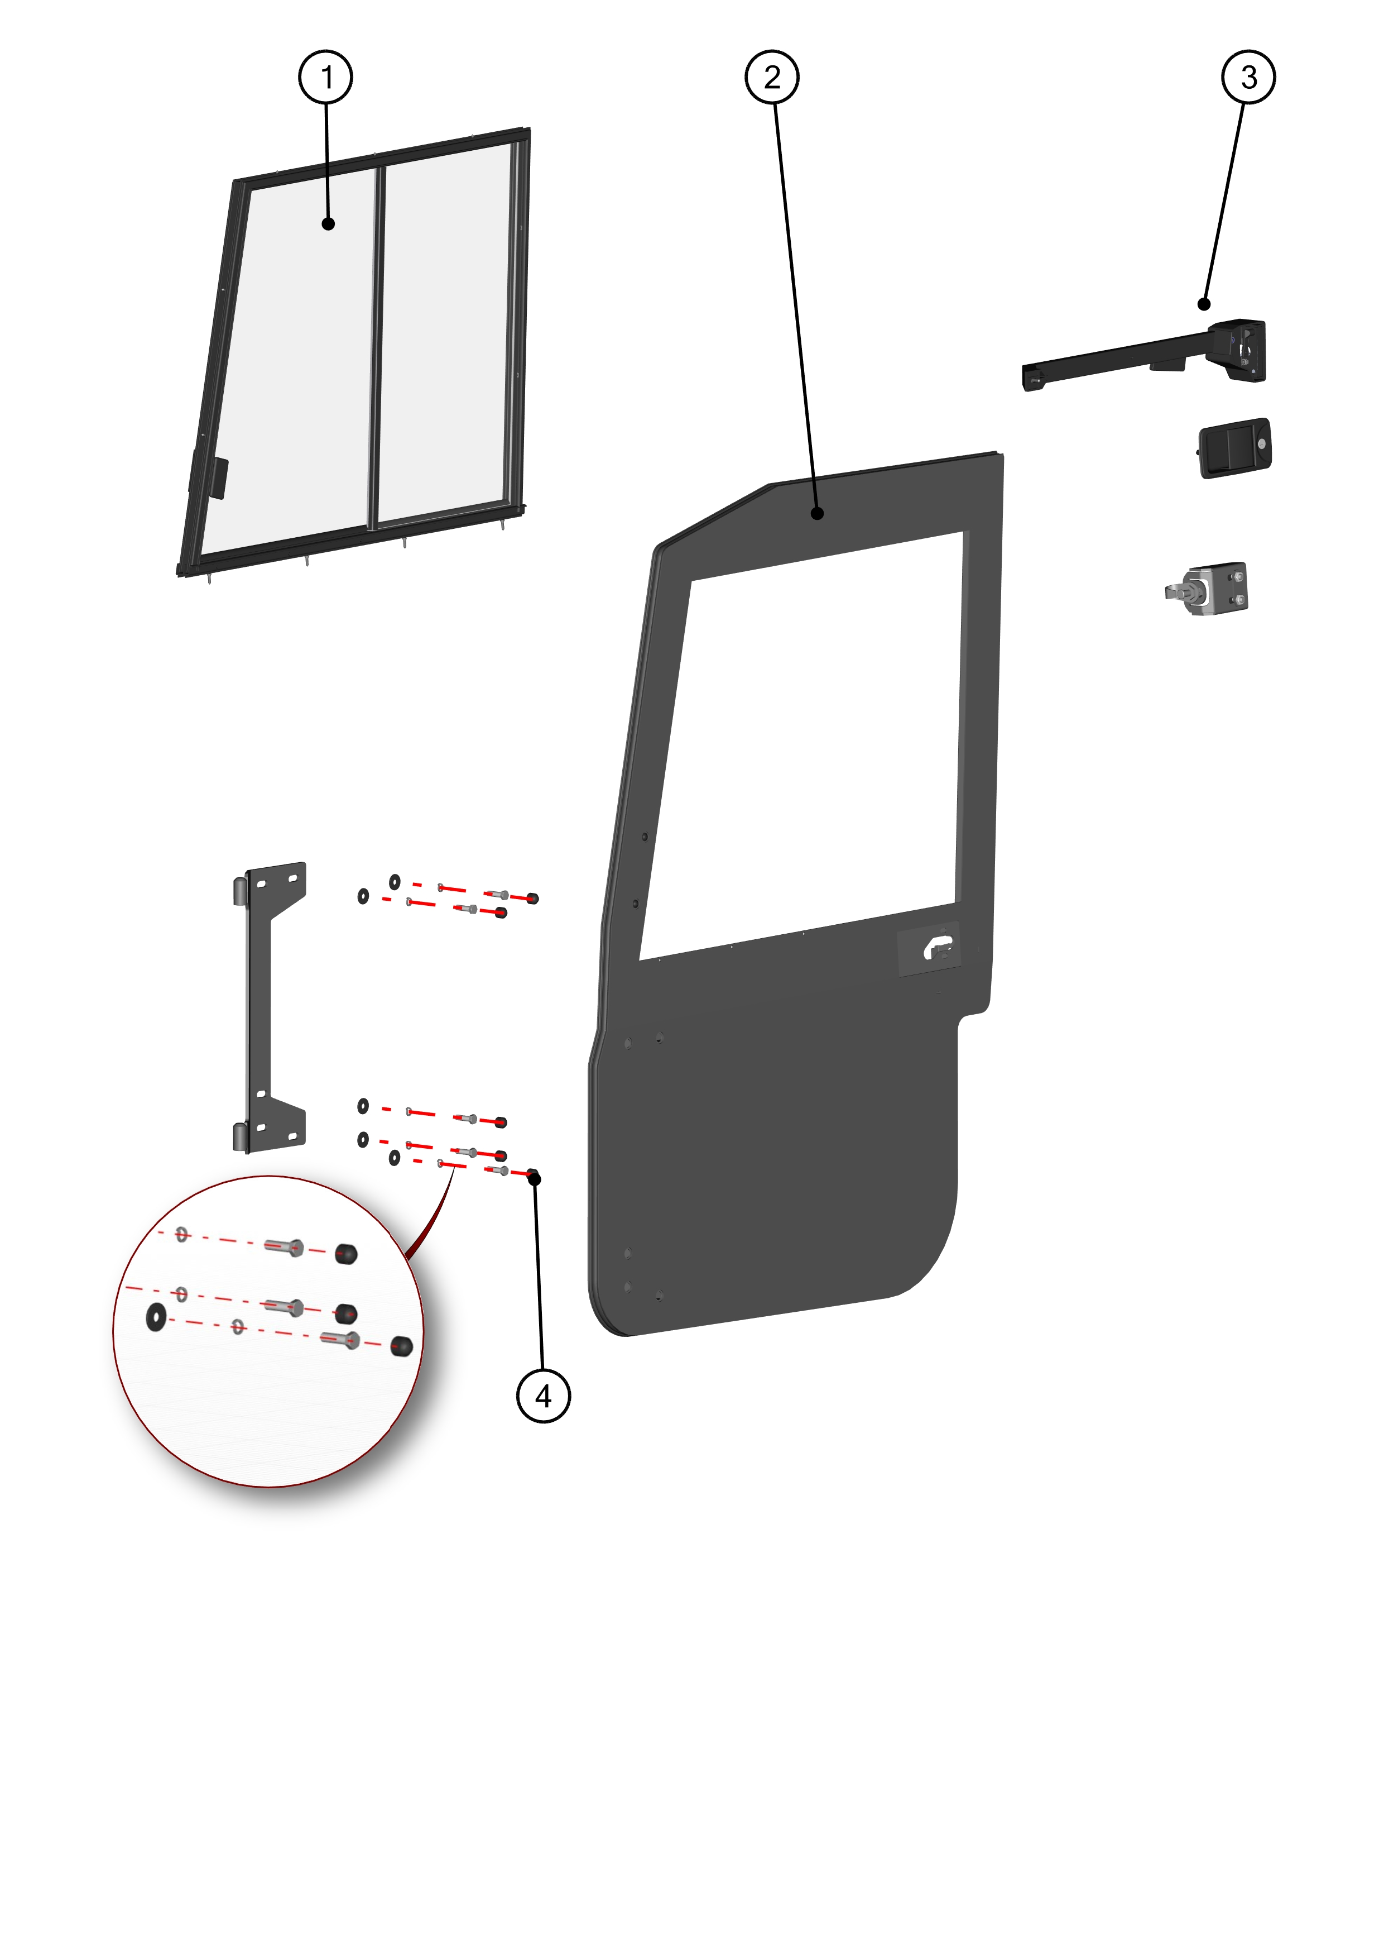
LEFT DOOR KIT

ID | KIT number | Description | List price (USD)
1 | 71S01K01-41M007 | Left door window assembly
2 | 71S01K01-41PKM001 | Left door with sealing assembly
3 | 71S01K01-40PKM006 | Left door locks with door stop kit
4 | 71S01K01-40PKM002 | Left door hardware kit
LEFT DOOR BASE KIT

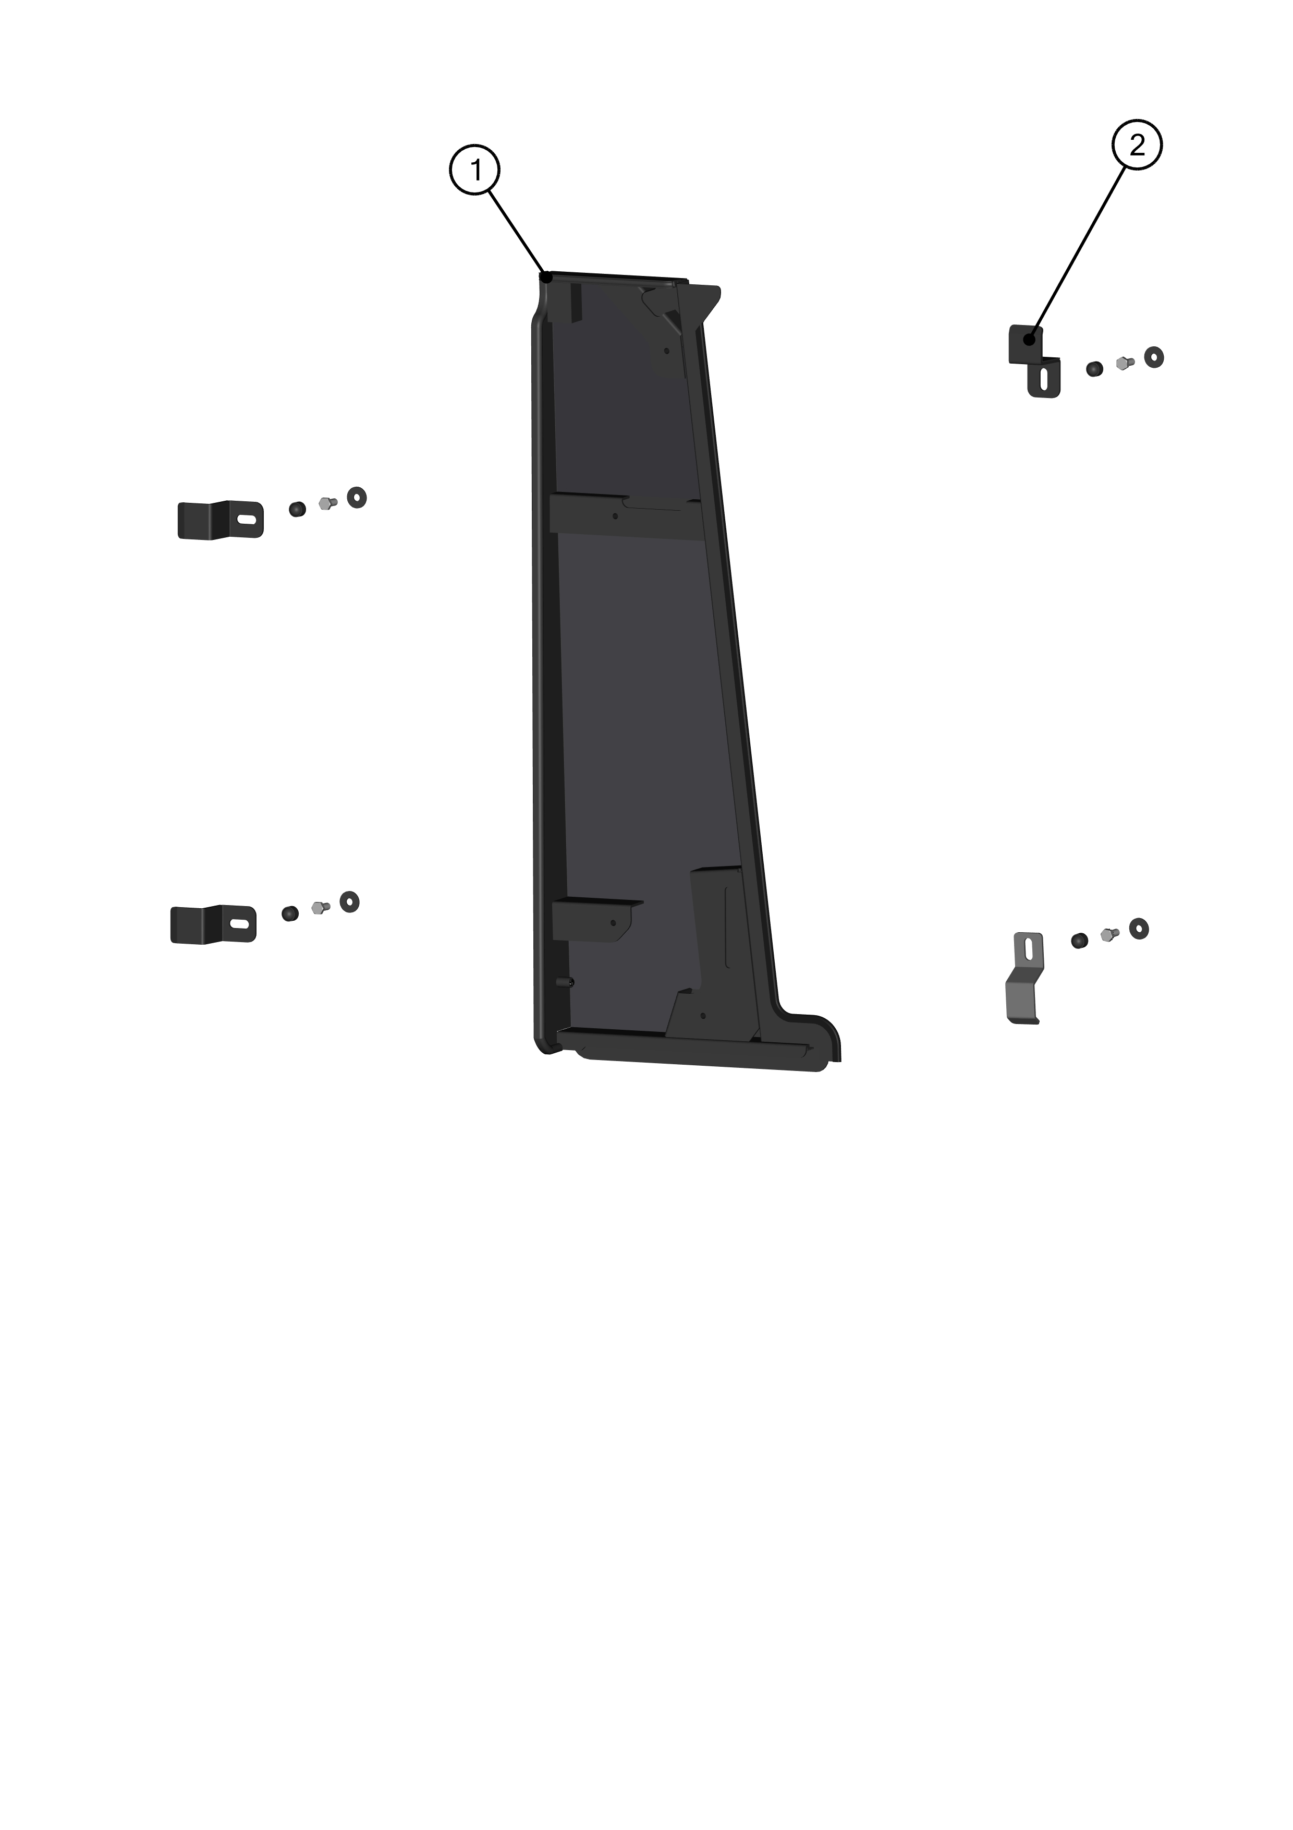

ID | KIT number | Description | List price (USD)
1 | 71S01K01-41M011 | Left door base assembly
2 | 71S01K01-40PKM003 | Left door base kit

LEFT HINGE LEDGE KIT

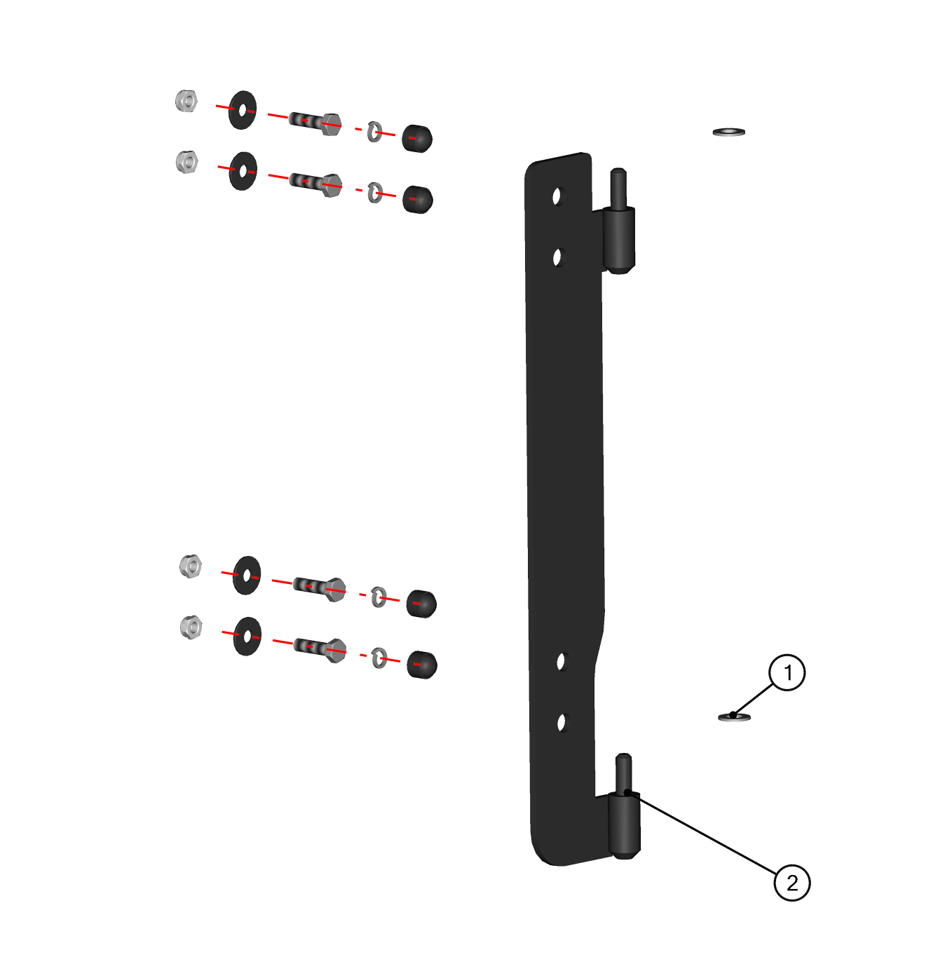

ID | KIT number | Description | List price (USD)
1 | 71S01K01-40PKM004 | Left hinge ledge frame kit
2 | 71S01K01-40W004 | Left hinge ledge welded

LEFT DOOR FRONT LEDGE KIT
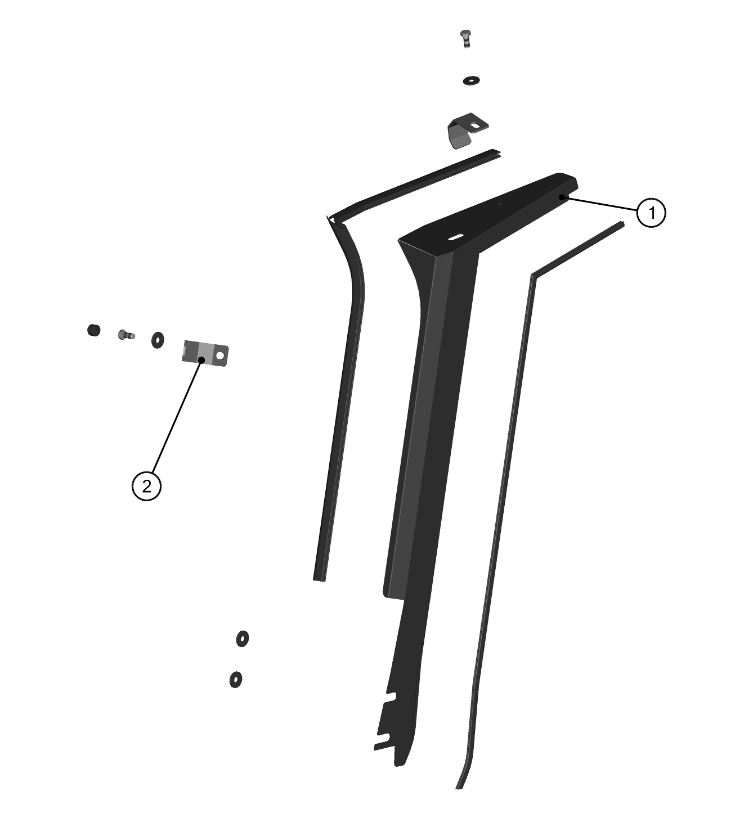

ID | KIT number | Description | List price (USD)
1 | 71S01K01-40PKM005 | Left door front ledge kit
2 | 71S01K01-40W020 | Left door front ledge welded

DOOR SIDE MIRROR KIT

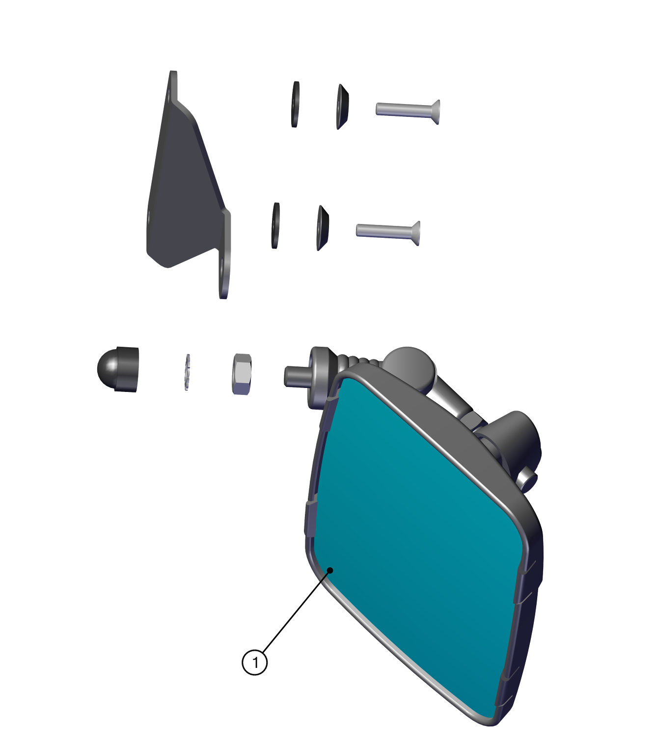

ID | KIT number | Description | List price (USD)
1 | 00-109U-M007 | Door side mirror kit

RIGHT DOOR

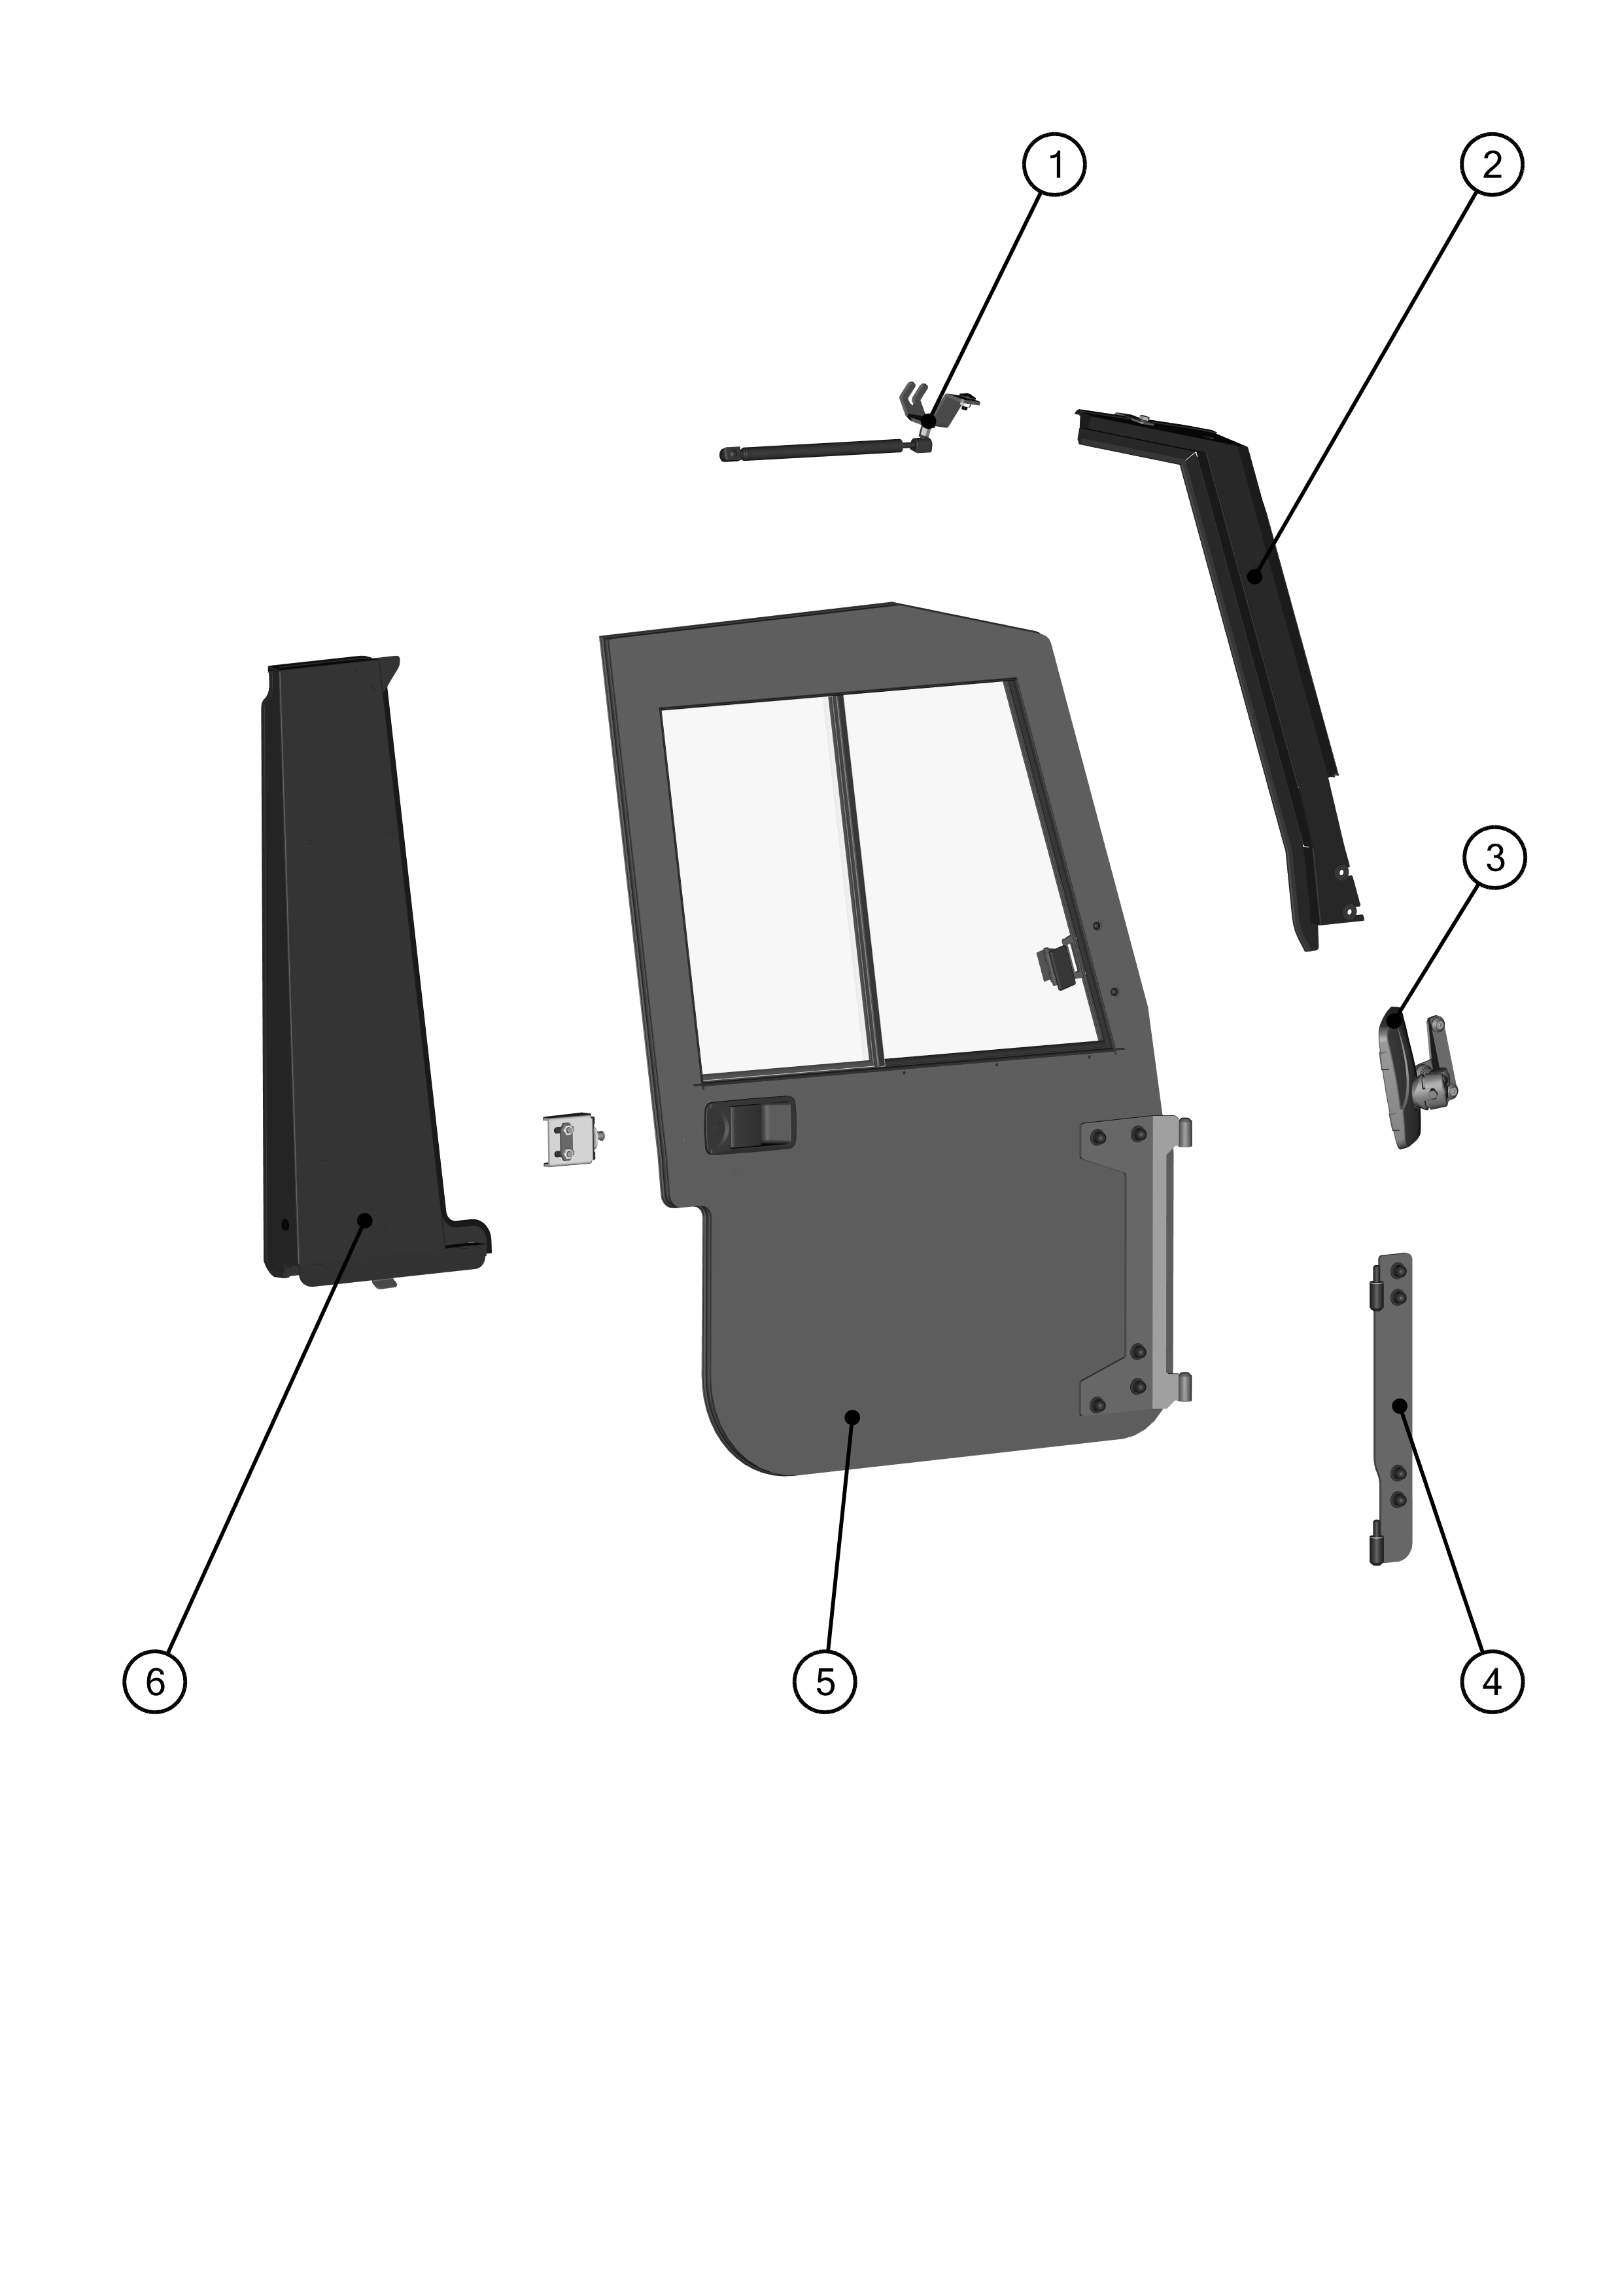

RIGHT GAS SPRING ASSEMBLY
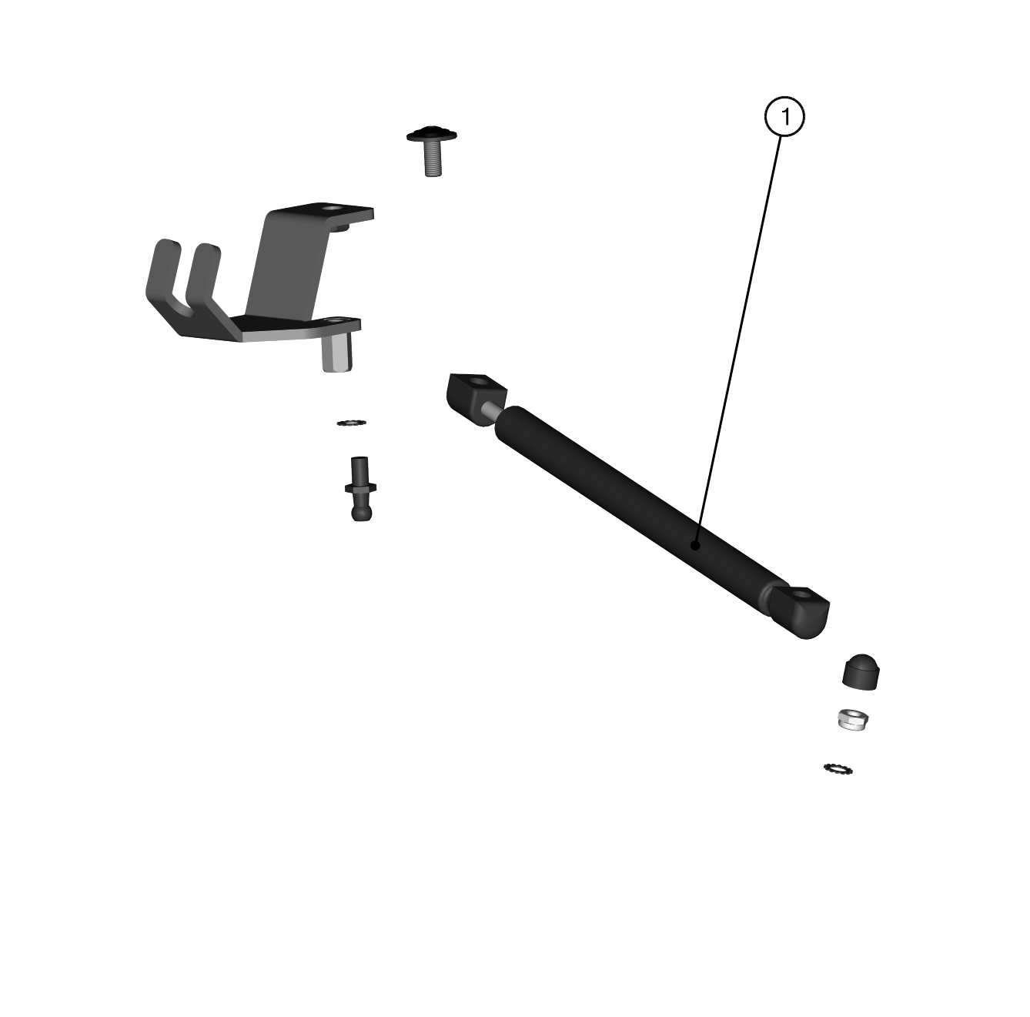

ID | KIT number | Description | List price (USD)
1 | 71S01K01-50M021 | Right gas spring assembly

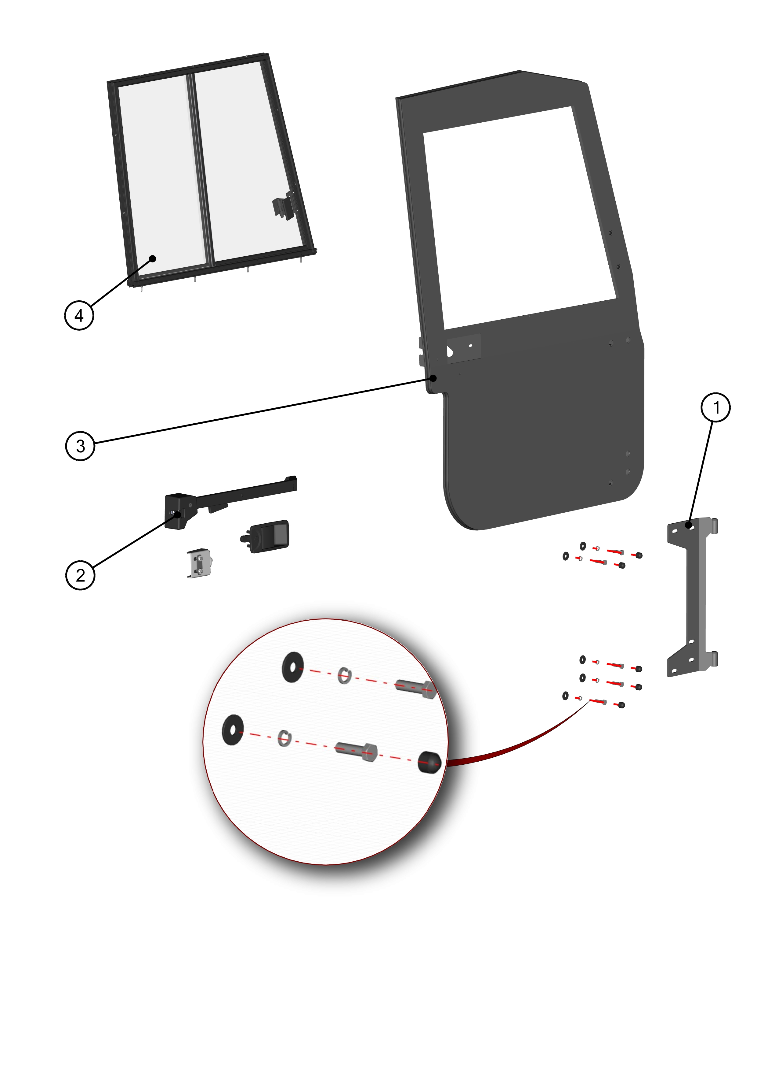
RIGHT DOOR KIT

ID | KIT number | Description | List price (USD)
1 | 71S01K01-50PKM002 | Right door hardware kit
2 | 71S01K01-50PKM006 | Right door locks with door stop kit
3 | 71S01K01-51PKM001 | Right door with sealing assembly
4 | 71S01K01-51M007 | Right door window assembly

RIGHT DOOR BASE KIT

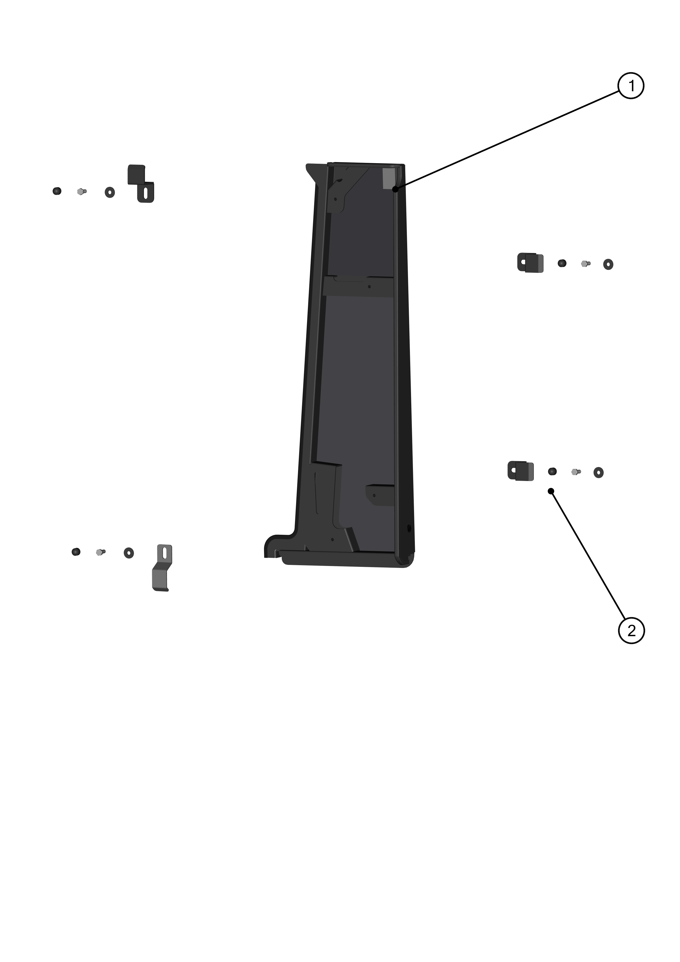

ID | KIT number | Description | List price (USD)
1 | 71S01K01-51M011 | Right door base assembly
2 | 71S01K01-40PKM003 | Right door base kit

RIGHT HINGE LEDGE KIT
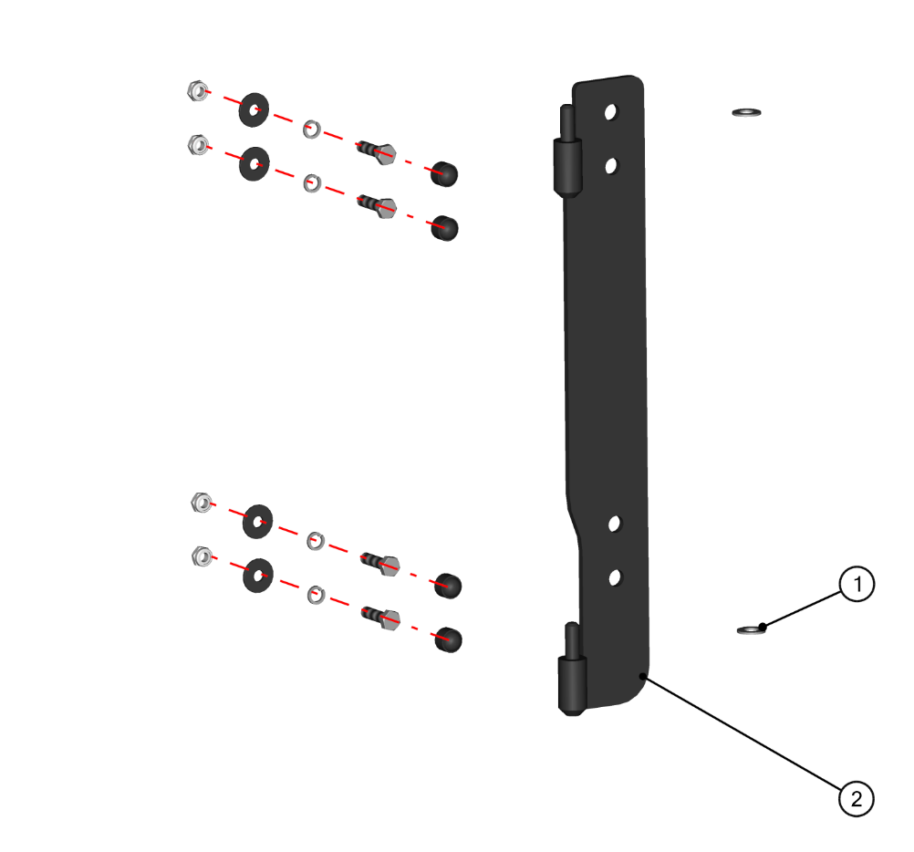

ID | KIT number | Description | List price (USD)
1 | 71S01K01-40PKM004 | Right hinge ledge kit
2 | 71S01K01-50W004 | Right front ledge welded

RIGHT FRONT COVER KIT

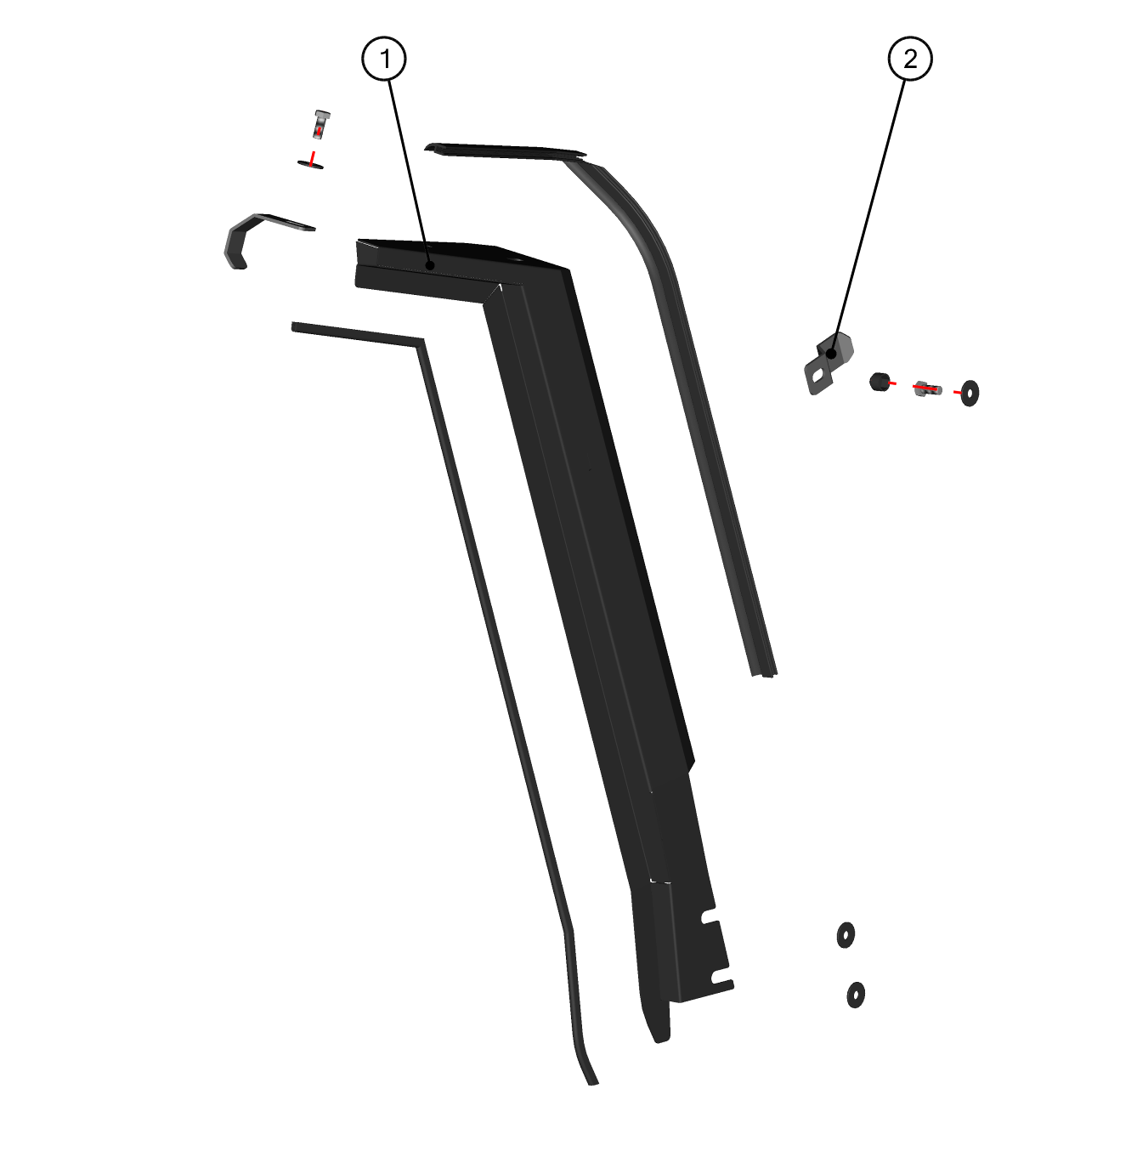

ID | KIT number | Description | List price (USD)
1 | 71S01K01-50W020 | Right front ledge welded
2 | 71S01K01-40PKM005 | Right front cover kit

DOOR SIDE MIRROR KIT

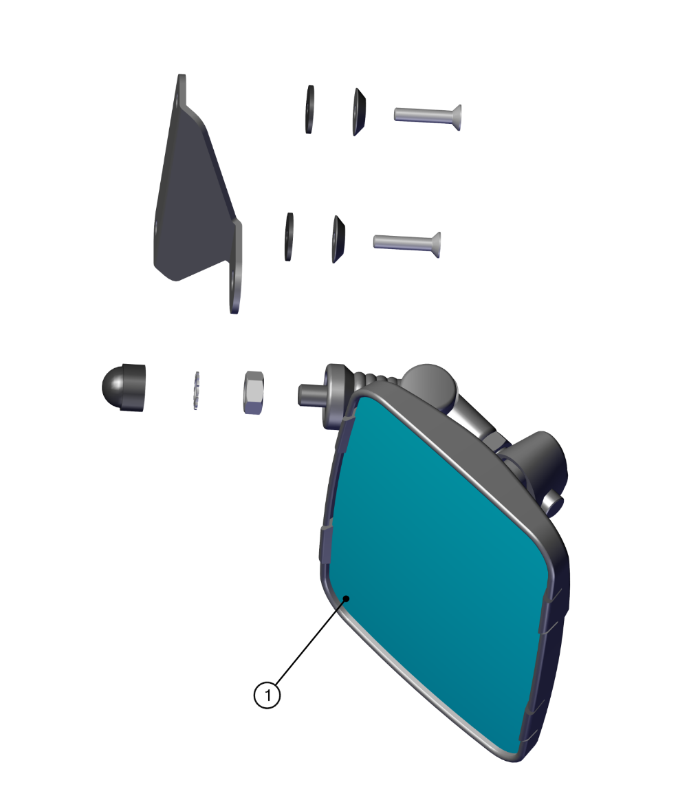

ID | KIT number | Description | List price (USD)
1 | 00-109U-M007 | Door side mirror kit

ELECTROINSTALLATION

Position | Catalogue no. | Description | Qty | List price (USD)
1 | 004322 | SWITCH WIPER /WASHER /OFF | 1
2 | 000885 | WASHER TANK | 1
3 | 001576 | WASHER MOTOR | 1
4 | 005611 | WIPER MOTOR 12V | 1
5 | 50S02U02-01M001 | WIPER HARNESS | 1
6 | 71S01K01-01M004 | RELAY HARNESS | 1
7 | 50S02U02-01M002 | SWITCH HARNESS | 1
8 | 71S01K01-03M002 | WASHER HARNESS | 1
9 | 71S01K01-03-001 | WASHER HOLDER | 1

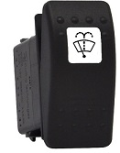 |  |  | 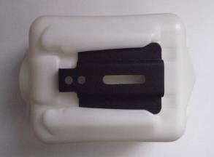 |  |  | 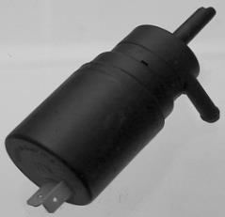
Position : 1 |  |  | Position : 2 |  |  | Position : 3
Catalogue no.: 004322 |  |  | Catalogue no.: 000885 |  |  | Catalogue no.: 001576
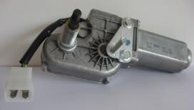 |  |  | 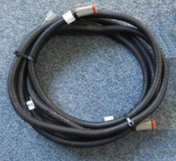 |  |  | 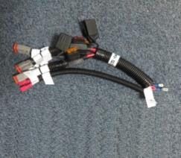
Position : 4 |  |  | Position : 5 |  |  | Position : 6
Catalogue no.: 005611 |  |  | Catalogue no.: 50S02U02-01M001 |  |  | Catalogue no.: 71S01K01-01M004
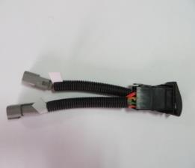 |  |  | 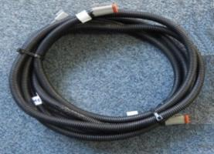 |  |  | 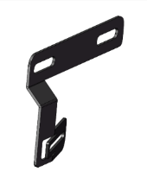
Position : 7 |  |  | Position : 8 |  |  | Position : 9
Catalogue no.: 50S02U02-01M002 |  |  | Catalogue no.: 71S01K01-03M002 |  |  | Catalogue no.: 71S01K01-03-001

HOT FIX KITS

UNI SCREW KIT

Catalogue no. | Description | Qty | List price (USD)
71S01K01-10PKM009 | PLASTIC WASHER 8 | 6
 | RUBBER WASHER 8 | 6
 | PLASTIC WASHER 6 | 6
 | RUBBER WASHER 6 | 6
 | SCREW M8x45 | 6
 | SCREW M8x30 | 6
 | SCREW M6x25 | 6
 | SCREW M8x30 | 4
 | SCREW M8x25 | 2
 | SCREW M8x20 | 2
 | SCREW M6x20 | 2
 | NUT M6 | 2
 | WASHER 6 | 2
 | WASHER 6 LARGE | 2
 | WASHER 8 LARGE | 4
 | PLASTIC NUT COVER OK 13 | 8
 | SPRING WASHER 8 | 2
 | SELF-LOCKING NUT M8 | 2

HANDI KITS

Catalogue no. | Description | Qty | List price (USD)
00-117U-M007 | FAST-LOCK ASSEMBLY | 4
000862 | FRONT HINGE | 2
64S03U01-15M004 | FRONT WINDOW LOCK | 2
002709 | FRONT HANDLE | 1
00-40M020 | RIGHT INNER DOOR LOCK | 1
00-50M020 | LEFT INNER DOOR LOCK | 1
000841 | OUTER DOOR LOCK | 1
004539 | GAS SPRINGS - Door | 2
002494 | GAS SPRINGS - Windshield | 2
002537 | WIPER BLADE | 1
001764 | WIPER ARM | 1

PANEL SEALING KITS

Catalogue no. | Description | Qty | List price (USD)
71S01K01-10PKM010 | FRONT WINDOW SEALING KIT | 1
71S01K01-20PKM010 | REAR WINDOW SEALING KIT | 1
71S01K01-30PKM010 | ROOF EDGE SEALING KIT | 1
71S01K01-40PKM010 | LEFT DOOR EDGE SEALING KIT | 1
71S01K01-40PKM010 | RIGHT DOOR EDGE SEALING KIT | 1

