***SPARE - PARTS CATALOGUE (PRICE LIST)***

**YAMAHA**

**VIKING**

**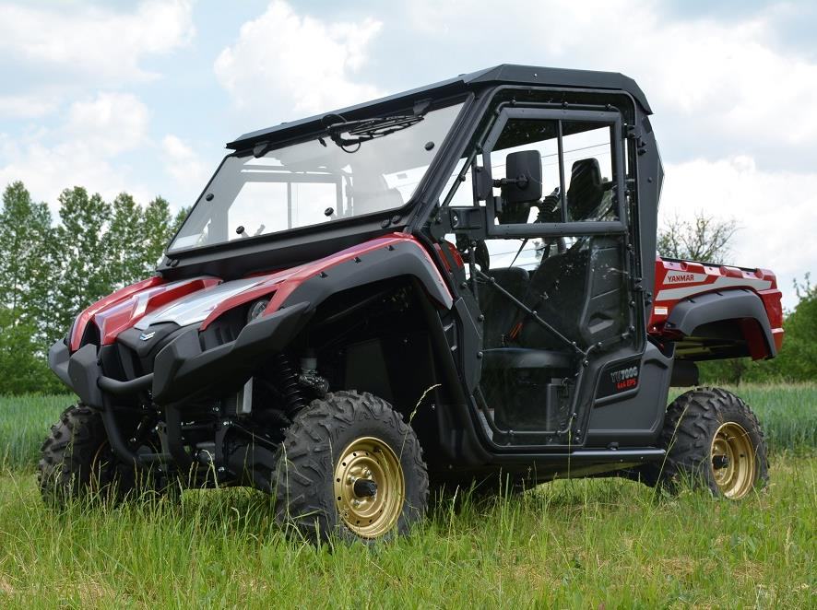**

***ROOF PANEL***

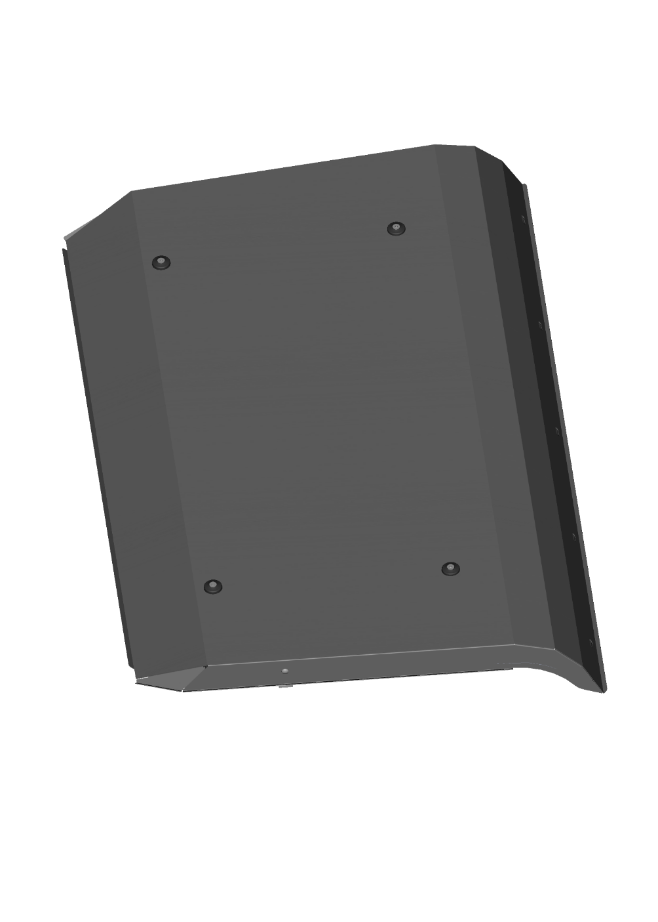

|  |  |  |  |  |  |  |  |
| --- | --- | --- | --- | --- | --- | --- | --- |
| **ID** | **Catalogue no.** | **Description** | **Qty** | **Price** | **Dist/OE** | **DLR** | **MSRP** |
| 1 | 41S04U04S30 | ROOF PANEL | 1 | Depends on a cab level | | | |

***REAR PANEL***

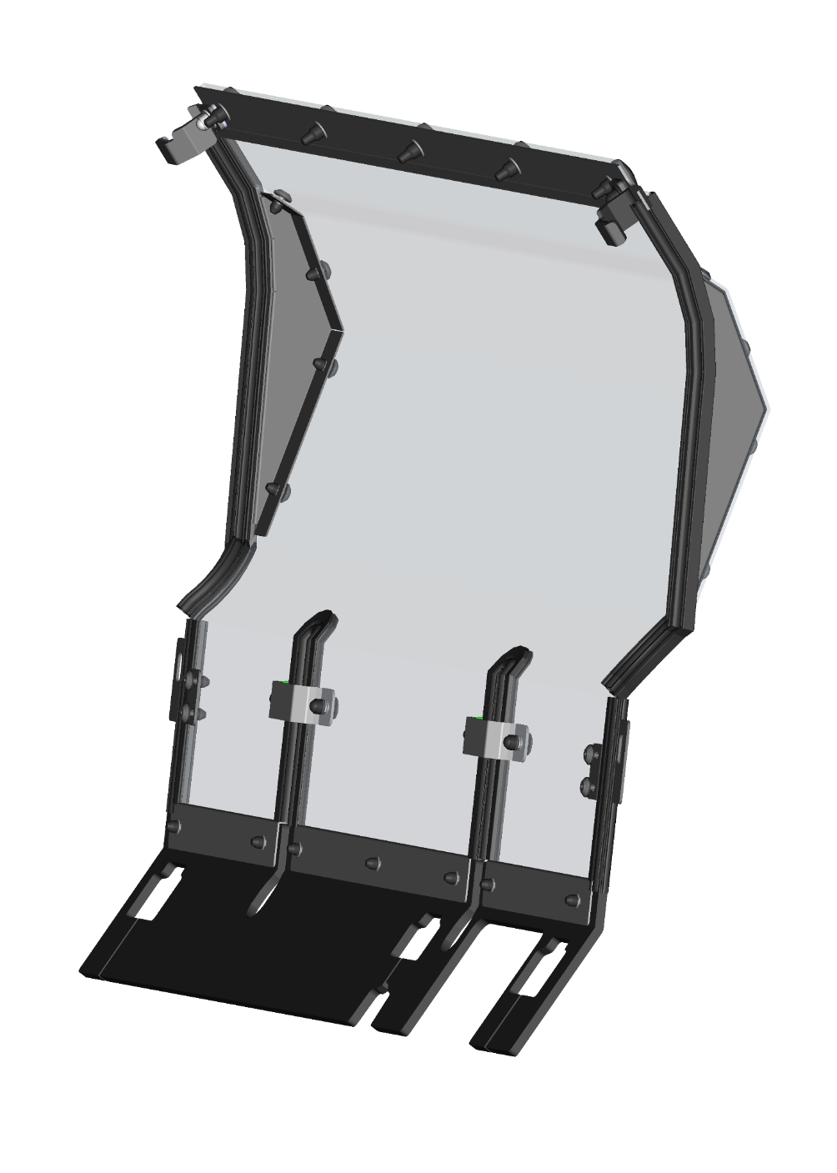

|  |  |  |  |  |  |  |  |
| --- | --- | --- | --- | --- | --- | --- | --- |
| **ID** | **Catalogue no.** | **Description** | **Qty** | **Price** | **Dist/OE** | **DLR** | **MSRP** |
| 1 | 41S05U02S20 | REAR PANEL | 1 | Depends on a cab level | | | |

***FRONT UPPER LEDGE***

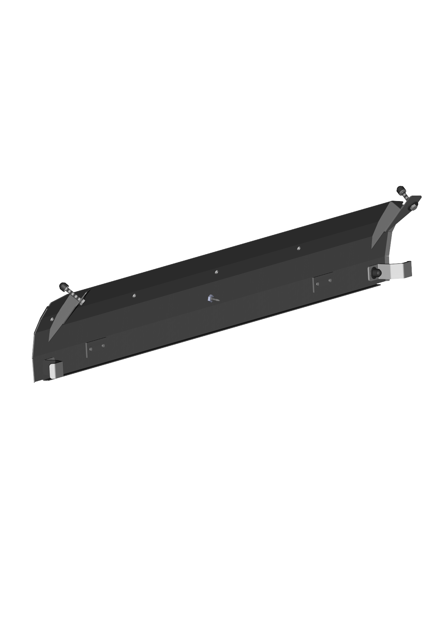

|  |  |  |  |  |  |  |  |
| --- | --- | --- | --- | --- | --- | --- | --- |
| **ID** | **Catalogue no.** | **Description** | **Qty** | **Price** | **Dist/OE** | **DLR** | **MSRP** |
| 1 | 41S04U01-10PKM007 | FRONT UPPER LEDGE KIT | 1 | 195 |  |  |  |

***FRONT WINDOW ASSEMBLIES***

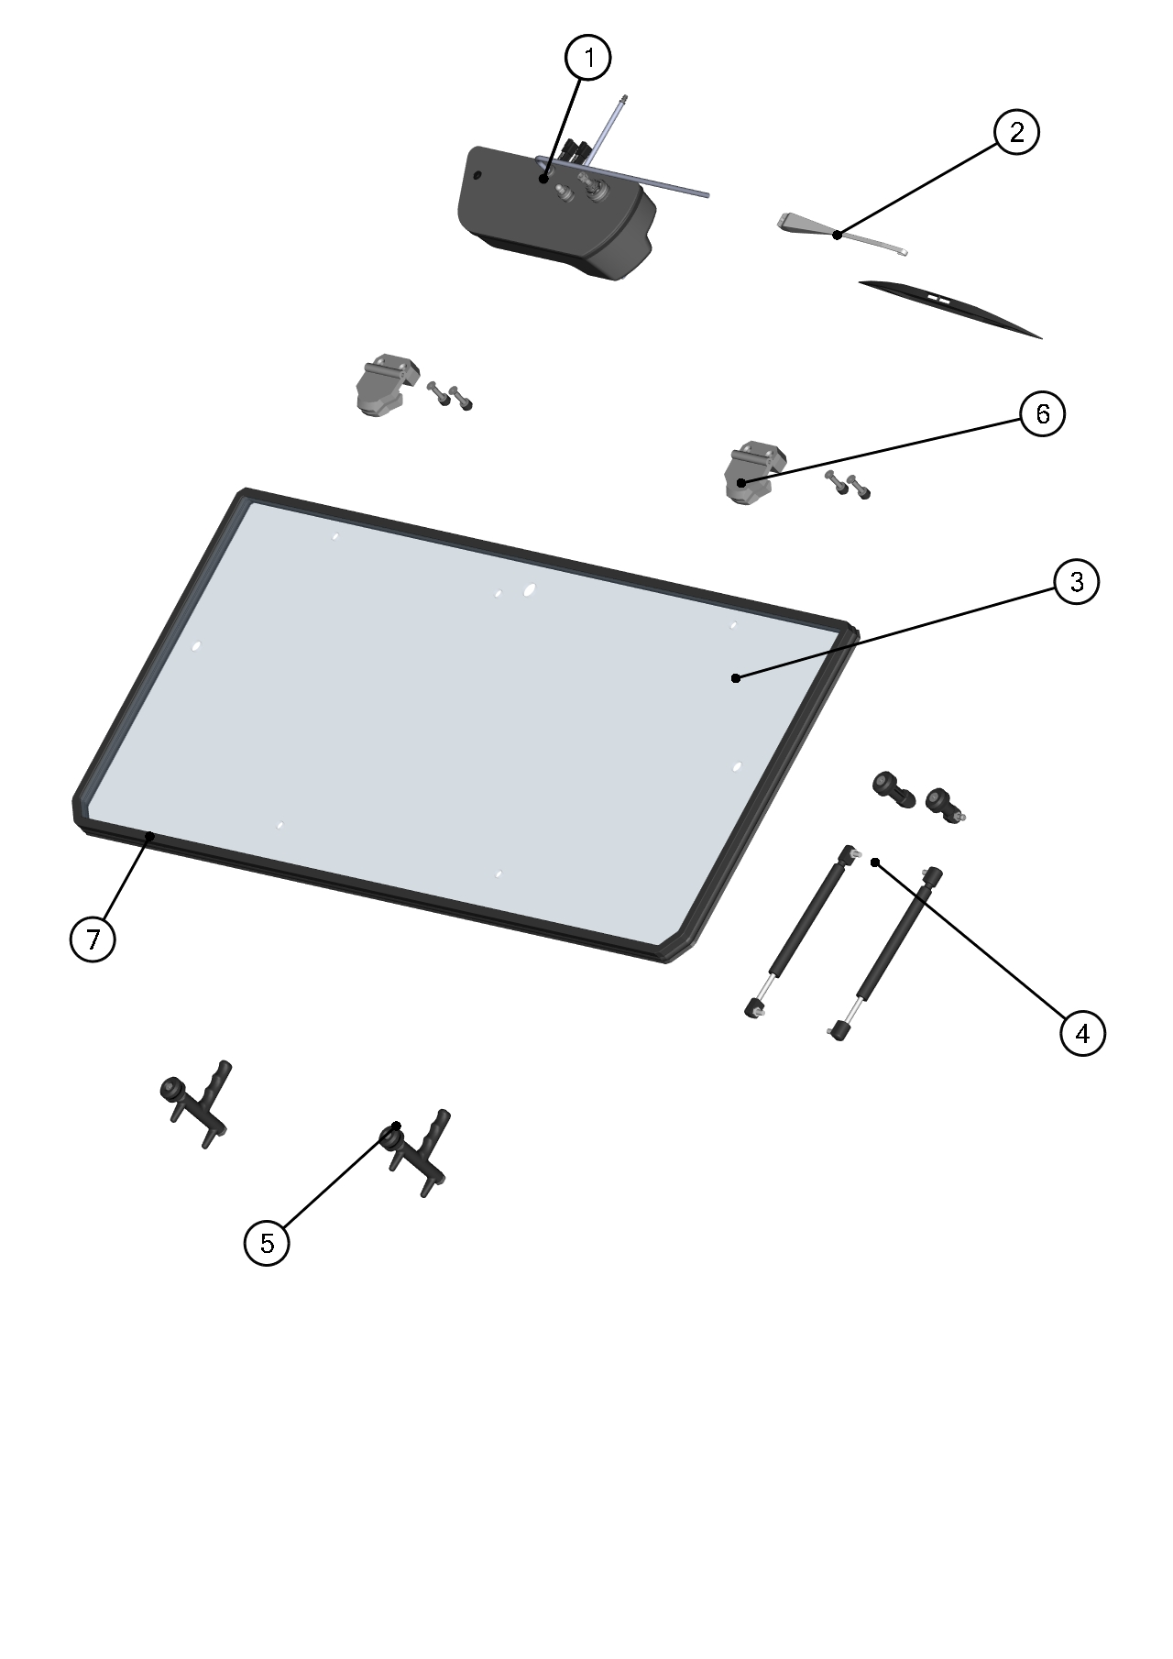

|  |  |  |  |  |  |  |  |
| --- | --- | --- | --- | --- | --- | --- | --- |
| **ID** | **Catalogue no.** | **Description** | **Qty** | **Price** | **Dist/OE** | **DLR** | **MSRP** |
| 1 | 41S04U04-01M001 | WIPER MOTOR ASSEMBLY | 1 | 175 |  |  |  |
| 2 | 41S04U04-10PKM004 | WIPER ARM WITH BLADE KIT | 1 | 65 |  |  |  |
| 3 | 41S04U01-10M003 | FRONT GLASS WITH SEALING | 1 | 430 |  |  |  |
| 4 | 41S04U01-10PKM008 | FRONT WINDOW GAS SPRING KIT | 1 | 84 |  |  |  |
| 5 | 41S04U01-10PKM009 | FRONT WINDOW HANDLE KIT | 1 | 65 |  |  |  |
| 6 | 41S04U01-10PKM010 | FRONT GLASS HINGE KIT | 1 | 65 |  |  |  |
| 7 | 001012 | FRONT GLASS RUBBER SEAL | 1 m | 8 |  |  |  |

***FRONT BOTTOM LEDGE ASSEMBLIES***

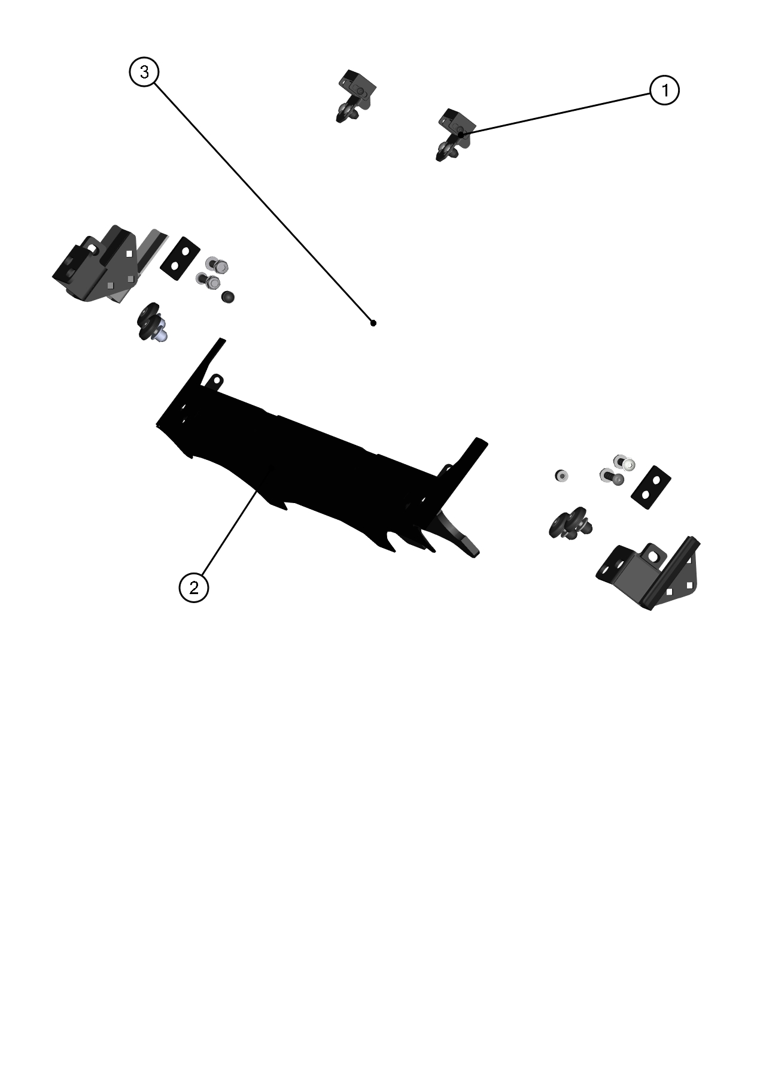

|  |  |  |  |  |  |  |  |
| --- | --- | --- | --- | --- | --- | --- | --- |
| **ID** | **Catalogue no.** | **Description** | **Qty** | **Price** | **Dist/OE** | **DLR** | **MSRP** |
| 1 | 41S04U01-10PKM011 | WINDOW STOP KIT | 1 | 65 |  |  |  |
| 2 | 41S04U01-10PKM006 | FRONT BOTTOM LEDGE KIT | 1 | 175 |  |  |  |
| 3 | 41S04U01-10PKM012 | FRONT BOTTOM HARDWARE KIT | 1 | 110 |  |  |  |

***DOOR GAS SPRING ASSEMBLY***

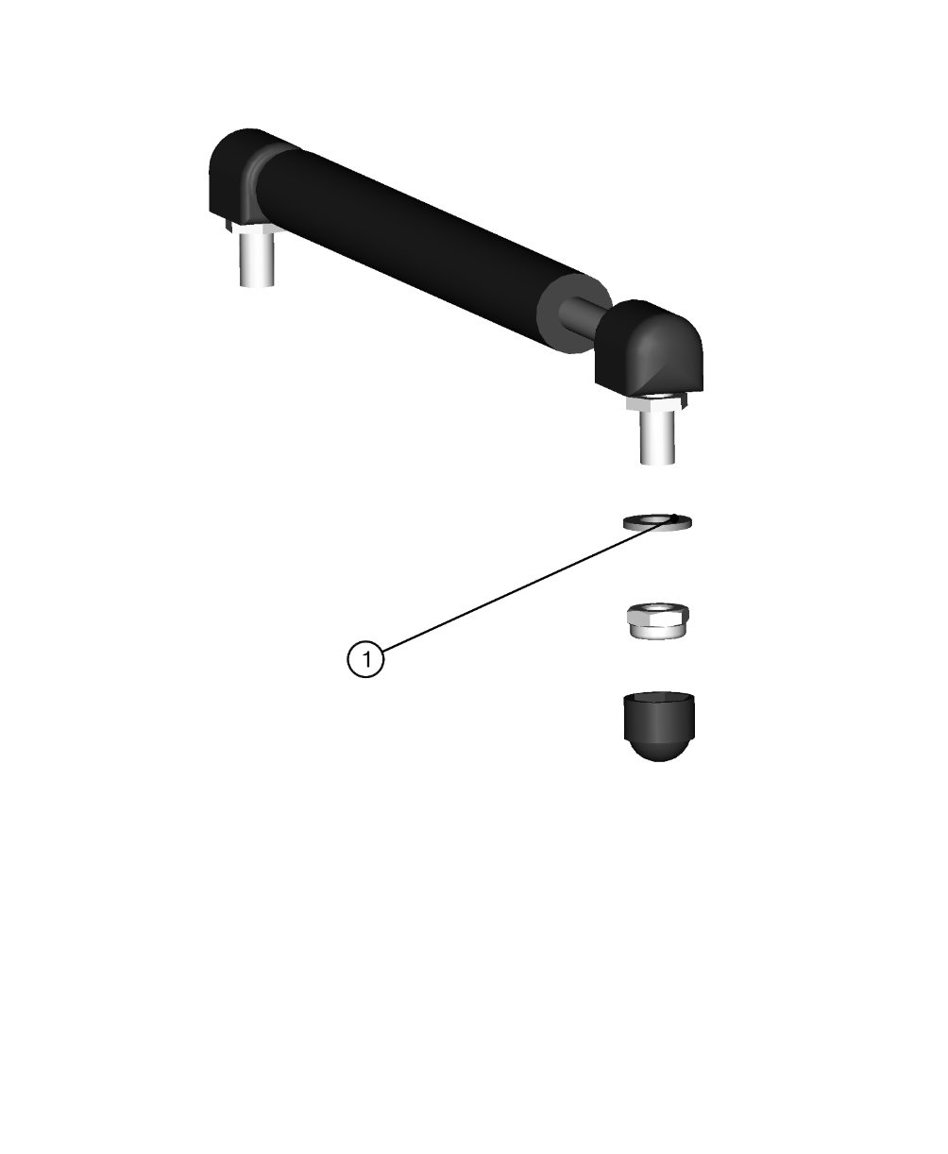

|  |  |  |  |  |  |  |  |
| --- | --- | --- | --- | --- | --- | --- | --- |
| **ID** | **Catalogue no.** | **Description** | **Qty** | **Price** | **Dist/OE** | **DLR** | **MSRP** |
| 1 | 41S04U01-40PKM003 | DOOR GAS SPRING KIT | 1 | 42 |  |  |  |

***LEFT DOOR ASSEMBLY***

4

5

3

2

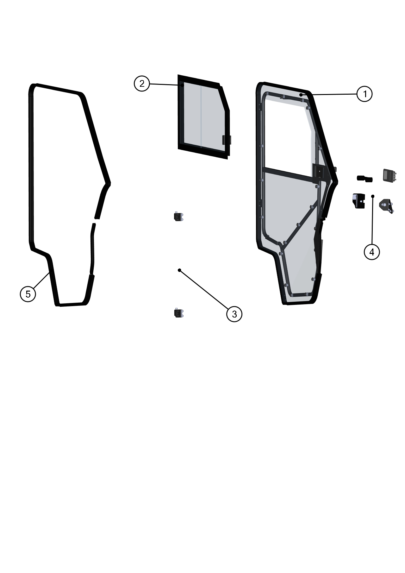

1

|  |  |  |  |  |  |  |  |
| --- | --- | --- | --- | --- | --- | --- | --- |
| **ID** | **Catalogue no.** | **Description** | **Qty** | **Price** | **Dist/OE** | **DLR** | **MSRP** |
| 1 | 41S04U01-40PKM010 | LEFT DOOR KIT | 1 | 935 |  |  |  |
| 2 | 41S04U01-40M001 | LEFT DOOR WINDOW ASSEMBLY | 1 | 330 |  |  |  |
| 3 | 41S04U01-40PKM009 | LEFT DOOR HINGES KIT | 1 | 110 |  |  |  |
| 4 | 41S04U01-40PKM006 | LEFT DOOR LOCK WITH STOP KIT | 1 | 65 |  |  |  |
| 5 | 002454 | DOOR RUBBER SEAL | 1 m | 8 |  |  |  |

***LEFT DOOR BASE KIT***

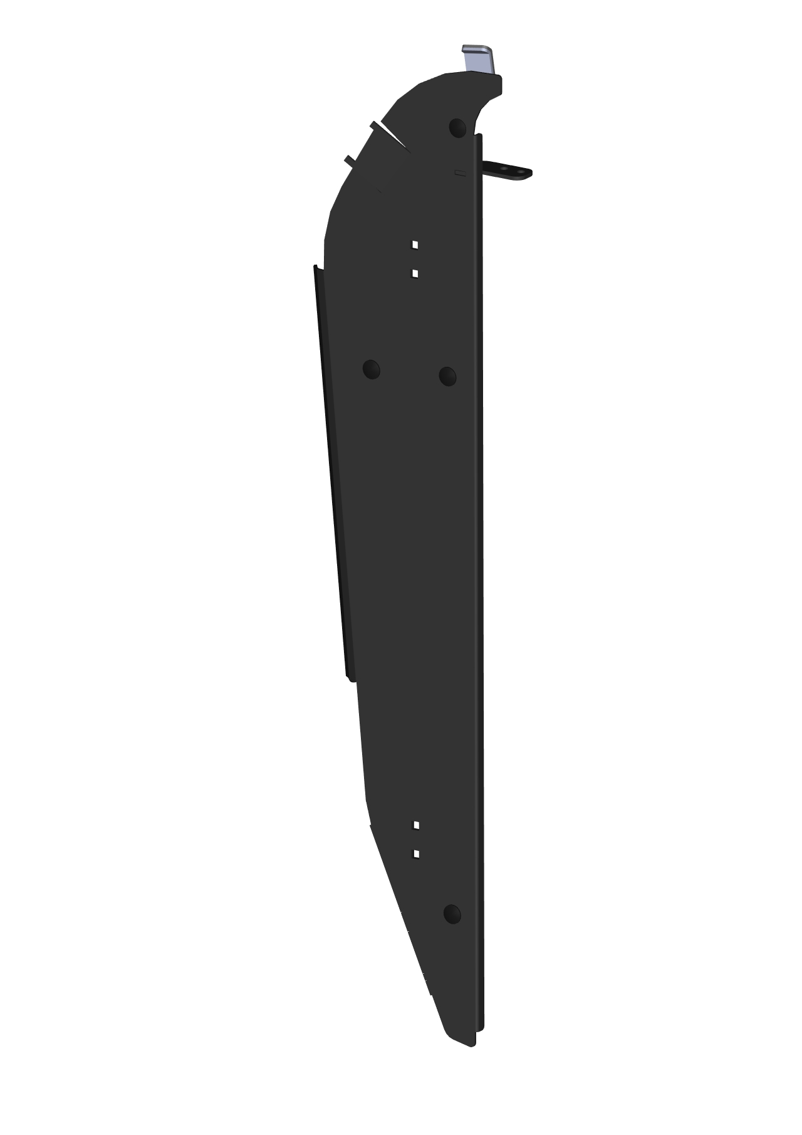

|  |  |  |  |  |  |  |  |
| --- | --- | --- | --- | --- | --- | --- | --- |
| **ID** | **Catalogue no.** | **Description** | **Qty** | **Price** | **Dist/OE** | **DLR** | **MSRP** |
| 1 | 41S04U01-40PKM011 | LEFT DOOR BASE KIT | 1 | 175 |  |  |  |

***DOOR GAS SPRING ASSEMBLY***



|  |  |  |  |  |  |  |  |
| --- | --- | --- | --- | --- | --- | --- | --- |
| **ID** | **Catalogue no.** | **Description** | **Qty** | **Price** | **Dist/OE** | **DLR** | **MSRP** |
| 1 | 41S04U01-40PKM003 | DOOR GAS SPRING KIT | 1 | 42 |  |  |  |

***RIGHT DOOR ASSEMBLY***



|  |  |  |  |  |  |  |  |
| --- | --- | --- | --- | --- | --- | --- | --- |
| **ID** | **Catalogue no.** | **Description** | **Qty** | **Price** | **Dist/OE** | **DLR** | **MSRP** |
| 1 | 41S04U01-50PKM010 | RIGHT DOOR KIT | 1 | 935 |  |  |  |
| 2 | 41S04U01-50M001 | RIGHT DOOR WINDOW ASSEMBLY | 1 | 330 |  |  |  |
| 3 | 41S04U01-50PKM009 | LEFT DOOR HINGES KIT | 1 | 110 |  |  |  |
| 4 | 41S04U01-50PKM006 | LEFT DOOR LOCK WITH STOP KIT | 1 | 65 |  |  |  |
| 5 | 002454 | DOOR RUBBER SEAL | 1 m | 8 |  |  |  |

***RIGHT DOOR BASE ASSEMBLIES***



|  |  |  |  |  |  |  |  |
| --- | --- | --- | --- | --- | --- | --- | --- |
| **ID** | **Catalogue no.** | **Description** | **Qty** | **Price** | **Dist/OE** | **DLR** | **MSRP** |
| 1 | 41S04U01-50PKM011 | RIGHT DOOR BASE KIT | 1 | 175 |  |  |  |

***ELECTROINSTALLATION***

|  |  |  |  |  |  |  |  |
| --- | --- | --- | --- | --- | --- | --- | --- |
| **Position** | **Catalogue no.** | **Description** | **Qty** | **Price** | **Dist/OE** | **DLR** | **MSRP** |
| 1 | 004332 | WIPER/WASHER SWITCH | 1 | 30 |  |  |  |
| 2 | 006441 | WIPER HARNESS | 1 | 110 |  |  |  |
| 3 | 005996 | RELAY HARNESS | 1 | 200 |  |  |  |
| 4 | 000885 | WASHER TANK | 1 | 65 |  |  |  |
| 5 | 006443 | WASHER HARNESS | 1 | 110 |  |  |  |
| 6 | 50S02U02-02M005 | HEATER HARNESS | 1 | 55 |  |  |  |
| 7 | 50S02U02-02M004 | HEATER ASSEMBLY | 1 | 360 |  |  |  |
| 8 | 00-109U-M006 | SIDE MIRROR ASSSEMBLY (PAIR) | 1 | 120 |  |  |  |
| 9 | 002386 | EL. VALVE | 1 | 70 |  |  |  |
| 10 | 41S04U01-02PKM001 | WATER PUMP ASSEMBLY | 1 | 110 |  |  |  |

|  |  |  |  |  |  |  |  |
| --- | --- | --- | --- | --- | --- | --- | --- |
|  | |  |  | |  |  | |
|  |  |
|  |  |
|  |  |
|  |  |
|  |  |
|  |  |
|  |  |
|  |  |
| ***Position : 1*** |  |  | ***Position : 2*** |  |  | ***Position : 3*** |  |
| ***Cat. no.: 004332*** |  |  | ***Cat.no.: 006441*** |  |  | ***Cat. no.: 005996*** |  |
|  | | | | | | | |
| elektro-Nádobka ostřikovače 12v | |  |  | |  | K:\DOKUMENTY\Vzory Kabeláží\08 - POLARIS RZR 1000 - (Předáno 22.11.2017)\FOTKY\TOPENÍ.jpg | |
|  |  |
|  |  |
|  |  |
|  |  |
|  |  |
|  |  |
|  |  |
|  |  |
| ***Position : 4*** |  |  | ***Position : 5*** |  |  | ***Position : 6*** |  |
| ***Cat. no.: 000885*** |  |  | ***Cat. no.: 006443*** |  |  | ***Cat. no.: 50S02U02-02M005*** |  |
|  | | | | | | | |
|  | |  |  | |  | 20121018_083934 | |
|  |  |
|  |  |
|  |  |
|  |  |
|  |  |
|  |  |
|  |  |
|  |  |
| ***Position : 7*** |  |  | ***Position : 8*** |  |  | ***Position : 9*** |  |
| ***Cat. no.: 50S02U02-02M004*** |  |  | ***Cat. no.: 00-109U-M006*** |  |  | ***Cat. no.: 002386*** |  |

|  |  |  |  |  |  |  |  |
| --- | --- | --- | --- | --- | --- | --- | --- |
|  | |  |  | |  |  | |
|  |  |
|  |  |
|  |  |
|  |  |
|  |  |
|  |  |
|  |  |
|  |  |
| ***Position : 10*** |  |  |  |  |  |  |  |
| ***Cat. no.: 41S04U01-02PKM001*** |  |  |  |  |  |  |  |
|  | | | | | | | |